Speakers
- Quynh-Anh McMahan, grant officer/The George Foundation
- Jason Twiss, director of member engagement/GEO
- J McCray, coo/GEO

Session Description
GEO is a diverse community of more than 500 grantmaking organizations working to reshape the way philanthropy operates. Where does your organization fit in? Designed with the first-time conference goer and the new-to-GEO attendee in mind, you’ll learn about the values and core practices that underscore GEO’s work and how we support our members working toward smarter grantmaking, stronger nonprofits and better results. Join this workshop to learn more about the conference program, create your own learning agenda to maximize your overall conference experience, and engage in speed networking to meet like-minded peers and share common questions and challenges you are encountering in your work.

Agenda
- Welcome and Introductions
- A Word From the Planning Committee
- Discover Your Personal Learning Agenda
- Deeper Dive Into GEO’s Core Content Areas
- About the GEO Community
- How to Navigate the Conference
- Speed Networking
- Closing

A Current Challenge or Problem to Solve at Work
What Do I Need To Learn?
Who Do I Need To Meet?
A Topic of Interest, Not Necessarily Related to a Current Challenge or Problem
What Do I Want To Learn?
Who Do I Want To Meet?

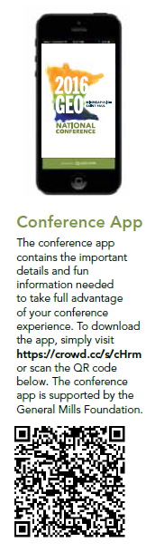
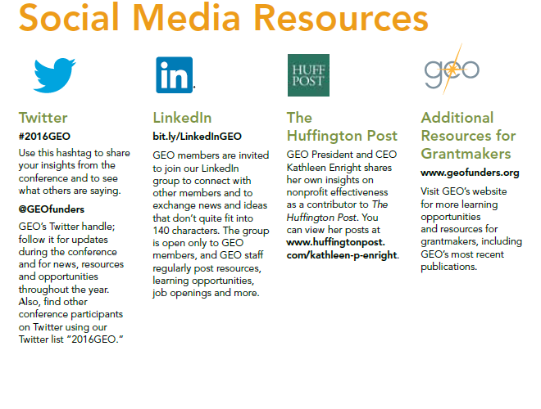

Additional Resources:
GEO Resource Booth. Find out more about your benefit, your one-stop location for all of GEO’s resources and publications, a media center showing all of GEO’s brand videos, and a networking tool for participants interested in setting a meeting location or researching who’s attending the conference based on demographics, focus areas, etc.

Ambassadors GEO’s Ambassador Program connects first-time attendees or those new to GEO with more seasoned GEO members to help both new and returning participants jump-start their networking and make the most of their conference experience. Have questions? Feel free to ask anyone with an Ambassador pin on their name tag — they along with any GEO staff member are happy to help!

