Teaching Nonfiction and the Secondary ESL Classroom

Workshop Created by
Nicole Tabolt Da Silva, NBCT
Boston Public Schools
ntabolt2@bostonpublicschools.org

Table of Contents

Common Core ELA Standards Introduction………………………3-4
Practice Article of the Week…………………………………………5-10
More Resources on Kelly Gallagher’s Article of the Week………11
Nicole Tabolt Da Silva’s ESL Resources …………………………..12-21
Venn Diagram………………………………………………………..23
Example Synthesis Paragraph………………………………………24
Resources for Planning………………………………………………25-26

Shared responsibility for students’ literacy development”

Excerpt from Common Core’s ELA Standards Introduction

The Standards insist that instruction in reading, writing, speaking, listening, and language be a shared responsibility within the school. The K-5 standards include expectations for reading, writing, speaking, listening, and language applicable to a range of subjects, including but not limited to ELA. The grades 6-12 standards are divided into two sections, one for ELA and the other for history/social studies, science, and technical subjects. This division reflects the unique, time-honored place of ELA teachers in developing students’ literacy skills while at the same time recognizing that teachers in other areas must have a role in this development as well.

Part of the motivation behind the interdisciplinary approach to literacy promulgated by the Standards is extensive research establishing the need for college and career ready students to be proficient in reading complex informational text independently in a variety of content areas. Most of the required reading in college and workforce training programs is informational in structure and challenging in content; postsecondary education programs typically provide students with both a higher volume of such reading than is generally required in K-12 schools and comparatively little scaffolding.

The Standards are not alone in calling for a special emphasis on informational text. The 2009 reading framework of the National Assessment of Educational Progress (NAEP) requires a high and increasing proportion of informational text on its assessment as students advance through the grades.

Distribution of Literary and Informational Passages by Grade in the 2009 NAEP Reading Framework
Grade | Literary | Information
4 | 50% | 50%
8 | 45% | 55%
12 | 30% | 70%
(2008). Reading framework for the 2009 National Assessment of Educational Progress. Washington, DC: U.S. Government Printing Office.
The Standards aim to align instruction with this framework so that many more students than at present can meet the requirements of college and career readiness. In K-5, the Standards follow NAEP’s lead in balancing the reading of literature with the reading of informational texts, including texts in history/social studies, science, and technical subjects. In accord with NAEP’s growing emphasis on informational texts in the higher grades, the Standards demand that a significant amount of reading of informational texts take place in and outside the ELA classroom. Fulfilling the Standards for 6-12 ELA requires much greater attention to a specific category of informational text—literary nonfiction—than has been traditional. Because the ELA classroom must focus on literature (stories, drama, and poetry) as well as literary nonfiction, a great deal of informational reading in grades 6-12 must take place in other classes if the NAEP assessment framework is to be matched instructionally.¹ To measure students’ growth toward college and career readiness, assessments aligned with the Standards should adhere to the distribution of texts across grades cited in the NAEP framework.

Pipeline – Screening -

Phobia –

Public pressure -

Why Is the U.S. Not Doing More to Help Syrian Refugees?
BY REUTERS September 7, 2015
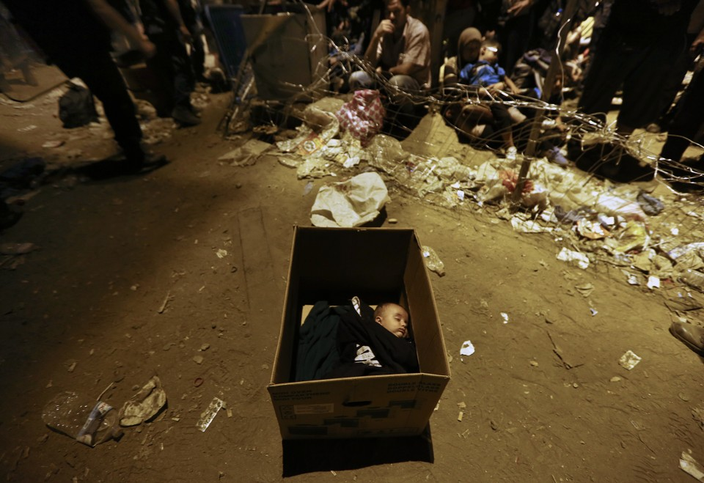
A Syrian baby sleeping in a box in Greece.

As Europe grapples with a flood of refugees from the Syrian war and the pope urges Catholics to help them, the U.S. government may lack the political appetite to offer American soil as a safe haven to more than the current trickle of Syrians.
Refugee and immigrant groups had urged the United States to admit more Syrian refugees long before the crisis erupted this summer in Europe.
Some hoped global outrage over images of a drowned Syrian toddler in Turkey last week, and Pope Francis's call on Sunday for European churches to take in refugees - coming just two weeks before a trip to the United States - might help push America into action.
"The U.S. could and should be doing more. The silence of the White House on this is unacceptable," said Michelle Brané of the Women's Refugee Commission.
Where do refugees live?
Many live in refugee camps, but not all of them.

In Jordan, there is a refugee camp named Za'atari, the first official refugee camp that opened in July 2012. It often gets the most news coverage because it is the destination for newly arrived refugees. It is also the most concentrated settlement of refugees: Approximately 81,500 Syrians live in Za'atari, making it the country’s fourth largest city. The desert is crowded with acres of white tents, makeshift shops line a “main street” and sports fields and schools are available for children.
Because Jordan’s camps are run by the government and the United Nation, they offer more structure and support. But many families feel trapped, crowded, and even farther from any sense of home, so they seek shelter in nearby towns.
Iraq has set up a few camps to house the influx of refugees who arrived in 2013, but the majority of families are living in urban areas. And in Lebanon, the government has no official camps for refugees, so families have established makeshift camps or find shelter in abandoned buildings. In Turkey, the majority of refugees are trying to survive and find work, despite the language barrier, in urban communities.
The fact is, the majority of refugees do not live in refugee camps.
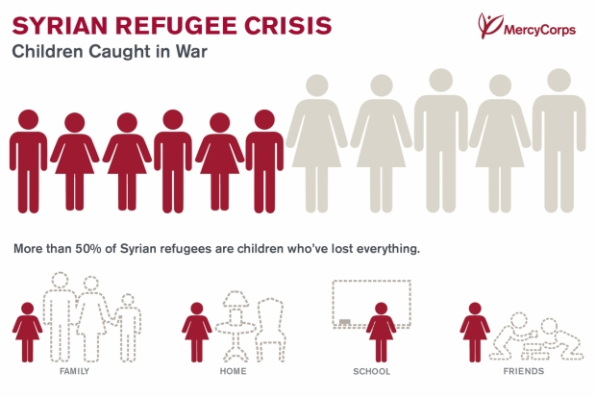
What conditions are refugees facing outside camps?
Refugees find shelter wherever they can. Our teams have seen families living in rooms with no heat or running water, in abandoned chicken coops and storage sheds.

Most refugees must find a way to pay rent, even for bad houses. Without any legal way to work in Jordan and Lebanon, they struggle to find jobs and accept low wages that often don’t cover their most basic needs.
The lack of clean water and sanitation in crowded, makeshift settlements is an important problem. Diseases like cholera and polio can easily spread — even more life-threatening without enough medical services. In some areas with the largest refugee populations, water shortages have reached emergency levels; the supply is as low as 30 liters per person per day — one-tenth of what the average American uses.
The youngest refugees face an uncertain future. Some schools have been able to divide the school day into two shifts and make room for more Syrian students. But there is simply not enough space for all the children, and many families cannot afford the transportation to get their kids to school.
How many refugees are children?
According to the U.N., more than half of all Syrian refugees are under the age of 18. Most have been out of school for months, if not years.

The youngest are confused and scared by their experiences, lacking the sense of safety and home they need. The older children are forced to grow up too fast, finding work and taking care of their family in desperate circumstances.
American Political Problems with Accepting Syrian Refugees
Some congressional Republicans have said allowing in Syrian refugees would represent a pipeline for terrorists.
"The discussion has been really awful," said James Zogby, president of the Arab American Institute. "The difficulty of doing it is met by this Islamophobia and belief that all Syrians and Iraqis are terrorists.
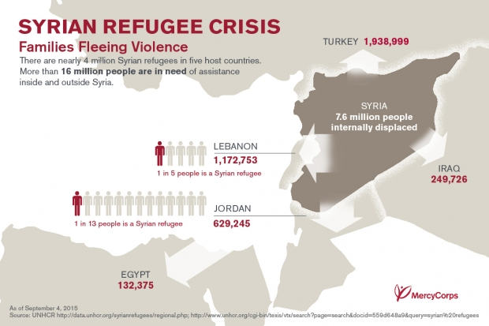
"Hopefully, Pope Franciss will be able to challenge that mentality.”
The Obama administration itself is concerned that militants from Islamic State (ISIS) or al Qaeda might enter the country as refugees. The State Department has cited Washington's screening process as a crucial but complicating factor for Syrians seeking entry.
Since the start of the Syrian war in 2011, Washington has accepted 1,500 Syrian refugees, most of them this year, and the State Department expects 300 more by October.
The number is tiny against the number of the European refugee crisis in which Germany is preparing for 800,000 asylum seekers this year, around 1 percent of its population, and compared with the overall number of 4 million Syrian refugees.
British Prime Minister David Cameron pledged on Monday to take in up to 20,000 refugees from camps in Syria over the next five years, responding to public pressure to help.
While President Barack Obama, a Democrat, does not need approval to allow in more refugees, Zogby said the President could be wary of risking a backlash at a time when he is trying to secure lawmakers' support for a nuclear deal between Iran and world powers, including the United States.
Terrorism Fears Prompt Caution
Previous efforts to increase the flow of Syrian refugees have met strong opposition.
In May, 14 U.S. Senate Democrats wrote a letter urging the Obama administration to allow at least 65,000 Syrian refugees to settle in the United States. The following month, Republican Representative Michael McCaul objected to the administration's plans to allow nearly 2,000 this year.
"While we have a proud history of welcoming refugees, the Syrian conflict is a unique case requiring heightened vigilance and scrutiny," McCaul, whose Homeland Security Committee has held hearings on the issue, wrote in a letter to Obama.
"It represents the single largest assembly of Islamist terrorists in history," including Islamic State, al Qaeda and Hezbollah, he continued, adding U.S. security officials did not have the information they need for effective screening.
Republican Representative Peter King of New York echoed that on Monday, saying there was a clear consensus at the hearings that terrorism was a concern.
"We have to have a very, very thorough screening process," King said on CNN.
The U.N. High Commissioner for Refugees is responsible for selecting refugees eligible for resettlement and spokeswoman Melissa Fleming said it has submitted more than 16,300 Syrian refugees for resettlement in the United States.
U.S. consulate and security officials, including from the Department of Homeland Security, then screen the applicants before allowing them to board a U.S.-bound plane.
Kevin Appleby, director of migration policy at the U.S. Conference of Catholic Bishops, said in an interview that the security worries over Syrians were misplaced, given the intense background checks on refugees.
But more resources would have to be allocated for faster vetting. For example, Appleby said, the United States does not process Syrian refugees from Europe but from Jordan and elsewhere in the Middle East, where most of the refugees are.
Pope Francis is likely to call on America to live up to its values as a nation that provides safe haven during his American visit this month, Appleby said.
The Conference of Catholic Bishops has long advocated for more Syrians to be allowed in and believes the country could accept 100,000.
"It is possible. It's certainly possible from our end in terms of resettling them in the United States," Appleby said, pointing to the U.S. absorption of Vietnamese refugees during the Vietnam War. "It's just a matter of political desire."

Reading Questions
1) Give two reasons why the United States government is afraid of accepting Syrian refugees.

2) Describe the conditions of Syrian refugees.

3) Which countries are accepting the most Syrian refugees?

Based on the article, “Why is the U.S. not doing more to help Syrian Refugees?” answer the question: Should the United States accept more Syrian refugees? Make sure you use LEVEL 2 and LEVEL 3 Transitions from MCAS page 1.

___________________________________________________________________
___________________________________________________________________
___________________________________________________________________

___________________________________________________________________

___________________________________________________________________

___________________________________________________________________

___________________________________________________________________

___________________________________________________________________

___________________________________________________________________

___________________________________________________________________

___________________________________________________________________

___________________________________________________________________

___________________________________________________________________

___________________________________________________________________

___________________________________________________________________

___________________________________________________________________

___________________________________________________________________

___________________________________________________________________

___________________________________________________________________

More Resources on Kelly Gallagher’s Article of the Week
- Article of the Week Online Archive: http://www.kellygallagher.org/article-of-the-week
- Dave Stuart Jr’s Blog Post on Implementing Article of the Week In His Classroom: http://www.davestuartjr.com/article-of-the-week-assignment/
- Stenhouse Publisher’s Article of the Week DVD
- Vale Middle School’s Article of the Week Materials, including useful rubric: http://vms.vale.k12.or.us/articles-week
Nicole Tabolt Da Silva’s Article of the Week Materials
 | Level 1 | Level 2 | Level 3
Introducing Evidence | For example  For instance  One reason is | As the author states, “____”  According to the author,  The author demonstrates that  In the author’s view, “____”  As the author goes on to explain, “_________________.”  As the author informs the reader, “_____________” | The author observes that “_____”  The article suggests that “_____.”  The author maintains that …  As demonstrated in the following quote, “ _____” One critical point of the text is that “_________.”
Analyzing Evidence | This quote demonstrates that…  This evidence proves that… | The point of this quote is that…  In other words, the article demonstrates that…  From this quote, the reader can conclude that… | In making this comment, the author urges the reader to ...  The essence of this quote is that ...  This evidence is corroborating the idea that…
Conclusion | In conclusion  All in all  Ultimately  Overall | As a result of …  To summarize…  This topic of ___________ is important because …  Consequently…  Therefore… | This discussion of the topic of _______________ is in fact addressing the larger matter of…  Ultimately, what is at stake is…  This topic is in fact crucial in terms of today’s concerns over…

Rubric for Article of the Week Annotations and Responses SY 2014-2015
Summaries | 3- Summaries are specific and accurate about each section; they use specific words from the article. (“To summarize, a high school student named Zoe who does not fall asleep until 1 am due to her homework and extracurricular activities.”)  2- Summaries accurately describe the ideas in each section (This section is about high school students who do not get enough sleep because of homework and sports team involvement.”)  1- Summaries are general and do not have details (“High school students are tired”)  0- There are no summaries or summaries are copied sentences from the article.
Talking to the Text | 3-Students uses all of the talking to text strategies (connections, important, question, agree, disagree) multiple times in the text.  2-Student uses all of the talking to text strategies at least once.  1- Student uses a few talking to the text strategies.  0 – Student does not use “talking to the text” strategies.
Thesis/Claim | 3- Expresses a thesis statement with supporting and convincing reason  2-Expresses topic sentence by turning question around with supporting reasons.  1- Expresses an elemental topic sentence by turning question around.  0- There is no claim or summarizes the text without answering the question.
Evidence and Analysis | 3-The most important examples from the text are chosen, and the analysis uses a variety of sentence frames to make a strong connection between the claim and the evidence.  2- There are many appropriate quotes/examples and analysis connects the evidence to the claim/thesis.  1-There is a list of evidence with some analysis that summarizes the text.  0- Text is only copied.
Organization | 3- Creates well-developed paragraph that supports the topic sentence with evidence and analysis. There is persuasive unity throughout the paragraph. Uses varied transitions to introduce points and evidence.  2- Creates a paragraph that supports the topic sentence with some evidence and vague or mechanical analysis. Attempts to develop points that connect to the topic sentence. Uses some transitions with some accuracy.  1. – Some transitions are used. Simple sentences are used to provide loosely connected ideas.  0- No transitions are used.
Academic Language | 3- Uses academic vocabulary (Tier 2 and content-specific) throughout the response. Uses academic vocabulary from the article correctly.  2- Uses general and some academic vocabulary that relates to the article’s topic.  1--Uses simple and commonly used vocabulary appropriate to ESL level.  0- Student does not complete assignment or does not address task. Student only copies text.

Example Leveled Article of the Week from Nicole Tabolt Da Silva’s Class
Directions for Article of the Week:
- Write 3-5 summary annotations of the article.
- Use several talking to the text strategies for each page of the article.
- By Friday, write your AOW response to the prompt: Based on the article “Police cases cause national protests,” explain the factors that contributed to the national protest and debate about police brutality. Support your answer with relevant and specific information from the text.

Article of the Week #10 Lite

Police cases cause national protests
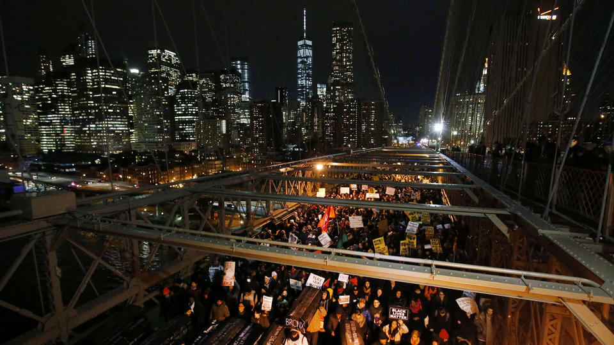
Boston Herald Friday December 5, 2014
Protesters stopped the Brooklyn Bridge after a grand jury's decision not to indict the police officer involved in the death of Eric Garner.

NEW YORK — Thousands and thousands of people protested in American cities, from New York City to San Francisco for a second straight night to protest a grand jury decision not to indict a police officer in the death of Eric Garner.
Grandparents marched with their grandchildren. Protesters, new and old and of all races, shouted and marched against the decision.
"This has to stop," Harlem resident Judy Edwards said at a protest Thursday night in Manhattan.
The 61-year-old black woman was with her daughter and twin 10-year-old grandchildren, a boy and a girl. She said it was important to her that the children saw a group that was racially mixed and diverse in many other ways all insisting upon the same thing — that something must be done.
That was the message, too, in cities across America: Atlanta, Boston, Chicago, Denver, Detroit, Minneapolis Oakland, San Francisco and Washington, D.C., among them. Demonstrators marched down busy streets and blocked highways and bridges. Politicians talked about the need for better police training, body cameras and changes in the grand jury process to create public faith in the legal system.
New York Governor Andrew Cuomo said the series of deaths of black men by police officers, not just the Eric Garner case in New York City, threaten to destroy the belief and trust many Americans have in the nation's criminal justice system.
Cuomo, speaking on NBC's "Today" on Friday, said the death of Michael Brown in Ferguson, Missouri, and similar previous cases in New York City show that it's necessary to understand that it is not just about the Eric Garner case.
The governor said if people don't feel they have fair representation by the justice system, "you have a major problem."
In New York, Mayor Bill de Blasio explained his plans to teach officers how to communicate better with people on the street.
President Barack Obama also discussed the case, saying one of the principal issues is "making sure that people have confidence that police officers and public lawyers are serving everybody equally."
But U.S. Representative Peter King, told The Associated Press, a news organization: "The black community is not right to be angry about the ruling. If this were a white person it would have been the same thing."
Tensions already were high after a grand jury last week did not indict a police officer in the shooting death of 18-year-old Michael Brown in Ferguson, Missouri. Then on Wednesday came the decision that Officer Daniel Pantaleo would not be indicted in the chokehold death of Eric Garner. In both cases the officers were white and the victims were black.
New York demonstrators marched to major traffic areas on Thursday. They met near the Holland Tunnel, the Manhattan Bridge and on the Westside Highway, temporarily stopping traffic.
Police say they arrested more than 200 demonstrators in New York City on Thursday night.
In Chicago, hundreds of protesters blocked Lake Shore Drive. The protesters tried to march to Soldier Field, where the NFL teams Chicago Bears and the Dallas Cowboys were playing.
In San Francisco, protesters blocked Market Street, at one point all of the protesters lay down on the street to represent the deaths of black men by police officers. In Oakland, several dozen protesters walked the streets shouting "No justice! No peace! Put the racist police in prison!"
In Arizona, about 150 people marched through the streets of downtown Phoenix. They protested the fatal shooting of a black, unarmed drug suspect by a white Phoenix police officer. The Phoenix police officer though the man had a gun, but it was only a bottle of pills. Protesters said that police violence against black men is a national problem.
In Washington, protesters gathered in front of the Justice Department and marched close to the Ellipse where holiday revelers — including the president and his family — celebrated the lighting of the national Christmas tree.
The government needs to fix “the broken system” that excuses police brutality, Reverend Al Sharpton said at a demonstration in New York. "Federal intervention must come now and protect people from state grand juries.”
Article of the Week #10 Medium

Police cases stir national protests, debate
Boston Herald Friday December 5, 2014
Protesters rallying against a grand jury's decision not to indict the police officer involved in the death of Eric Garner carry a collection of mock coffins bearing the names of victims of fatal police encounters as they cross the eastbound traffic lanes of the Brooklyn Bridge, Thursday, Dec. 4, 2014, in New York. A grand jury cleared a white New York City police officer Wednesday in the videotaped chokehold death of Garner, an unarmed black man, who had been stopped on suspicion of selling loose, untaxed cigarettes.

NEW YORK — Thousands and thousands of diverse people united by anger took to the streets from New York City to San Francisco for a second straight night to protest a grand jury clearing a white police officer in the chokehold death of an unarmed black man, Eric Garner.
Grandparents marched with their grandchildren. Experienced activists stood alongside newcomers, and protesters of all colors chanted slogans.
"We're under siege and it has to stop," Harlem resident Judy Edwards said at a rally Thursday night in lower Manhattan's Foley Square.
The 61-year-old black woman was accompanied by her daughter and twin 10-year-old grandchildren, a boy and a girl. She said it was important to her that the children saw a crowd that was racially mixed and diverse in many other ways all insisting upon the same thing — that something must be done.
That was the message, too, in cities across America: Atlanta, Boston, Chicago, Denver, Detroit, Minneapolis Oakland, San Francisco and Washington, D.C., among them. Sign-carrying, chanting demonstrators marched down busy streets and shut down highways and bridges. Politicians talked about the need for better police training, body cameras and changes in the grand jury process to restore faith in the legal system.
New York Governor Andrew Cuomo said a "long string of events" involving the deaths of black men at the hands of police, not just the Eric Garner case in New York City, threaten to destroy the belief and trust many Americans have in the nation's criminal justice system.
Cuomo, speaking on NBC's "Today" on Friday, said the death of Michael Brown in Ferguson, Missouri, and similar previous cases in New York City show that it's necessary to "pull back the lens to understand it's not just about Eric Garner."
The governor said if people don't feel they're fairly represented by the justice system, "you have a fundamental problem."
In New York, Mayor Bill de Blasio explained his plans to teach officers how to communicate better with people on the street.
President Barack Obama also weighed in, saying one of the chief issues at stake is "making sure that people have confidence that police and law enforcement and prosecutors are serving everybody equally."
But U.S. Rep. Peter King, R-N.Y., told The Associated Press: "The black community is not right to be upset about the ruling. If this were a white person it would have been the same thing."
Tensions already were high after a grand jury last week did not indict an officer in the shooting death of 18-year-old Michael Brown in Ferguson, Missouri. Then on Wednesday came the decision that Officer Daniel Pantaleo would not be indicted in the chokehold death of Eric Garner. In both cases the officers were white and the victims were black.
New York demonstrators targeted the city's major traffic arteries again on Thursday. They gathered near the Holland Tunnel, the Manhattan Bridge and on the Westside Highway, temporarily shutting them down. One group converged on the Staten Island Ferry Terminal.
Police say they arrested more than 200 demonstrators in New York City on Thursday night.
New Orleans residents held a die-in at a holiday light show and police moved in to separate them from spectators, some of whom yelled at the demonstrators.
In Chicago, hundreds of protesters blocked Lake Shore Drive. The protesters were thwarted in their efforts to march to Soldier Field, where the Chicago Bears and the Dallas Cowboys were playing.
In San Francisco, protesters blocked Market Street, at one point lying down en masse, causing gridlock until police spurred them to move to Union Square. In Oakland, several dozen protesters walked the streets shouting "No justice! No peace! Jail the racist police!"
In Arizona, about 150 people took part in the march through the streets of downtown Phoenix protesting the deadly shooting of a black, unarmed drug suspect by a white Phoenix police officer who thought the man was carrying a gun but it was only a bottle of pills. The crowd called for an end to what they say is a nationwide epidemic of police brutality.
In Washington, protesters gathered in front of the Justice Department and marched close to the Ellipse where holiday revelers — including the president and his family — celebrated the lighting of the national Christmas tree. A second march went from the district's police headquarters to city hall, where former D.C. Mayor Marion Barry's remains are lying in repose.
At a news conference in New York on Thursday after a night of protests led to 83 arrests, the Rev. Al Sharpton called the state-level grand jury system "broken" when it comes to police brutality cases and urged federal authorities to fix it.
"The federal government must do in the 21st century what it did in the mid-20th century," he said. "Federal intervention must come now and protect people from state grand juries.”

Based on the article “Police violence seems to result in no punishment,” describe the factors that have led to a “pandemic phase” of police violence in the United States. In your conclusion, explain if you think there is any possible solution this phase. Support your answer with relevant and specific information from the article

Article of the Week #10 A+ Challenge

Police Violence Seems to Result in No Punishment
DEC. 4, 2014 Adapted from New York Times
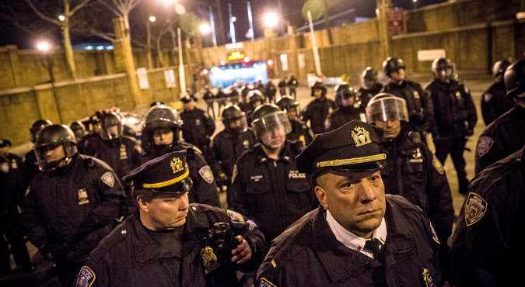
The police stopped protesters from entering the Lincoln Tunnel after a grand jury did not indict an officer in the death of Eric Garner on Wednesday. Credit
Andrew Burton/Getty Images

When a grand jury on Staten Island declined, on Wednesday, to indict Officer Daniel Pantaleo in the killing of Eric Garner, some critics blamed the conservative culture of the neighborhood Staten Island. But grand juries rarely give an indictment in cases involving police officers who have killed civilians. And they have failed to do so in more liberal environments — in Manhattan, Brooklyn and the Bronx.
The year 1999 was a horrific one for police shootings in New York City. On Feb. 4, Amadou Diallo was killed in the doorway of a Bronx apartment building after the police, mistakenly believing he was reaching into his pocket for a gun, fired 41 shots. Diallo was only trying to show his identification card in his wallet. He was unarmed. A few days later, in September, an unarmed man named Richard Watson was fatally shot by the police in Harlem after he tried to run away when the police accused him of not paying for a taxi.

Mr. Watson’s death represented the fifth fatal shooting by police officers in four weeks. The new millennium would get underway with the killing of Patrick Dorismond in March 2000 after an undercover narcotics agent shot him outside a Midtown Manhattan bar; he too was without a weapon. None of the police officers involved in the Busch, Watson or Dorismond cases faced criminal charges. Officers in the Diallo case were acquitted. Thirteen years after the shooting, the Police Department gave one of them, Kenneth Boss, the right to use his gun again.
In the current moment, police violence seems to be in a pandemic phase. Last month, the Federal Bureau of Investigation reported that 461 felony suspects had been killed by police officers across the country last year, the highest figure in two decades. These are the recent cases of police killing civilians: Darren Wilson, who shot Michael Brown in Ferguson, Mo.; Officer Pantaleo; and Peter Laing, the police officer who killed Akai Gurley last month in the Pink Houses in Brooklyn.
Whatever the psychological causes, it is almost certain that the absence of real repercussions makes this type of behavior acceptable.
“If you believe in deterrence theory,” as Jeffrey A. Fagan, a Columbia University law professor who specializes in policing, put it to me, “then you believe that people will not break the law if they believe that punishment is real. But the legal system is incapable of creating repercussions for police officers who kill civilians.”

Also the prosecuting lawyers treat police officers differently. “The way the questioning often goes, it allows the officer to set forward a narrative that gives a series of justifications for his actions,” Professor Fagan said.
As anyone who has watched “Law & Order” knows, the relationship between police officers and prosecutors is built on loyalty and trust after working many other cases together, which is why advocates of police reform have called for independent prosecutors to be assigned to cases involving potential criminal misconduct on the part of the police.
Mr. Jeffry Emdin, a former assistant district attorney in the Bronx, represented the family of Ramarley Graham, an unarmed teenager who was shot and killed by a police officer, Richard Haste, two years ago. “The district attorney’s office works daily with members of the N.Y.P.D.,” Mr. Emdin said.
In one instance he had a client who alleged that a police officer broke his nose in the police precinct. “The D.A.'s office said, ‘No, no, he couldn’t have done that.’ ”
The city believes that requiring police officers to wear cameras, a program that is to begin immediately, will help reduce instances of transgression. It’s hard to absorb the logic of that after the Garner decision to not indict a police officer who choked Garner to death. For that case, a witness videotaped the use of a chokehold on Mr. Garner, but the prosecutors failed to persuade the grand jury that Officer Pantaleo’s actions even demanded a criminal trial.
In a television appearance on Wednesday night, the city’s public advocate, Letitia James, called upon Governor Andrew M. Cuomo to push for independent prosecutors in these cases. Asked about this the next day, Governor Cuomo, whose initial response to the Garner decision was relatively dispassionate, deflected. “I think we should look at the whole system,” he said. “I don’t think there’s any one answer.”
Article of the Week #10 Lite Vocabulary

Vocabulary Words:

PROTEST TENSIONS CRIMINAL JUSTICE SYSTEM

GRAND JURY CHOKEHOLD DEATH NEW YORK CITY

INDICT POLICE BRUTALITY FERGUSON, MISSOURI

DEMONSTRATORS INTERVENTION

People/Places | Conflict | Resolution | Don’t Know

MY COMIC STRIP ABOUT THE ARTICLE
First… | Next… | Ultimately…
Venn Diagram for Synthesis Paragraph
“We Walk Together:
a Syrian Refugee Family’s Journey to the Heart of Europe”
Europe
“Why is the US Not Doing More To Help Syrian Refugees?”

2-3 Ways I Can Use More Informational Multimedia In My Classes:

Example Synthesis Paragraph on Topic of School Uniforms
Which is more distracting to a student: a classmate’s wildly colored t-shirt or worrying about the smell of your uniform because you couldn’t go to the Laundromat the day before? This is the question we have to consider as our school committee votes on implementing a school uniform policy. As immigrant students, many of us wore uniforms in our home countries and are accustomed to the requirements of wearing uniforms. Every day, we loyally put on our blue jumpers without question. In fact, the French Toast Unform Company website asserts that when you “Put on your team uniform and you suddenly belong. A sense of loyalty emerges from inside, as does an extra effort to perform at the student's best.” While French Toast Company argues that uniforms equal loyalty and academic achievement, Nancy Bailey of Misguided Education Reform refutes these ideas. Bailey highlights the idea that “Students should learn to make informed decisions about the clothes they wear... The practice discourages independent thinkers.” Likewise, my position is that high schools, especially our school, should allow students to dress freely and not restrict students’ creativity and independence with a school uniform.

Resources for Future Planning
Articles of the Week:
- Newsela.com
- Tweentribune.com
- Think Cerca
- Library of Congress Classroom Materials: http://www.loc.gov/teachers/ (includes many primary sources and photos)
- NYTimes Teaching Topic Resource Compilations: http://learning.blogs.nytimes.com/teaching-topics
- Short Texts: Newser.com, Newsinlevels.com and Fox News
- Need to have your school purchase subscriptions for these resources: New York Times Upfront (grades 9-12), Scholastic Scope (grades 6-8), Scholastic Action (3 Lexile levels offered for each article)
Literary Nonfiction:
- Collection of Literary Articles and Essays: http://tetw.org/Greats
- Teaching Tolerance Classroom Resources: http://www.tolerance.org/classroom-resources
- Perspectives by Teaching Tolerance (a database of Common Core-aligned texts): http://perspectives.tolerance.org/
- Collection of Reading Passages and Paired Texts: www.Readworks.org
Multimedia:
- National Geographic Video Archive
- Smithsonian Channel Video Archive
- History Channel’s Famous Speeches Archive with Audio/Video: http://www.history.com/speeches
- Podcasts (History Channel, Discovery Channel, Grammar Girl, etc.)
- CNN video, ABC Video, CBS Video, NBC Video Archives of Current Events
- Freedocumentaries.org

CCSSO. (2009). English Language Arts Standards » Introduction » Key Design Consideration. Retrieved July 20, 2015, from http://www.corestandards.org/ELA-Literacy/introduction/key-design-consideration/
Table developed by Nicole Tabolt Da Silva. Many of these frames for AoW response writing were selected and/or modified from the text They Say/I Say. Graff, Gerald, and Cathy Birkenstein. “They Say/I Say": The Moves That Matter in Persuasive Writing. New York: W.W. Norton, 2007. Print

