Vocabulary Instruction with Quizlet
Theron Willis
Massachusetts International Academy
theron.w@maia.edu
What is Quizlet?
- An online learning tool (app or website)where users can create their own study flashcards or find existing flashcard sets to study
- Lots of activities and features to aid in vocabulary acquisition
- Can be used for individual study or as a component to a class
Uses for Quizlet in your class
- Flashcard function is useful for introducing and reviewing vocab in the class.
- When students join your Quizlet class, they can study and practice vocab sets that you create.
- Students can use their Quizlet account on their smartphone or computer.
- Teachers can collaborate together by joining the same class and creating and sharing vocabulary sets with one another.
- Quizlet Live: interactive game where students compete live with one another in teams.
How to set up Quizlet in your class
- Create a Quizlet account (you can use your Facebook or Google account to sign up
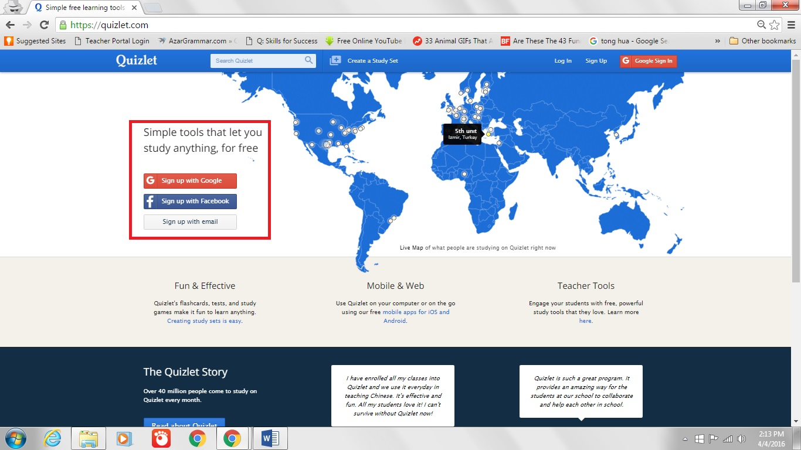

- Create a class
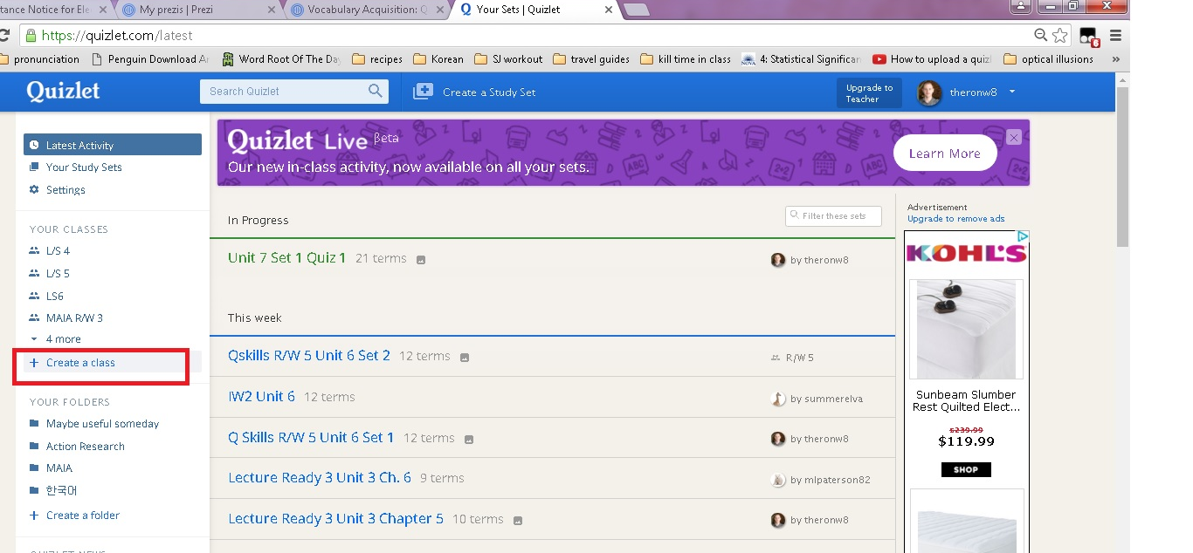

- Create or add existing study sets to your class

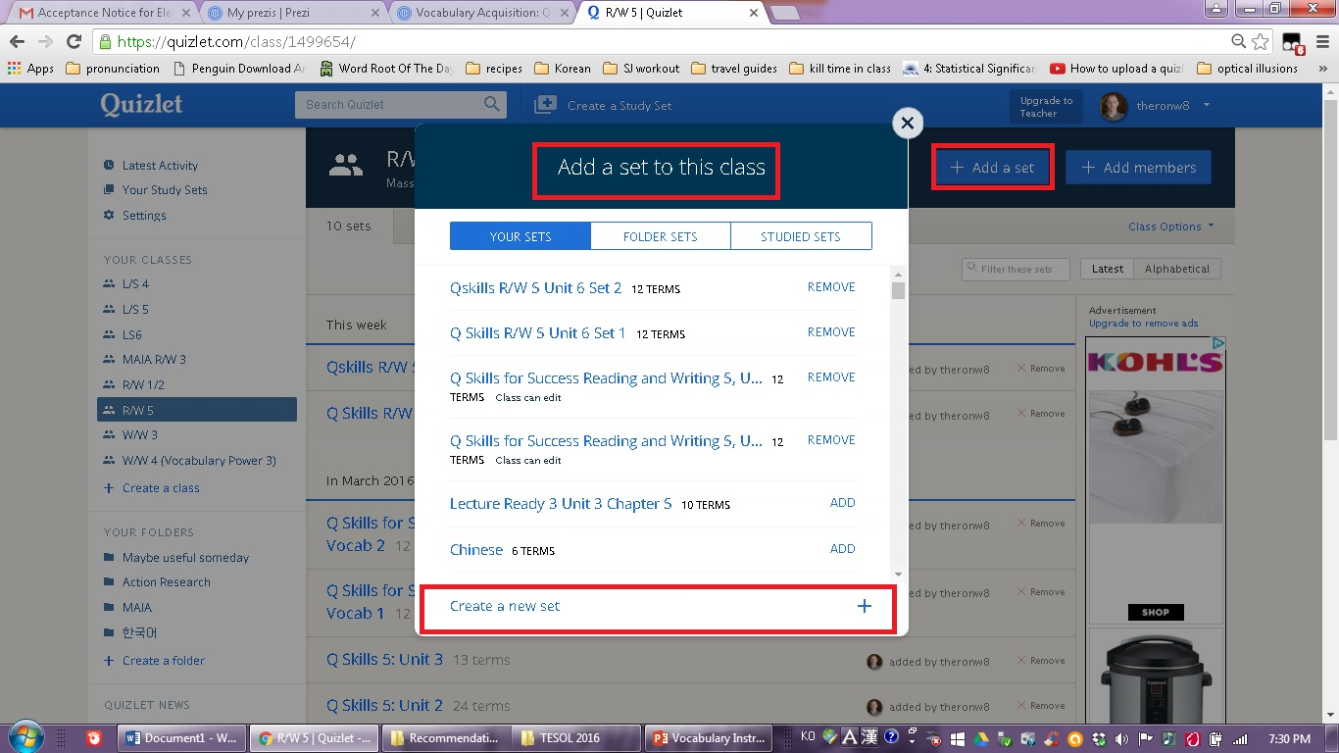

- Add members to your class either by entering their email or sending them a join link
Note: Students can also search for your class on Quizlet and ask to join

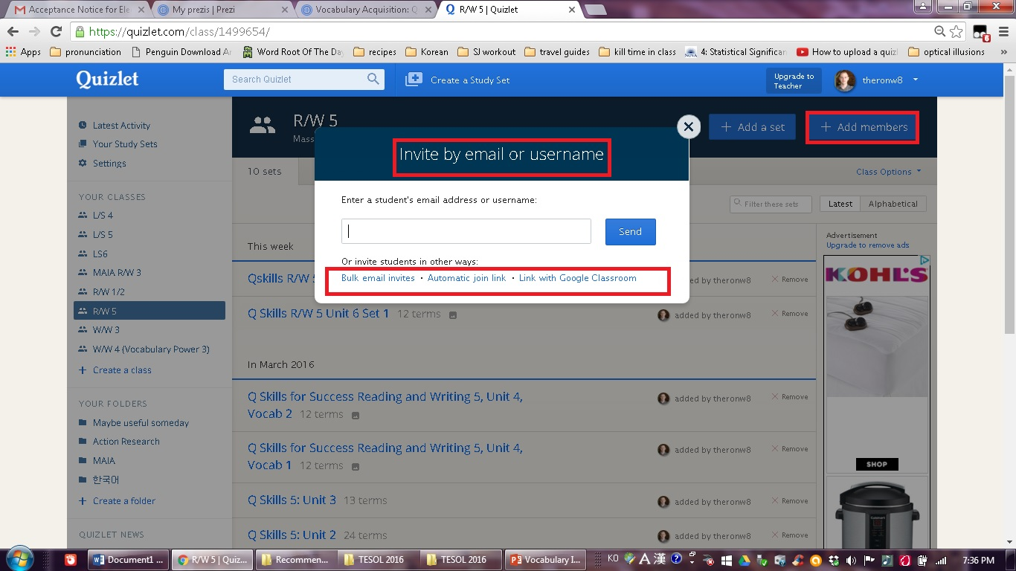

- Teachers can also join your class and become co-admins

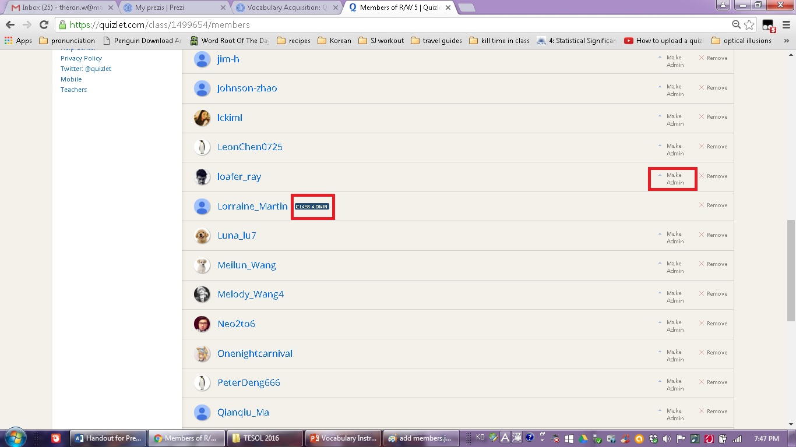

How to find my Prezi
Link to Prezi: http://prezi.com/ebrn2va5ja-m/?utm_campaign=share&utm_medium=copy&rc=ex0share

or Google “MATSOL 2016 Vocabulary Acquisition: Quizlet vs. Paper Wordlists” to find my Prezi Online

