In this project, ELL students became insiders in the world of memoir.

“Teaching about genres is made more powerful by allowing students to become insiders in the world of that genre.” - Lattimer

Students grappled with essential questions that immersed them in the memoir genre, moving them through reading workshop to writing workshop, to creating a digital presentation of their own memoir:

What are the defining characteristics of a memoir?

What is the structure of a memoir?
How is narrative text crafted?
What understandings about others and myself will I gain through writing a memoir?

For this memoir unit, The Goals and Instructional Focus Progressions for reading and writing workshop were taken from Heather Lattimer’s book, “Thinking Through Genre: Units of Study in Reading and Writing Workshop 4-12”. (Stenhouse, 2003). (These are provided on pages 3 and 4). Further inspiration was provided by Nanci Atwell’s work on teaching middle school students about memoir. Guidance for using a digital format was taken from a publication by K. Harris.
“Reading, after all, like writing, is an act of composing meaning and reading memoir, like writing memoir, involves a student in the act of composing meaning from his own life.”
- Lattimer

Students made sense of memoirs through lessons that were tailored to English language learners -- by attending to features of memoirs that were read aloud to them, and crafting their own memoirs. They planned their texts, composed them, and revised them using the metacognitive knowledge gained through their experience with listening to memoirs and having meaningful memoir discussions.

1
The writing was supported for some students by allowing them to write in their native language. The writing was then translated into English; most students wrote in English. Their words were made to come alive through the support of technology specialists who worked with students to integrate their words with students’ own photographs and downloaded images using the i-movie application. Transforming memoirs into i-movies was a huge motivating factor for the students. The infusion of technology into this project maximized student engagement. (An excerpt from a student’s written memoir that was written in English is provided on page 5.)

Students gained the following enduring understandings through their work during reading and writing workshops, and finally, the presentation of their i-movies at an ‘Oscar’-inspired event presented to peers, parents, and district personnel:
- Reflection helps us to make sense of prior experiences.
- Memoirs help us to make meaning of our lives.
- To share a memoir is an act of trust and courage.

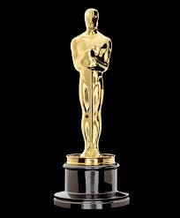
2
CONTACT INFORMATION:
Carrie Powers, District Support Specialist, cpowers@lowell.k12.ma.us
Carmen Blasini, ELL teacher, cblasini@lowell.k12.ma.us
Véronique Roberts, District Technology Integration Specialist, vroberts@lowell.k12.ma.us

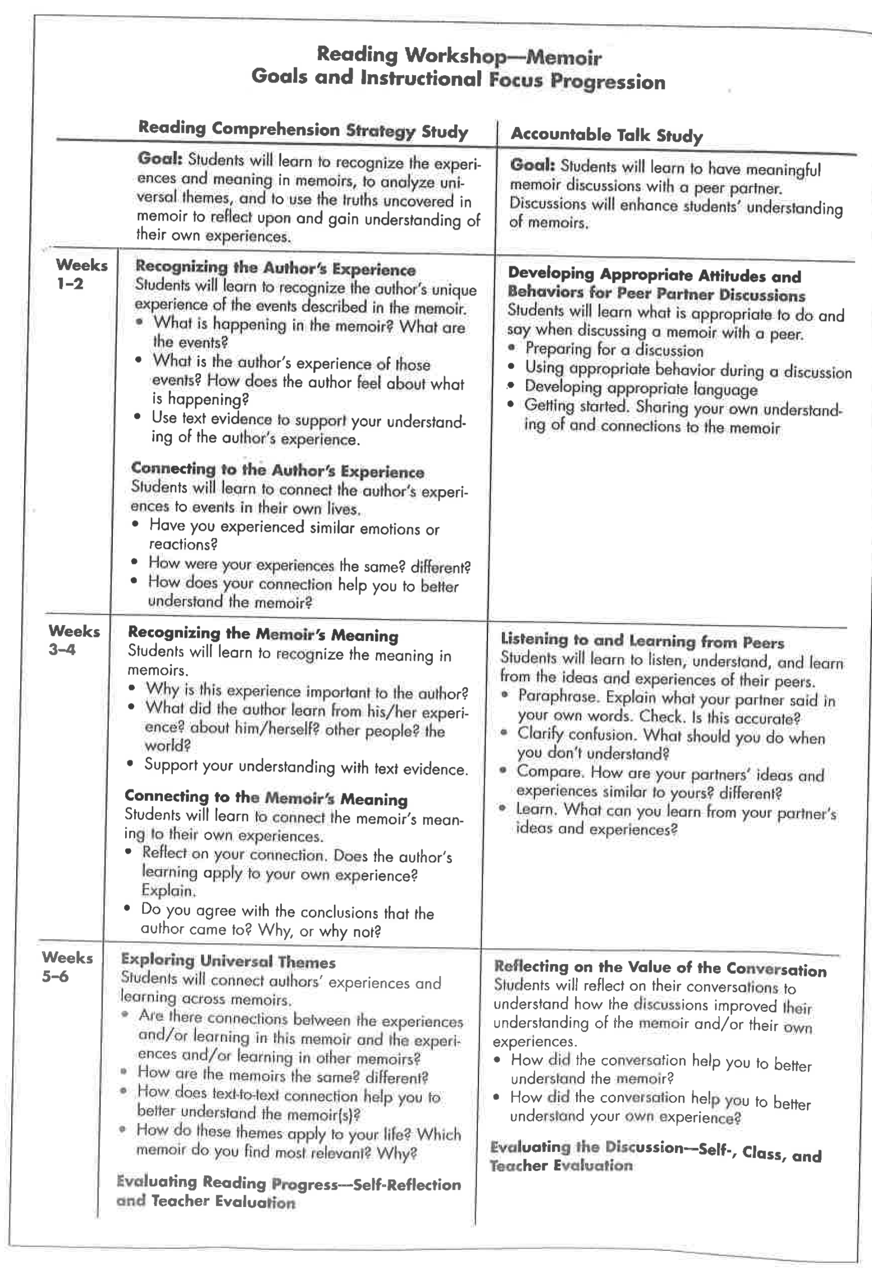
3
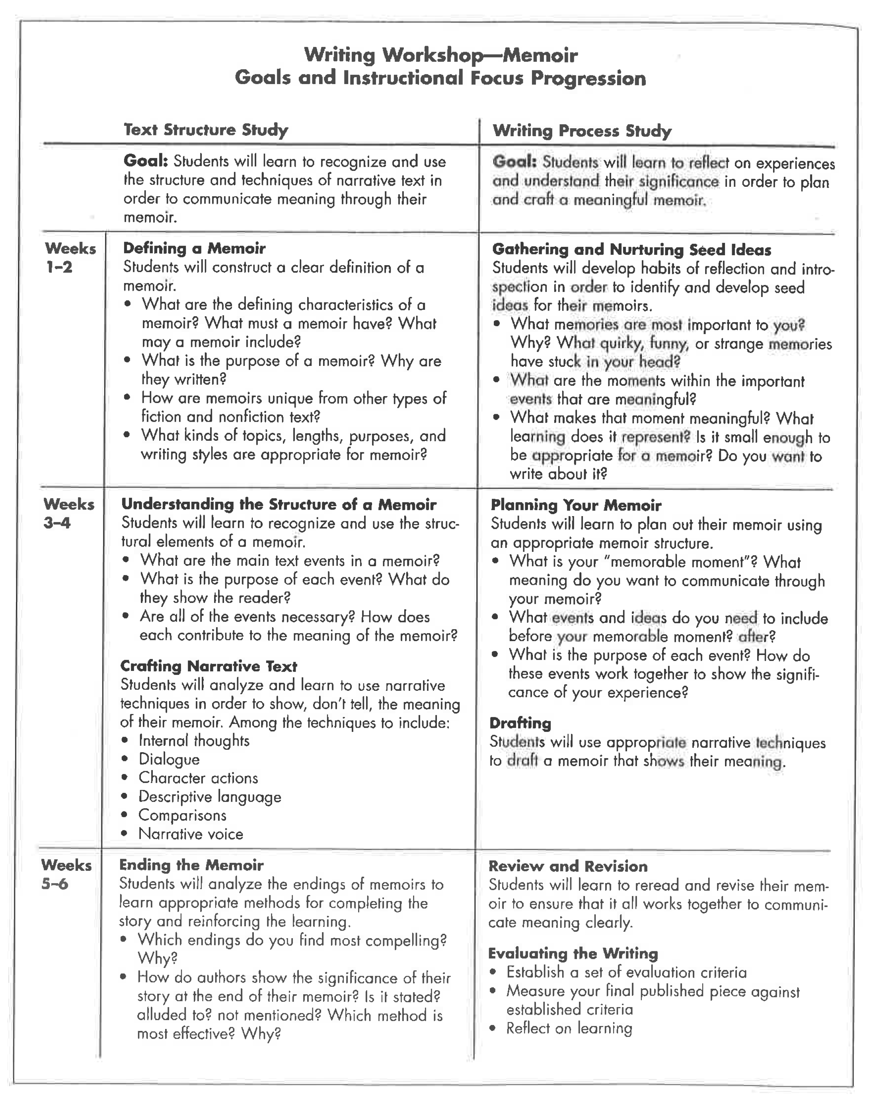
4

EXCERPT FROM
Coming to America
by Manuela Gutierrez

Coming to America has been one of the best experiences in my life, I came with my Mom. It was difficult for us to say goodbye to all the people that we left behind, my grandmas, grandpa, cousins, aunts, uncles, but specially my grandma Lupi and my Dad. They told me that I was going to America just a week before it happened. It was like a mound of dark chocolate, bitter and sweet, sad and exciting, golden wrapped with a dark inside, a conflicting wish to stay and the lure to go to a new place. I started packing all my things and also saying bye to all my friends and family. Two days after I gave my dad the paper that he needed to sign, to authorize me to come here., he said “You are not going”.
I felt that my heart was broken and all the pieces were falling down.
“Why?!” I said
“Because you are my girl, my little girl”
Silence started grabbing us. Later I went home, and I told my Mom about it, and she said, “So he needs to take care of you”.
I did not answer.
My grandmothers started telling him that he should let me come, that I would have a better future, and he just remained quiet, well it worked! He handed the signed paper to me, crying…
“Daddy I’m going to be safe and I will never forget you, I will always be by your side, you do not need to worry about me but I know you will, I will call you or text you every single day”, I said
“Obviously, hija (daughter)”
We smiled at each other, and we hugged. I was so excited, because I was going to America in two more days. The day after he gave me the signed paper, I spent all the day with my friends and teachers, and we could not because my dad was drunk, and my grandma was in the church; so there were only my aunt and my grandma Lupi, we took the picture; however I was so mad and also disappointed because I wanted them to be in the picture. Next day, the day that my life was going to change, we said bye crying to the people that were with us at the airport, we entered the waiting room, they named the number of our flight, my mom was crying, we took our first plane, we held hands and we said
-- Dios llévanos con bien. -- …

5

Lattimer, H. (2003). Thinking Through Genre. Portland, ME: Stenhouse.
Atwell, N. (2002). Lessons That Change Writers. Portsmouth, NH: Heinemann.
Harris, K. Integrating Digital Literacy Into English Language Instruction. Retrieved from https://lincs.ed.gov/publications/pdf/ELL_Digital_Literacy_508.pdf.

