Seven Hills Robotics Education Club Curriculum
Jennifer L. Otto, MSA Teacher
Seven Hills Charter Public School
Presented at MATSOL
June 2, 2017

Table of Contents
Notes on the SHREC Curriculum p. 6
Focus Language Goals p. 7
Essential Questions p. 8

CONCEPTS Curriculum p. 9
Lesson 1: Introduction to the Club p. 10
Lesson 2A: What is a Robot? p. 11
What is a Robot? Graphic Organizer p. 12
What is a Robot? Graphic Organizer (completed) p. 13
Lesson 2B: What is a Robot p. 14
What is a Robot? Worksheet p. 15
Lesson 2C: What is a Robot p. 16
What is a Robot? Compilation p. 17
Lesson 3A: What is a Sensor? p.18
Sensor Web (example) p. 19
Lesson 3B: What is a Sensor? p. 20
What is a Sensor? worksheet p. 21
Lesson 4: Robot Motion p. 22
Robot Motion worksheet p. 23
Lesson 5: Similar p. 24
Similarities worksheet p. 25
Lesson 6: Similarities and Differences p. 26
Comparing and Contrasting Robots and Humans worksheet p. 27
Comparing and Contrasting Sentence Frames p. 28
Lesson 7A: Informational Text Features p. 29
Lesson 7B: Informational Text Features p. 30
Text features Checklist p. 31
Lesson 8: Choosing a Robotics Writing Topic p. 33
Robotics Project Organizer p. 34
Robotics Project Ideas p. 35
Lesson 9A: Researching a Robotics Writing Topic p. 36
Lesson 9B: Researching a Robotics Writing Topic p. 37
Lesson 9C: Writing an Introductory Paragraph for an Informational Poster p. 38
Introductory paragraph Frame p. 39
Lesson 9D: Using Google Classroom to Write p. 40
Lesson 9E: Adding Photos and Captions with Google Docs p. 41
Lesson 9F: Putting the Poster Together p. 42
Lesson 10A: Sharing an Opinion: Reasons For Robots p. 43
Lesson 10B: Supporting an Opinion: Reasons For Robots p. 44
“House” Organizer for Opinion Writing p. 45
“House” Organizer for Opinion Writing (completed) p. 46
Lesson 10C: Supporting an Opinion: Reasons Against Robots p. 47
Additional Lesson Topics p. 48
LEGO Mindstorms Curriculum p. 49
Lesson 1: Protocols and Elements of LEGO Mindstorms EV-3 p. 50
Materials Protocols Anchor p. 52
Lego Mindstorms Ev-3 Elements Vocabulary Grid p. 53
Lesson 2A: Major Components of LEGO Mindstorms EV-3: Motors p. 57
Major Components Worksheet p. 58
Lesson 2B: Major Components of LEGO Mindstorms EV-3: Sensors p. 59
Lesson 3: Palettes and Blocks: Action Palette: Motors p. 61
Palettes and Blocks Visual p. 63
Lesson 4A: Palettes and Blocks: Flow Control Palette:
Touch and Color Sensors p. 64
Lesson 4B: Palettes and Blocks: Flow Control Palette:
Gyro and Ultrasonic Sensors p. 67
Lesson 5: Describing Programs p. 70
Mindstorms Word Bank p. 71
Program Description p. 72
Lesson 6A: Beginning to Build p. 73
Teamwork Anchor p. 75
Steps Involved in Building p. 76
Requesting Parts Sentence Starters p. 77
Building process Sentence Frames p. 78
Lesson 6B: Continuing to Build p. 79
Lesson 7: Action Palette: Move Steering p. 80
Steps Involved in Debugging p. 82
Lesson 8: Action Palette: Move Tank p. 83
Lesson 9: Add a Touch Sensor p. 85
Lesson 10: Adding Some Fun: Action Palette: Display Blocks p. 87
Lesson 11: Add a Lift Arm (Move Object) p. 88
Lesson 12: More Fun: Light Blocks and Loops p. 89
Lesson 13: Putting it Together: Multitasking p. 91
Lesson 14: Add an Ultrasonic Sensor (Stop at Object) p. 92
Lesson 15: Add a Gyro Sensor p. 94
Lesson 16A: Last but Not Least: The Color Sensor (Stop at Line) p. 95
Lesson 16B: The Color Sensor (Line Follower) p. 97
Lesson 16 C: The Color Sensor (Measure Color) p. 99
Lesson 16D: The Color Sensor (Measure Color with Multiple Switch) p. 100
Lesson 16E: The Color Sensor (Ambient Light) p. 102
Lesson 17: Describing Reactions with Cause and Effect Language p. 103
Examples of Cause and Effect Language p. 104
Lesson 18: Putting It all Together: Describing Your Robot p. 105
Robot Description Word Bank p. 106
Robot Description p. 107
Lesson 19: Disassembling Robots and Choosing Your Next Project p. 108
Lesson 20: Building a More Complex Project p. 109
Lesson 21: Understanding and Describing the LEGO-Supplied Programs p. 110
Notes on the SHREC Curriculum
- I have revised the curriculum extensively based on our experiences. I split it into two parts, the concepts and the LEGO Mindstorms, after finding the need to be more flexible on time. We essentially spent half an hour per curriculum in one lesson. Some groups may progress faster on one curriculum than the other. Some “lessons” may take several weeks to complete.
- My students were third-grade multilingual students. The average English Proficency level was a 3-4 overall; however, most students’ oral skills were much higher than their literacy skills. Quite a few students started the year at a first-grade or even kindergarten reading level. Average ACCESS writing levels were 2-3. Many students improved from a beginning-of-first-grade reading level to an end-of-of-first-grade reading level, or from second grade to third. A few made it to third-grade on-level; one to fourth grade! I had a number of students dually-identified as Special Ed students. A few students were as low as Level 1 on the ACCESS composite.
- I wrote the MPIs and curriculum largely for the average student at a Level 3 overall. Adjustments can be made in terms of scaffolding and supports for students at higher and lower levels.
- This curriculum is by no means complete! I hope it is a step in the right direction.
- Because of the subject material, I could not precisely synchronise the curriculum with ELA, though I tried! There was no point in beginning the year with personal narratives about robotics, for example.
- The microfunctions and Focus Language Goals also bounced back and forth according to whether we were building, programming, or discussing concepts. In short, it was a bit hard to focus!
- Please send me your corrections, suggestions and questions! I’ve spent over a month revising, with a lot of cutting and pasting. I wanted to get this up on the link as quickly as possible.

Focus Language Goals

(There were actually quite a few in play!)

The Concepts:
Explain by elaborating on the motto of the club what the learning goals are.
Discuss the norms of classroom behavior by building upon the ideas of others and articulating your own.
Recount by describing key features and components of a robot, including intelligence, sensors and motion.
Explain by comparing and contrasting robots and humans or animals.
Recount by identifying features of an informational text.
Explain by discussing key points of a text.
Explain by elaborating by planning and carrying out inquiries.
Explain by communicating research findings.
Argue by stating a claim and supporting with reasoning and evidence.

Mindstorms:
Recount by identifying and describing elements of the Lego Mindstorms Ev-3 Kit.
Explain by classifying elements of the Lego Mindstorms Ev-3 Kit.
Explain by elaborating on the functions of the major components of EV-3.
Explain by sequencing the steps of building, programming and debugging.
Recount by identifying palettes and blocks used to program the EV-3 robot.
Explain the cause and effect relationship of the blocks on the EV-3 robot.
Discuss by requesting clarification.
Recount by describing a program.
Explain the cause and effect relationships of the major components of the EV-3 robot.
Argue by predicting what the robot will do.
Argue by disagreeing about a project choice.
ESSENTIAL QUESTIONS
Q1. What is a robot?
Q2. How do robots compare to humans?
Q3. Are robots beneficial to humanity?
Q4. How do we design robots?
Q5. How do we teach robots?
Q6. How can you be a valuable member of a team?

Seven Hills Robotics Education Club Robotics Concepts Curriculum

Lesson 1: Introduction to the Club  MPI: Define key terms in robotics.  MPI: Discuss expectations for the club using sentence starters.  Materials: Club Poster, robotics definition, past photos of club, Club Expectations Anchor Chart, binders  SEI Strategies: Seven Steps, Sentence Starters, Visuals  Lesson:  - Explain that we are studying “reading, ‘riting, robotics and respect”. Ask them to read the name of our club from the poster (Seven Hills Robotics Education Club). Give an overview of the club. Why are reading and ‘riting part of our motto? (We will be improving our language skills as we learn about robots and robotics. Good communication is an important skill for roboticists.) What is robotics? (Technology that is used to design, build and program robots) Why is respect part of our motto? We will develop teamwork skills as we learn to build and program robots together. Teamwork is an important skill for roboticists and engineers.)  - Show photos from past years. Mention possible field trips and presentations. Emphasize that our behavior will be very important so that we are good representatives of Seven Hills when we go somewhere else.  - Create an anchor chart together for behavior in the classroom. Practice the sentence starter “SHREC members should…”  - Pass out binders (prepared with cover). Have students write their names neatly on the spine with a sharpie. | Vocabulary  robot  robotics  roboticist  respect  definition

Lesson 2A: What is a Robot?  MPI: Define a robot by referring to visuals.  Materials: Various non-fiction books on robotics, pencils, Robot Components organizer  SEI Strategies: Seven Steps, Sentence Starters, Graphic Organizers  Lessons:  - Remind students that we are studying “reading, ‘riting, robotics and respect”. Ask them to read the name of our club from the board (Seven Hills Robotics Education Club). Remind them of the goals of the club. (Improving our language skills and teamwork skills as we learn to build and program robots. ) Review the SHREC Expectations Anchor.  - Today we are going to try to define a robot, or answer the question, “What is a robot?” We can talk about what a robot looks like, what a robot has, what a robot can do…All of these can help us answer the question, “What is a robot?”  - We are going to begin by learning some important vocabulary. Show flashcards for key vocabulary (machine, intelligence, controller, actuator, sensor, human.) Teach using seven steps, including visuals from books.  - Let’s start with the question, “What does a robot have?” Create an array with major components of a robot vertically(ROBOT: controller, actuator, sensor, power source. ) Speak and add the following words in the next column as you go: intelligence, action, senses, power). A robot is smart. It makes decisions. It has intelligence. The controller is its brain, its intelligence. A robot carries out actions. Its actuators carry out actions. A robot can sense what’s going on around it. Its sensors give it senses. A robot needs a power source to give it power, or energy.  - Let’s review part of our definition of a robot. What does a robot have? A robot has a controller, actuators, sensors and a power source. Or we could say: a robot has intelligence, actions, senses and power. Our array shows us the purpose or function of each part of the robot. Next time we will learn about the LEGO Mindstorms components. | Vocabulary  robot  intelligence  actuator  action  senses  power source  brick  controller  motor  sensor  battery  definition  purpose  function

 | ROBOT
 | COMPONENT | FUNCTION |  | MINDSTORMS  EXAMPLE

 | ROBOT
 | COMPONENT | FUNCTION |  | MINDSTORMS  EXAMPLE
 | controller | intelligence |  | brick
 | actuator | action |  | motor, lift arm
 | sensor | senses |  | color sensor
power source |  |  | power | battery

Lesson 2B: What is a Robot?  MPI: Identify text features to locate information relevant to a given topic with teacher modeling and peer supports  MPI: Ask/answer questions on a given topic with teacher modeling and peer supports  Materials: Chapter 1, “What is a Robot?” from National Geographic Kids: Robots, pencils, ”What is a Robot?” worksheet and wordbank  SEI Strategies: Seven Steps, Sentence Starters, Word Wheels, Word Banks visuals  Lessons:  - Remind students that we are studying “reading, ‘riting, robotics and respect”. Ask them to read the name of our club from the board (Seven Hills Robotics Education Club). Remind them of the goals of the club. (Improving our language skills and teamwork skills as we learn to build and program robots.  - Pass out the book Robots. Ask if it is fiction or non-fiction. Clarify that this is non-fiction or informational text. Who remembers any of the features of informational text? Point to title. For example, what do we call this? Show Table of contents, captions, labels, index.  - Read the first chapter of Robots (What is a Robot?). Allow higher-level students to read aloud. Stop for discussion.  A. Do all robots look like humans?  B. What else do robots look like?  C. Can you find the definition of a robot in this book? (A robot is…)  D. How does a robot think?  E. Note the Tech Talk box. We will be learning a lot of special words about robots.  (skip p. 8 for now)  F. According to the text on p. 10, what are the three kinds of parts every robot has? What do they do?  - Review the vocabulary from Lesson 1.  - Students will complete the worksheet “What is a Robot?” and store in binder. | Vocabulary  fiction  non-fiction  informational text  text features  table of contents  captions  labels  index  definition  purpose  robot  roboticist  program  human  surroundings  intelligence  movement  senses  brick  controller  motor  sensor  actuator

What is a robot?
A real robot is a ______________________
that can __________________________ and do different ________________
without _________________________ help.

True robots have three things:
- ____________________
- ____________________
- _____________________

WORD BANK
human intelligence machine
move movement senses
tasks

Lesson 2C: What is a Robot?  MPI: Ask/answer questions on a given topic with teacher modeling and peer supports  MPI: Build on others’ ideas and express their own clearly, following a model, when engaging in collaborative conversations with diverse partners about a topic and text  Materials: “What is a Robot? compilation of several definitions of a robot from different robotics texts, What is a Robot? graphic organizer, sentence starter reference sheet, pencils  SEI Strategies: Seven Steps, Sentence Starters, Word Wheels, visuals  Lessons:  - Remind students that we are studying “reading, ‘riting, robotics and respect”. Ask them to read the name of our club from the board (Seven Hills Robotics Education Club). Remind them of the goals of the club. (Improving our language skills and teamwork skills as we learn to build and program robots.  - Pass out the compilation of several texts on what a robot is.  - Students will review the worksheet and graphic organizer“What is a Robot?”  - Turn and talk to a partner. Tell your partner what you have learned so far about robots, looking at the sentence starters. | Vocabulary  fiction  non-fiction  informational text  definition  purpose  robot  roboticist  program  human  surroundings  intelligence  movement  senses  brick  controller  motor  sensor  actuator  power source
What is a Robot?
- A robot, or bot, is a machine that has movable parts and can make decisions. People design it to do a job by itself.

How is a robot like a person? It collects information from its surroundings. Then it processes the information and figures out the best way to do its job.

But a robot doesn’t think the way a person does. It can only do things that engineersand roboticists (roh-BOT-ti-sists) program into its computer “brain.”

- Robots are machines that do work. They move around. They carry out commands.

- Most robots have similar main parts. Sensors let the not see, hear, and feel what is happening. A computer “brain,” or controller, takes in that information. It signals actuators—
parts like motors—when to move. A battery, or other power source, gives the bot energy.

- A robot has intelligence, movement and senses.
It can think, move, and
see, hear or feel.

Lesson 3A: What is a Sensor?  MPI: Ask/answer questions on a given topic with teacher modeling and peer supports  MPI: Define technical terms (robot, sensor) by referring to leveled text and visuals  MPI: Build on others’ ideas and express their own clearly, following a model, when engaging in collaborative conversations with diverse partners about a topic and text  Materials: Lightning Bolt Books : Robots at Home pp. 6, 11, 13-15, Helper Robots pp. 8, 12-13, Weather Robots p.6, 24-25, Scholastic Really Robots pp. 36-37, paper, pencils  SEI Strategies: Seven Steps, Sentence Starters, graphic organizers (webs)  Lessons:  - Remind students that we are studying “reading, ‘riting, robotics and respect”. Ask them to read the name of our club from the board (Seven Hills Robotics Education Club). Remind them of the goals of the club. (Improving our language skills and teamwork skills as we learn to build and program robots.  - Explain that today we will learn more about sensors. Read aloud from the texts above. Stop to ask students what sensors they heard mentioned. Jot on a web.  - Also ask what functions/jobs each sensor has. Add sensor functions to the web.  - Have students create their own web.  - Store in binder. | Vocabulary  fiction  non-fiction  informational text  definition  purpose  senses  sensor

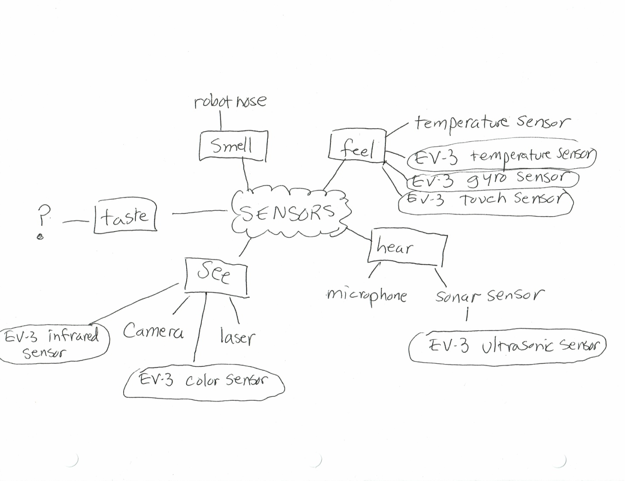
Lesson 3B: What is a Sensor?  MPI: Ask/answer questions on a given topic with teacher modeling and peer supports  MPI: Define technical terms (robot, sensor) by referring to leveled text and visuals  MPI: Explain by comparing and contrasting a familiar topic to new information, using sentence frames  Materials: Lightning Bolt Books : Robots at Home pp. 6, 11, 13-15, Helper Robots pp. 8, 12-13, Weather Robots p.6, 24-25, Scholastic Really Robots pp. 36-37, Sensor Webs, “What is a Sensor?” worksheets, pencils  SEI Strategies: Seven Steps, Sentence Starters/frames, Word Wheels, graphic organizers (webs)  Lessons:  - Remind students that we are studying “reading, ‘riting, robotics and respect”. Ask them to read the name of our club from the board (Seven Hills Robotics Education Club). Remind them of the goals of the club. (Improving our language skills and teamwork skills as we learn to build and program robots.  - Today we will review what we have learned about sensors.  - Look at your web. How are robot sensors like human senses? What does a robot use to see? To hear? To feel? To smell? Can they taste? (Yes, robots are now using sensors to taste food. (Consider showing a short video).  - Pass out the “What is a Sensor?” worksheet and word bank.  Students will complete the worksheet as a group, referring to the books as needed. Store in binder. | Vocabulary  fiction  non-fiction  informational text  definition  purpose  function  senses  sensor

What is a Sensor?
In our first lesson, we learned that real robots have senses. Humans have five senses:
- We ______________________ with our ears.
- We _______________________ with our eyes.
- We ___________________________ with our noses.
- We ___________________________ with our mouths.
- We feel or _______________________ with our hands or skin.
Actually, our ears, eyes, nose, mouth or skin send ________________________ to our brains. If one part of our brain does not work right, we cannot hear even if our ears are fine!

Robots need senses, too, but they use ____________________ instead of body parts. A few kinds of sensors are
- _____________________ sensors
- _____________________ sensors
- _____________________ sensors
These sensors send information to the robot’s “brain” or _________________________. The information is called ________________.
Lesson 4: Robot Motion  MPI: Ask/answer questions on a given topic with teacher modeling and peer supports  MPI: Define technical terms (robot, motion) by referring to leveled text and visuals  MPI: Explain by comparing and contrasting a familiar topic to new information, using sentence frames  Materials: videos on robot motion, Robot Motion worksheets, pencils  SEI Strategies: Seven Steps, Sentence Starters, Word Wheels, graphic organizers (webs), visuals (videos)  Lessons:  - Remind students that we are studying “reading, ‘riting, robotics and respect”. (Remind of goals needed from here on, or point to anchors.)  - Today we will learn about robot motion, or how robots move.  - Show videos of robots in motion. (Do a Google search for videos showing rolling, walking, flying, swimming, crawling)  - Discuss with students ways that robots might move. Humans have muscles to make them move. What powers robot movement? How is it the same as animal motion?  - Have students complete the Robot Motion worksheet. | Vocabulary  fiction  non-fiction  informational text  definition  purpose  function  motion  motors  movement

Robot Motion
Robot motion, or movement, often copies nature or other machines. One kind of motion is rolling. This type of robot uses ________________ like a car. An example is the delivery robot or our EV3 Driving Base.
Another kind of motion is walking. This type of robot uses ____________ like a human or a spider.
A third kind of motion is swimming. This type of robot uses _________ like a fish.
Finally, some robots can fly. They use ____________ like a plane or a beetle. One example is a UAV (Unmanned Aerial Vehicle.)
WORD BANK
fins
legs
wheels
wings

Lesson 5: Similar  MPI: Ask/answer questions on a given topic with teacher modeling and peer supports  MPI: Explain by comparing and contrasting a familiar topic to new information, using sentence frames  Materials: “What is a Sensor?” and “Robot Motion” worksheets, Similar worksheets, pencils  SEI Strategies: Seven Steps, Sentence Starters/Frames, Word Wheels, graphic organizers (webs)  Lessons:  - Remind students that we are studying “reading, ‘riting, robotics and respect”. (Remind of goals needed from here on, or point to anchors.)  - Today we will practice comparing, or talking about how robots are similar to humans or animals.  - Similar means that some features are the same, but not everything is the same. When we talk about what is similar, we tell which things are the same. Let’s compare these two water bottles. What is the same? This bottle is similar to that bottle because they are both containers. They are both plastic. They both have caps. They both have a green label. Now let’s compare these two students. What’s similar about them? They are similar because…  - Write the sentence starters on the board:  - _____ and ____ are similar because they both ______.  - These two ______s are similar because________.  - _____ is similar to _______ because______.  - Have students complete the Similar worksheet. | Vocabulary  fiction  non-fiction  informational text  definition  purpose  function  compare  similar  motion  motors  movement

SIMILARITIES
Robots and Humans
One way that robots and humans are the same is that they both _________________________________________________________.
Another similarity is how _____________________________________.
Something else that is similar is ________________________________.

Robots and Animals
One similarity between robots and animals is that _________________________________________________________.
They are also the same because _______________________________
__________________________________________________________.
A third thing that’s similar is robots and _______________ both
_________________________________________________________.

Lesson 6: Similarities and Differences  MPI: Ask/answer questions on a given topic with teacher modeling and peer supports  MPI: Explain by comparing and contrasting a familiar topic to new information, using sentence frames  Materials: “What is a Sensor?” and “Robot Motion” worksheets, Compare/Contrast worksheets , pencils  SEI Strategies: Seven Steps, Sentence Starters/Frames, Word Wheels, graphic organizers (webs)  Lessons:  - Remind students that we are studying “reading, ‘riting, robotics and respect”. (Remind of goals needed from here on, or point to anchors.)  - Today we will practice comparing and contrasting, or talking about how robots are similar to or different from humans.  - Students will review the worksheets in their binders.  - How are robots and humans different? Look at your worksheets for reminders.  - How are robots and humans similar? Look at your worksheets for reminders.  - Students will complete a worksheet on similarities and differences between robots and humans.  - Write sentence starters on the board:  - One similarity between _robots______ and __humans_____ is that __humans ____________and robots _both__________________.  - One difference between _robots______ and __humans_____ is that _robots_ ____________ but_humans ___________.  - Have students complete the Compare/Contrast worksheet. | Vocabulary  fiction  non-fiction  informational text  definition  purpose  function  compare  similar  similarity  different  differences  motion  motors  movement

COMPARING AND CONTRASTING ROBOTS AND HUMANS

Word Bank
alike but
similar different
similarity difference
similarities differences

There are a number of __________________ between robots and
humans. One way that robots are ____________________to humans is
intelligence. Another ____________________ is movement. Finally,
robots and humans are _______________________ because they both
have senses.
There are some ________________________ between robots and
humans, though. First, robot controllers are _________________ from
human brains. Another ___________________ is how a lot of robots
have wheels instead of legs. Finally, humans use their eyes, ears, noses
and mouths, __________________ robots use sensors.

Comparing and Contrasting: Sentence Frames
1._______________________ and ____________________ are similar because _____________________________________________________________.

2._________________ is similar to _______________because_________.

3. One similarity is that _________ and _____________ both _________.

4. Another similarity is that they both _________________________.

5. ______________ and _______________ are different because ____________________________________________________.

6. _______________ is different from _________________ because ________________________________________________________.

7. One difference between _________ and ____________ is that
__________________________________________________.

8. Another difference is that ____________ but ____________________.

Lesson 7A: Informational Text Features  MPI: Identify text features (e.g. bold print, headings and subheadings, captions, glossaries and indexes) to locate information relevant to a given topic, using anchor charts and peer supports.  MPI: Ask and answer questions to demonstrate understanding of a text, referring explicitly to the text as a basis for the answers, using sentence starters, graphic organizers and sentence frames.  MPI: Build on others’ ideas and express their own clearly, following a model, when engaging in collaborative conversations with diverse partners about a topic and text  Materials: Nonfiction Robot books (Cool Robot Series, NGK Robots, others) text features anchor, text features checklist, pencils  SEI Strategies: Seven Steps, Sentence Starters, Word Wheels, graphic organizers, visuals  Lesson:  - Show NGK Robots book. Ask students how to preview the book.  - Discuss the title. Will this book be fiction or non-fiction?  - Read the blurb on the back. This tells us what we will learn about in this book.  - Let’s begin to look inside the book. Let’s see how this book is organized. What kind of features does it have?  - What do you see at the top of each page? Yes, these are called headings. They tell us what the page will be about.  - What do we call these bigger letters? Yes, they are called subheadings. They tell us what the next part of the page will be about.  - What else do you see on the page? (Photos) What do you see next to the pictures? What color is it? This part is a caption. It tells what is in the picture.  - What do we call these darker letters? Yes, bold print. These are important new words in the text.  - Show and explain the glossary and index at the back of the book. | Vocabulary  fiction  non-fiction  informational text  preview  blurb  organize  text feature  heading  subheading  caption  text box  bold print  glossary  index

Lesson 7B: Informational Text Features  MPI: Identify text features (e.g. bold print, headings and subheadings, captions, glossaries and indexes) to locate information relevant to a given topic, using anchor charts and peer supports.  MPI: Ask and answer questions to demonstrate understanding of a text, referring explicitly to the text as a basis for the answers, using sentence starters, graphic organizers and sentence frames.  MPI: Build on others’ ideas and express their own clearly, following a model, when engaging in collaborative conversations with diverse partners about a topic and text  Materials: Nonfiction Robot books (Cool Robot Series, NGK Robots, others) text features anchor, text features checklist, pencils  SEI Strategies: Seven Steps, Sentence Starters, Word Wheels, graphic organizers, visuals  Lesson:  - Pass out Robots and other non-fiction robotics books. Review the anchor for Informational text features.  - Students will work with a partner to observe the organization of a book. Prompt them to use sentences starters such as “I notice that this page has a ______________. “The ____________ on this page says/shows____________.” | Vocabulary  fiction  non-fiction  informational text  preview  blurb  organize  text feature  heading  subheading  caption  text box  bold print  glossary  index

TEXT FEATURE | CHECK
Title

Table of Contents

Heading

Subheading

Special Print Style (Bold/Italics)

Caption

Label

Textbox

Footnote

Index

Glossary

ILLUSTRATIONS | CHECK
Title

Photograph

Map

Chart

Graph

Diagram

Drawing

Expanded View

Timeline

Lesson 8: Choosing a Robotics Writing Topic  MPI: Build on others’ ideas and express their own clearly, following a model, when engaging in collaborative conversations with diverse partners about a topic and text  Materials: Nonfiction Robot books (Cool Robot Series, NGK Robots, others), Project Organizer, writing folders, pencils  SEI Strategies: Sentence Starters, visuals  Lesson:  - Tell students they are going to create a poster on a robotics topic, with text and photos. Show an example.  - First we are going to brainstorm some topics. What are some different types of robots you can think of? (Prompt for different functions, different appearances, different origins, real vs. fiction robots, etc. )(Some examples we came up with: Water Robots, Humanoid Robots, Spy Robots, Tiny Robots, Star Wars Droids, Factory Robots)  - Students may work alone or with one or two others.  - Students will discuss with team members and choose a topic, or suggest a different one. Prompt them to use collaborative conversation frames such as “I agree with ___________’s suggestion because______________. “I disagree with ____________’s idea because ____________. “I’d like to make a suggestion.” “I’d like to add on to what ___________ said.”  - On the Project Worksheet, students will write the names of their group members and project title.  - Students will begin to look through books to see which books they might use for research, and jot down titles. | Vocabulary  fiction  non-fiction  informational text  agree  disagree  suggestion

Robotics Project Organizer
Names: ____________________________________________________
Topic: _____________________________________________________
Books: ____________________________________________________
__________________________________________________________
__________________________________________________________
Project Type: _______________________________________________

Robotics Project Ideas
Flying Robots
Dog Robots
Star Wars Robots
Service Robots
Spy Robots
Teacher Robots
Military Robots
Medical Robots
Cook Robots
Factory Robots
Water Robots
Space Robots
Game-Playing Robots
Making Robots Feel
Robots from Different Countries
Famous Roboticists
Career in Robotics
Animal Robots
Tiny Robots
Lesson 9A: Researching a Robotics Writing Topic  MPI: Decide on appropriate books for a research topic by consulting the index, Table of Contents, or subheadings, following teacher modeling and working with a partner  Materials: Nonfiction Robot books (Cool Robot Series, NGK Robots, others), Project Organizers, writing folders, pencils  SEI Strategies: Sentence Starters, visuals, modeling  Lesson:  - Tell students they are going to choose books for their robotics topics.  - Demonstrate how to preview the Table of Contents or search in the index for the topic (e.g., Military Robots).  - Students may work alone or with one or two others.  - Students will discuss with team members and choose books. Prompt them to use collaborative conversation frames such as “This book lists “spy robots” in the index.“ or “I don’t see anything here about spy robots.” Or “Have you checked the Table of Contents?” or “Have you skimmed through the book and checked the subheadings?”.  - On the Project Worksheet, students will jot down titles of useful books. | Vocabulary  fiction  non-fiction  informational text  index  Table of Contents  Heading  Subheading  skim  agree  disagree  suggestion

Lesson 9B: Researching a Robotics Writing Topic  MPI: Copy down key information on a topic with teacher modeling.  MPI: Build on others’ ideas and express their own clearly, following a model, when engaging in collaborative conversations with diverse partners about a topic and text  Materials: Nonfiction Robot books (Cool Robot Series, NGK Robots, others), Project Organizer, writing folders, pencils  SEI Strategies: Sentence Starters, visuals, modeling  Lesson:  - Tell students they are going to choose one book for their robotics topics.  - Locate information on the topic as you did last time.  - Write notes on post-its and save them in your folder.  - Students may work alone or with one or two others. Each student can choose another book.  - At the end of the session, students may discuss their findings with team members.  - Note: some topics may be hard to research using available texts. Teacher may assist by printing out some relevant articles from the Internet, or finding a few videos for students to watch.  - This research should continue for several weeks, until students have amassed enough information for a short informational piece. | Vocabulary  fiction  non-fiction  informational text  index  Table of Contents  Heading  Subheading  skim  agree  disagree  suggestion

Lesson 9C: Writing an Introductory Paragraph for the Informational Poster  MPI: Write an introductory paragraph using a paragraph frame.  Materials: Nonfiction Robot books (Cool Robot Series, NGK Robots, others), Project Organizer, writing folders, Introductory Paragraph Frame, pencils  SEI Strategies: Sentence Frames, visuals, modeling  Lesson:  - Tell students they are going to write introductory paragraphs for their robotics topics.  - First, choose a question to hook the reader. (see frame)  - Next, define your topic (What are military robots?)  - What are the functions, or jobs, of these robots? What can they do?  - Following the model, write the conclusion to your paragraph. | Vocabulary  fiction  non-fiction  informational text  index  Table of Contents  Heading  Subheading  skim  introduction  conclusion  definition  function

_______________________________________ Robots

(Hook) Have you ever seen/Have you heard of/Do you know
about _______________________________ robots?

(Definition) ________________________ robots are robots that

_____________________________________________________.
(Functions)They can ____________________________________,

_______________________________________________________,

and ______________________________________________________.

(Conclusion)There are so many kinds of ______________________ robots! Let me tell you about a few of them.

Lesson 9D: Using Google Classroom to Write  MPI: Write and edit an introductory paragraph using a paragraph frame and Google docs.  Materials: Nonfiction Robot books (Cool Robot Series, NGK Robots, others), Project Organizer, writing folders, Introductory Paragraph Frame, laptops  SEI Strategies: Sentence Frames, visuals, modeling  Lesson:  - Ahead of class, set up Google Classroom if you have not already. Create a topic (Kinds of Robots).  - Invite students to join the classroom.  - Tell students they are going to use Google Classroom to create their posters.  - Have the students click on the topic and create a Google doc.  - If students are working together, show them how to share the document.  - Have students begin to type their introductory paragraph.  - Inform students that they document will save by itself, and that they can edit for spelling later. They can also choose fonts and colors later.  - When students have finished the paragraph, have them edit for spelling and punctuation. Point out the editing assistance given by Google docs. | Vocabulary  introduction  conclusion  definition  function  Google Classroom  Google doc  File  Shared doc

Lesson 9E: Adding Photos and Captions with Google Docs  MPI: Add photos and captions, referring to notes and using Google docs.  Materials: Nonfiction Robot books (Cool Robot Series, NGK Robots, others), Project Organizer, writing folders, Introductory Paragraph Frame, laptops  SEI Strategies: Sentence Frames, visuals, modeling  Lesson:  - Students will open their previous documents. Remind them if sharing the work to open the “shared with me” file if necessary.  - Tell students they are going to use Google Docs to add photos and captions to their posters.  - Have the students choose a sticky and search for a photo to illustrate it. Insert the image. (It can be resized later.)  - Now use the information on the sticky to write a caption. Make sure it is a full sentence or more.  - Students sharing work can each add different photos to the document.  - Edit for spelling and punctuation.  - More advanced students may add a concluding paragraph. | Vocabulary  introduction  conclusion  definition  function  Google Classroom  Google doc  File  Shared doc  caption

Lesson 9F: Putting the Poster Together  MPI: Create a finished project with an introductory paragraph and details supported by photos.  Materials: Nonfiction Robot books (Cool Robot Series, NGK Robots, others), Project Organizer, writing folders, Introductory Paragraph Frame, laptops, poster or legal-size paper  SEI Strategies: Sentence Frames, visuals, modeling  Lesson:  - Students will open their previous documents.  - Now it is time to adjust the size, fonts and colors.  - (We used legal-sized paper, so I helped students resize the photos to half the width and length of the page. A size 18 font worked well for the introduction, and size 14 for the captions. I reset margins to fit the captions to half the width of the page as well.)  - After printing, students cut apart the photos and introduction, and glued them onto their “poster”.  - Students shared their posters with their classmates. | Vocabulary  introduction  conclusion  definition  function  Google Classroom  Google doc  File  Shared doc  caption

Lesson 10A: Sharing an Opinion: Reasons For Robots  MPI: Argue for the use of robots in society by stating a claim and supporting it with reasons  MPI: Supporting reasons with examples, following a model and using a graphic organizer  MPI: Build on others’ ideas and express their own clearly, following a model, when engaging in collaborative conversations with diverse partners about a topic and text  Materials: Student Informational Posters, Opinion Writing graphic organizers, popsicle sticks and paper, tape, pencils  SEI Strategies: Seven Steps, Sentence Starters/Frames, graphic organizers, visuals  Lessons:  - Note: I like to create a simple “house” visual for opinion writing out of popsicle sticks:  - Write a claim on a square of construction paper. (Robots are helpful to humans.)This is the roof of my house. (Hold in the air.) But nothing is supporting it. If I let go, it will fall.  - Add four popsicle sticks (the joists) to support the roof. Say, “These are the joists of my roof. They support it, or hold it up.. In the same way, I need reasons to support my claim. Let’s think of what we’ve learned. What is one reason I could say robots are helpful? Yes, military robots can protect us. (Write protect on a stick.) Food service robots can serve us. (Write serve on a stick.) Continue until you have four reaons.  - The joists are holding up the roof, but it’s not really off the ground. What holds up the joists in a house? Studs! Tape some sticks onto each joist to represent the studs. Show how the studs support the joists, and the joists support the roof.  - Examples are like the studs. They support the reasons. Tell me two examples of military robots that protect us. (Write on sticks). How do food service robots serve us? (Write on sticks.) Continue until you have at least two examples for each reason. | Vocabulary  fact  opinion  state  claim  reasons  examples  joist  stud  purpose  function  use  serve  protect

Lesson 10B: Supporting an Opinion: Reasons For Robots  MPI: Argue for the use of robots in society by stating a claim and supporting it with reasons  MPI: Supporting reasons with examples, following a model and using a graphic organizer  MPI: Build on others’ ideas and express their own clearly, following a model, when engaging in collaborative conversations with diverse partners about a topic and text  Materials: Student Informational Posters, Opinion Writing graphic organizers, previous “house“ visual, tape, pencils  SEI Strategies: Seven Steps, Sentence Starters/Frames, graphic organizers, visuals  Lessons:  - Review the “house” visual for opinion writing.  - Now introduce the “flattened” house graphic organizer. Four lines for reasons surround the central square. Lines running perpendicular to the “reasons” hold the examples.  - Have the students fill in the graphic organizer with the information from the popsicle sticks.  - Have students look at their organizer with a partner, and argue that robots are helpful to humans, touching each part of the organizer as they speak. | Vocabulary  fact  opinion  state  claim  reasons  examples  joist  stud  purpose  function  use  serve  protect

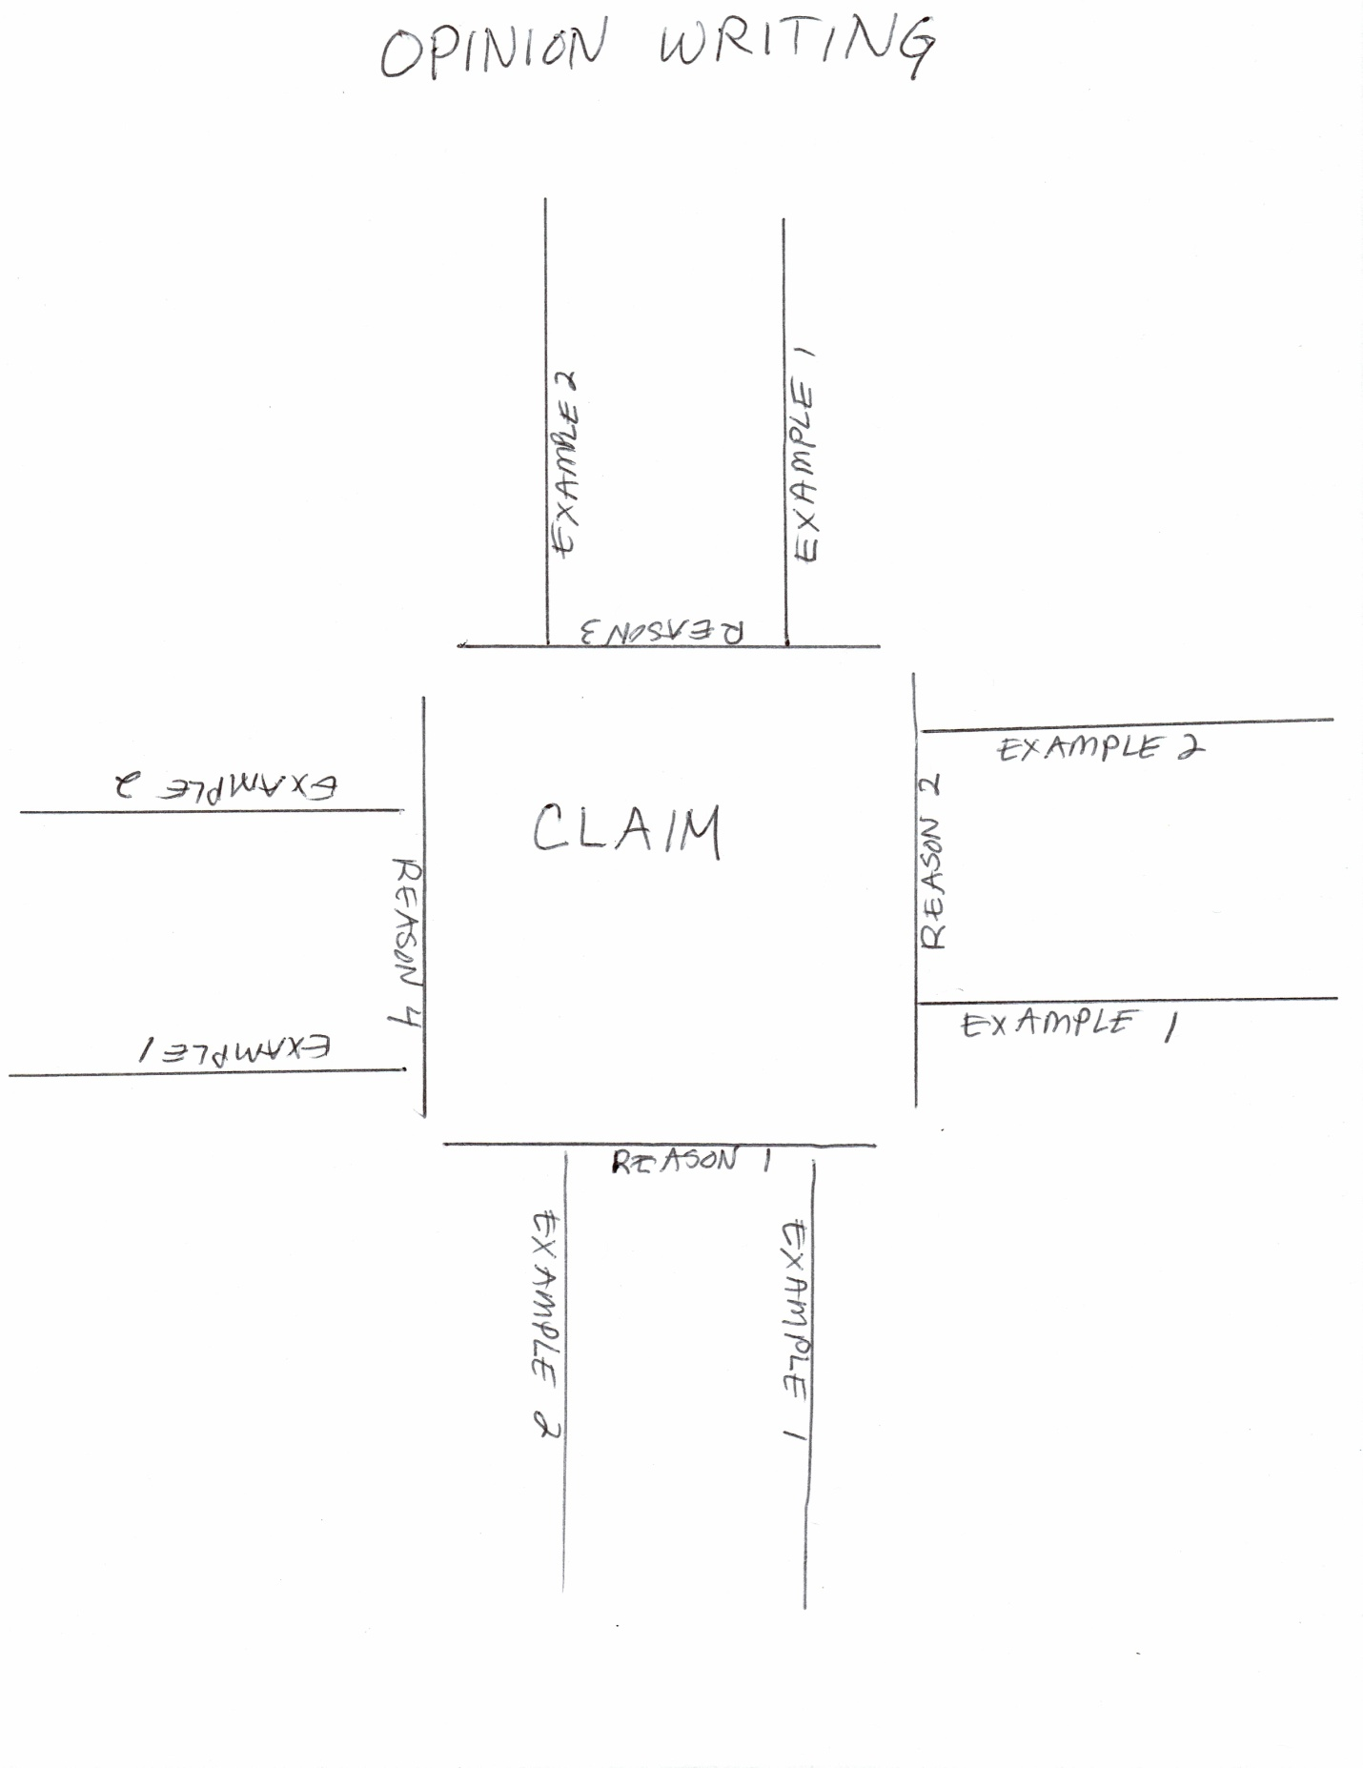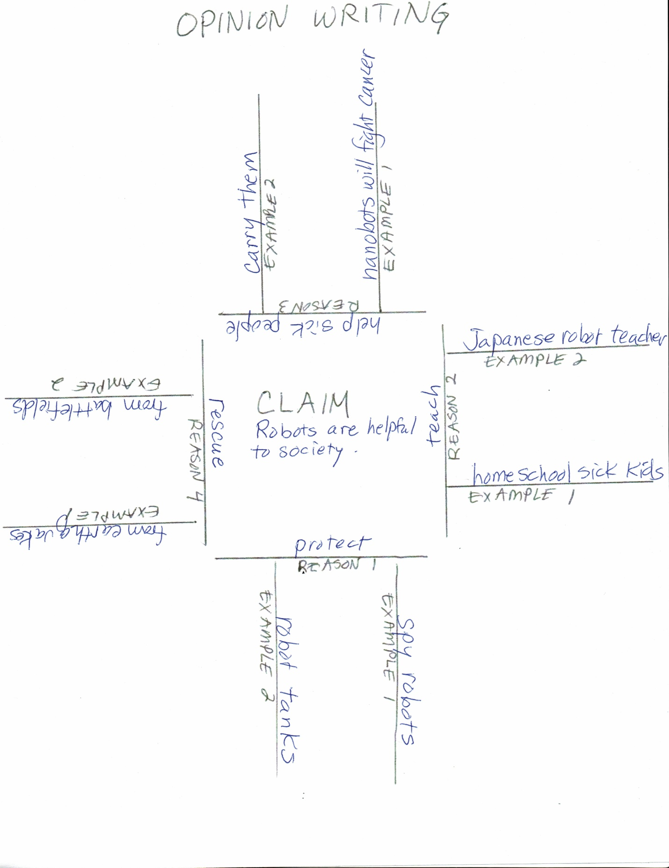
Lesson 10C: Supporting an Opinion: Reasons Against Robots  MPI: Argue for the use of robots in society by stating a claim and supporting it with reasons  MPI: Supporting reasons with examples, following a model and using a graphic organizer  MPI: Build on others’ ideas and express their own clearly, following a model, when engaging in collaborative conversations with diverse partners about a topic and text  Materials: Student Informational Posters, Opinion Writing graphic organizers, previous “house“ visual, tape, pencils  SEI Strategies: Seven Steps, Sentence Starters/Frames, graphic organizers, visuals  Lessons:  - Have students sketch their own “house” graphic organizer.  - Have the students fill in the center with the claim, “Robots could be harmful to humans.”  - Read “Robots Rising“ from Robots by Clive Gifford. What reasons and examples does the author give to support this claim?  - Now watch a video or two on the topic of robot displacement of humans . (For example, www.wired.com/2012/12/ff-robots-will-take-our-jobs/ )  - What reasons does the video give to support this claim that robots could be harmful to humans?  - How could we lose jobs to robots?  - Search “Uncanny Valley” for images (a good one of toasters exists!) Explain that scientists have found out that when a robot or doll looks too much like a human, we actually don’t like it. Children will actually get angry and start beating the robot up because it looks human but doesn’t act human! This causes emotional problems for the children. Could this be another reason against robots?  - Can you think of any more reasons? Did you find any in the books you read?  - Add more reasons and examples to the organizer. | Vocabulary  fact  opinion  state  claim  reasons  examples  joist  stud  purpose  function  use  serve  protect
Additional Lesson Topics

Due to time limitations, we were not able to cover as much ground as I would have liked. Some other connections to ELA I had thought of were:

- Writing twisted fairy tales with robots as characters.
- Writing poems about robots.
- Writing a personal narrative about building a robot or going on a robotics field trip.
- Reading fiction about robots. How might their traits be different from those of humans?
- Reading biography about a roboticist (though I haven’t found any at low reading levels. Might have to write my own!)
- Writing realistic fiction about robots.
- Using excerpts from texts to practice past tense, or edit punctuation…
- Etcetera, etcetera…

Seven Hills Robotics Education Club LEGO Mindstorms EV-3 Curriculum
Adapted by Jennifer L. Otto, MSA Teacher, Seven Hills Charter Public School
June 2, 2017

Lesson 1: Protocols and Elements of LEGO Mindstorms EV-3  MPI: Name components of the EV-3 robot and explain their purposes.  Materials: Pre-built LEGO Mindstorms Driving Base, EV-3 Elements catalog and list, Protocols Anchor, pencils  SEI Strategies: Seven Steps, Sentence Starters/Frames, Word Wheels  Lessons:  - We will be building our own robots using LEGO Mindstorms EV-3 Education kits. Here is one of the robots you can build. Show robot. Here are some others you might get to try. (Show pictures on the tray insert.) But first we have quite a bit to learn about how LEGO Mindstorms works.  - Take out Mindstorms kits. Go over ground rules for taking care of the kits. Create an anchor as you go:  - Only one person taking parts out at a time.  - Take out only the pieces you are told to take and be gentle.  - Put pieces on tray so they don’t get lost.  - Demonstrate how to remove the tray from the bin with two hands.  - Demonstrate how to put the parts away in the correct compartments to make them easier to find the next time.  - We are working to become roboticists. Roboticists need to have clear communication. When you are building with your team, you will not grab the parts you need yourself. You will ask another team member for the parts.  - Pass out LEGO Elements List (found on software for Teachers). Pass out the SHREC Elements list. If possible, also show the elements on the overhead projector. Explain that the parts can be classified into groups.  - For example, there are many kinds of beams on page 2. A beam is flat with holes in it. We measure the beam by counting the holes. (Pass out a beam to each student.). How long is your beam? There are different colors, different lengths and different shapes. It is very important to notice all these features when you are building.  - On page 1, another example is that there are many kinds of axles. Axles usually connect wheels or gears to other parts. An axle has a cross shape on each end. There are different colors and different lengths. We can use a beam to measure the axles. (Pass out an axle to each student.) Put your axle next to the beam. Count the number of holes it covers. This is its length.  - Now look at the pegs on page 1. Pegs hold parts together, like nails or screws. There are also many kinds of pegs. You should pay attention to their colors, and whether they are short or long. You don’t need to measure them. Notice that some ends are shaped like a circle, and some are shaped like a cross. This will help you check if you are putting them into the right place. The blue pegs can be tricky. Notice that there are long ones and short ones. When you are building, the long blue peg has two ends, a long end and a short one. Pay careful attention to which end they are showing you!  - Let’s look at one more kind of element. (Give each student a gear.) Gears fit together to make things go. The gears are different colors. Sometimes it’s hard to see the color on the directions, especially whether it is light gray, dark gray or black. You can also identify them by the number of teeth, or any patterns you see.  - There are a lot of other kinds of components. Try to check the worksheets to learn their names. We will learn about the most important, or major, components next time. Store worksheets in binders.  - If time remains, have students use the directions at the beginning of the manual to build the cuboid as a team. | Vocabulary  roboticist  bin  tray  compartment  element  axle  beam  gear  peg  manual  cuboid

MATERIALS PROTOCOLS ANCHOR
- Only one person taking parts out at a time.
- Take out only the pieces you are told to take and be gentle.
- Put pieces on tray so they don’t get lost.
- Take out the tray from the bins with two hands.
- Put the parts away in the correct compartments.

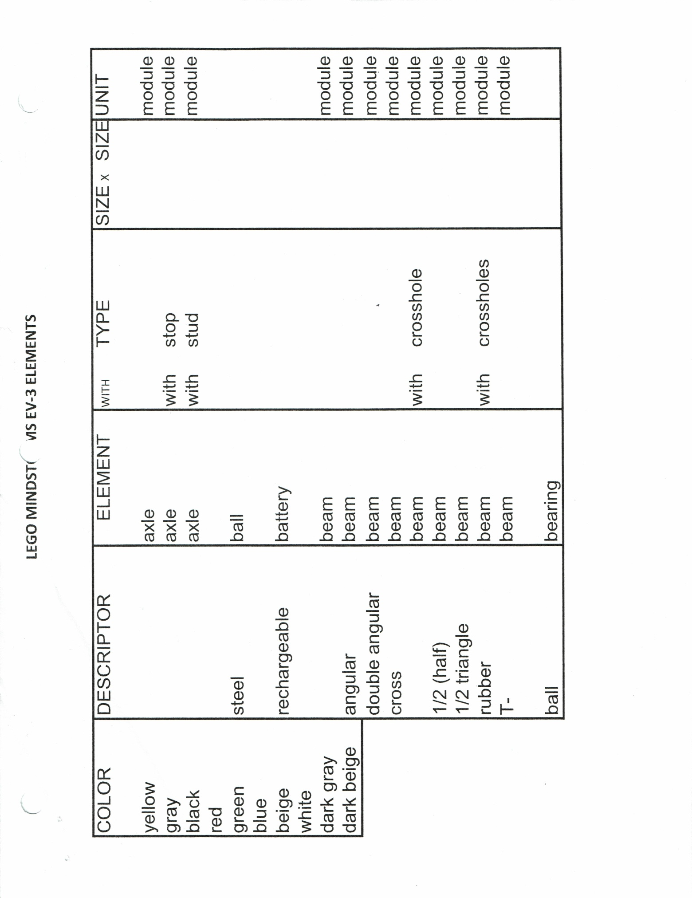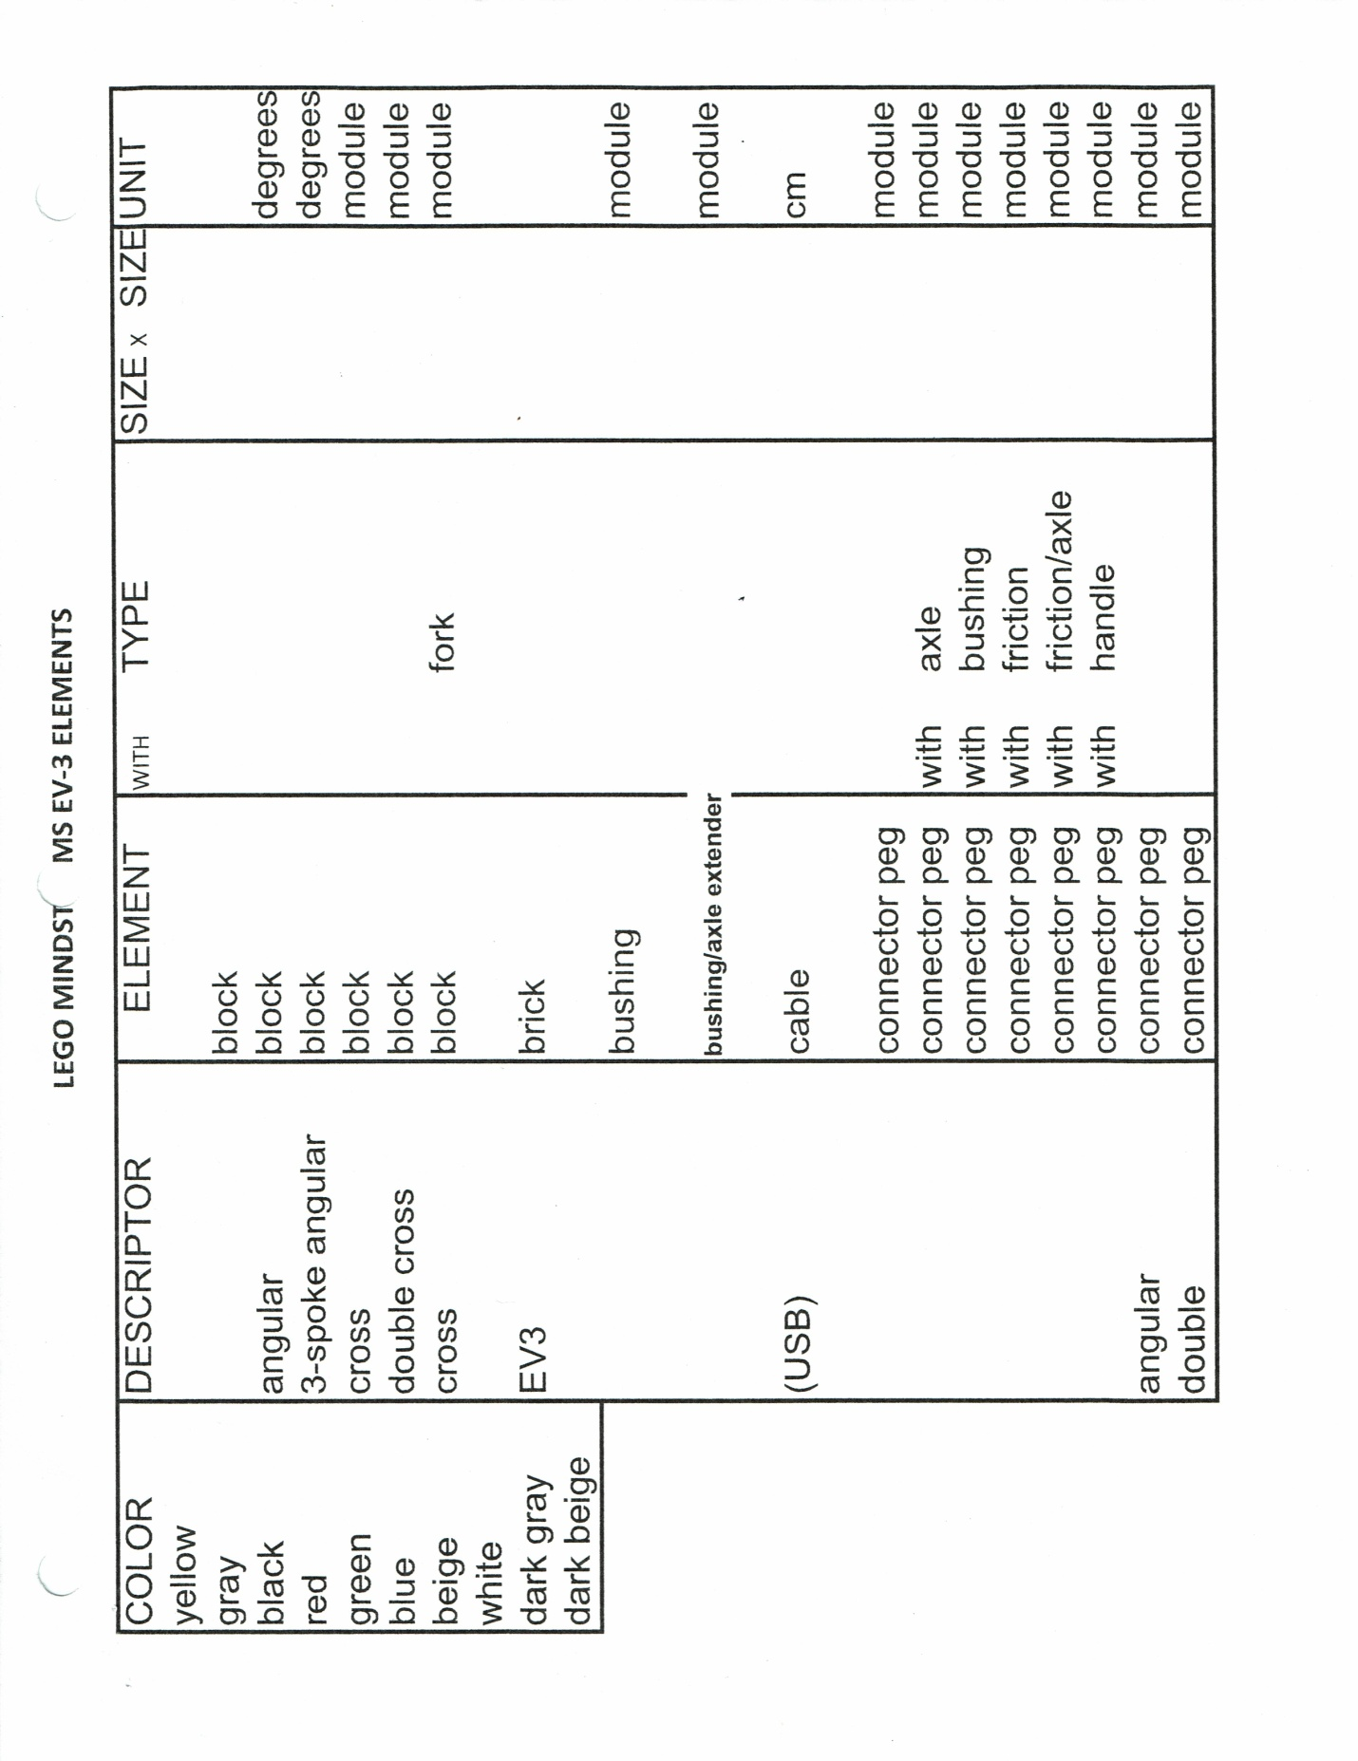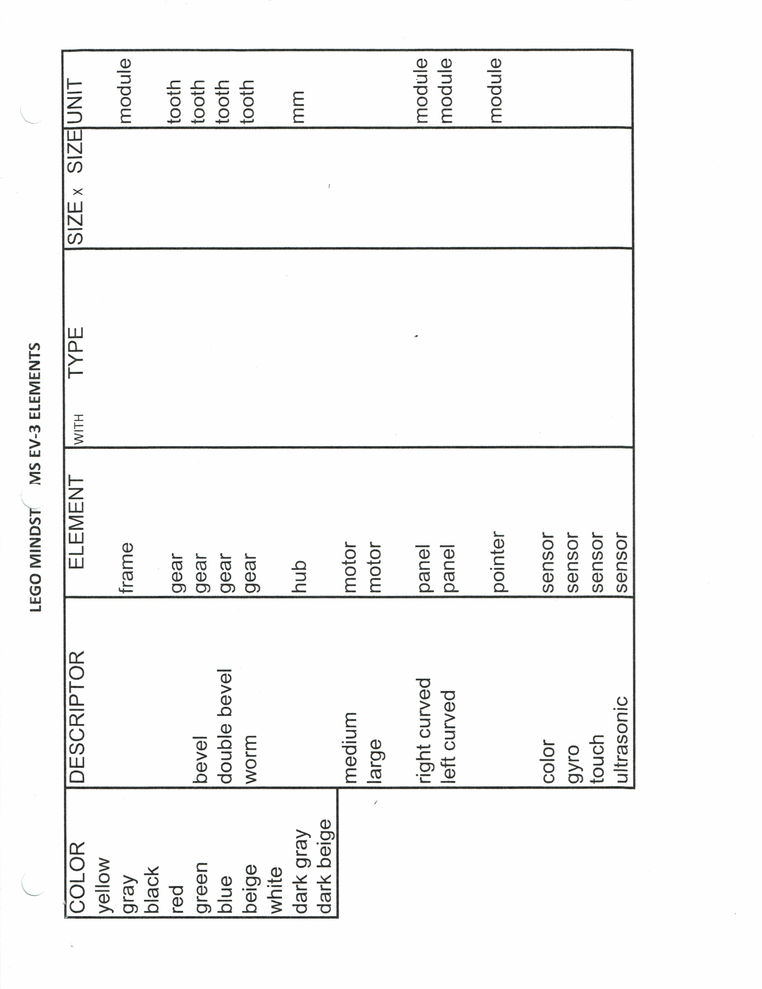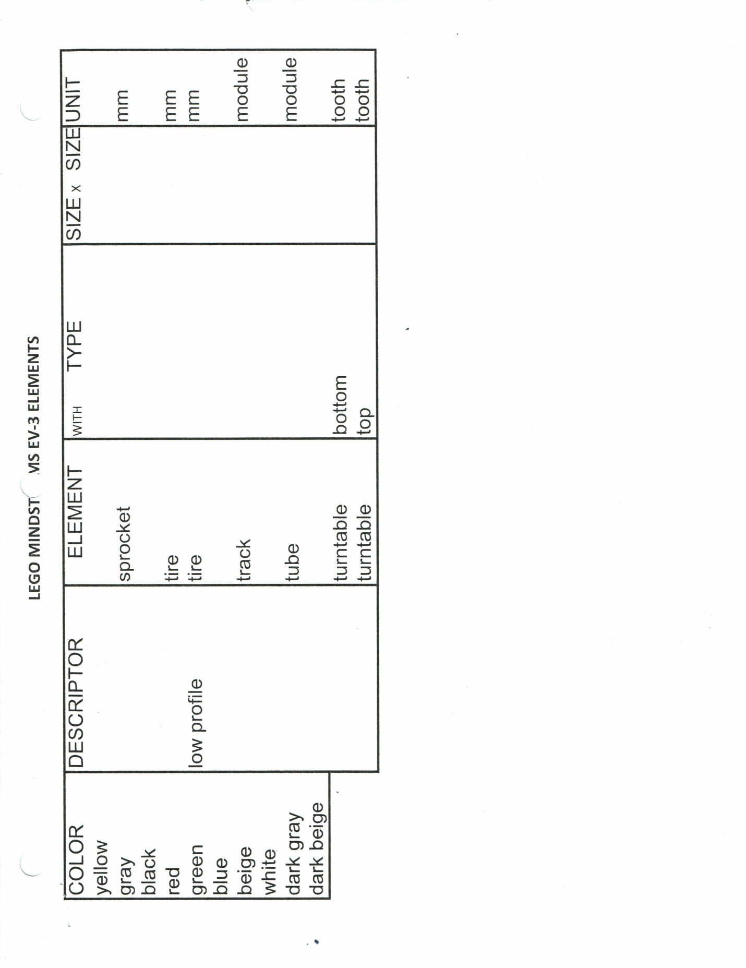
Lesson 2A: Major Components of LEGO Mindstorms EV-3: Motors  MPI: Name components of the EV-3 robot and explain their purposes.  Materials: EV-3 Elements catalog, EV-3 Components worksheets, (pre-programmed Bricks as described below), Medium Motors, Large Motors, Cables, Sensors, pencils  SEI Strategies: Seven Steps, Sentence Starters/Frames, Word Wheels  Lessons:  - (Pre-program the brick with the following programs:  - Go to the tutorial at Robot Educator-Hardware-Large Motor-p.3, recreate, and download the program to each brick.  - Go to the tutorial at Robot Educator-Hardware-Medium Motor-p.3, recreate, and download the program to each brick.)  - Show students major components of the LEGO MINDSTORMS EV-3 robot (“brick” or controller, motors, sensors, battery.) From what we just learned about the definition of a robot, what is the purpose of each part? Fill out your worksheet with the name of each part and its purpose. (brick-intelligence, motors-movement, sensors-senses, battery-power). Add to binder.  - Add another layer to the robot word wheel/web with names of EV-3 components.  - We will learn about the sensors next time. Today we are going to learn about the EV-3 motors. Have students connect motors to ports in the brick with cables:  - Connect a Large Motor to Port D with a medium cable. Add an axle and pointer so they can see the movement. Explain that you have already put a program on the brick for the Large Motor. Explain that a program is a set of step-by-step directions. We will start learning how to create our own programs soon. Show students how to locate and run the program for the medium motor. What did the program tell the motor to do?  - Connect a Medium Motor to Port A with a long cable. Add an axle and pointer so they can see the movement. Show students how to locate and run the program for the medium motor. What did the program tell the motor to do?  - Explain that the lettered ports are used for output to the motors. Output is instructions going out to the motors. The numbered ports are used for input from the sensors. Input means information coming in to the brick. Be careful to pay attention to the port number or letter.  - (Students can complete the cuboid if there is time remaining.) | Vocabulary  robot  intelligence  movement  senses  brick  controller  motor  sensor  battery  medium  large  input  output  port  cable  program  definition  purpose
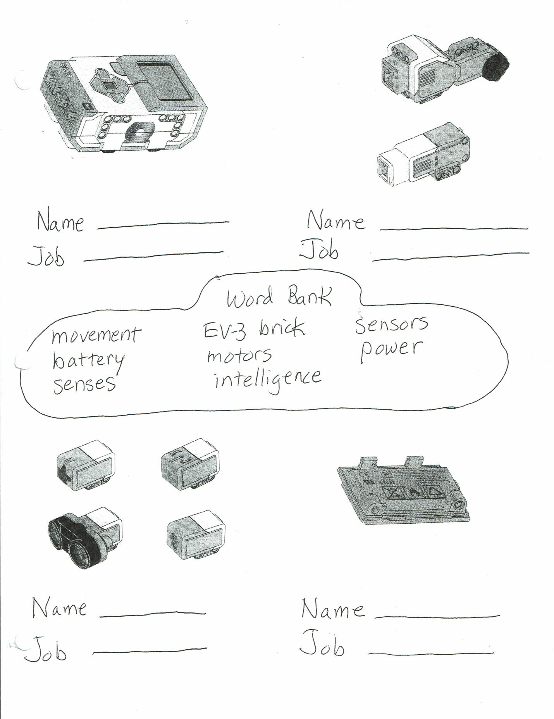
Lesson 2B: Major Components of LEGO Mindstorms EV-3: Sensors  MPI: Name components of the EV-3 robot and explain their purposes.  Materials: EV-3 Elements catalog, EV-3 Components worksheets, Sensors web, Lego Mindstorms EV3 kits, (pre-programmed bricks as described below), sensors, cables, cuboids, pencils  SEI Strategies: Seven Steps, Sentence Starters/Frames, Word Wheels  Lessons:  - (Pre-program the brick with the following programs:  - Go to the tutorial at Robot Educator-Hardware-Touch Sensor-p.3 and download the program to each brick.  - Go to the tutorial at Robot Educator-Hardware-Gyro Sensor-p.3 and download the program to each brick.  - Go to the tutorial at Robot Educator-Hardware-Color Sensor-p.3 and download the program to each brick.  - Go to the tutorial at Robot Educator-Hardware-Ultrasonic Sensor-p.3 and download the program to each brick.)  - Today we are going to learn about the EV-3 sensors. Have students connect sensors to ports in the brick with cables:  - Connect a Touch Sensor to Port 1 with a small cable. Tell the students that the program is waiting for the Touch Sensor to be pressed. Show students how to locate and run the program for the touch sensor. What did the program tell the robot to do when the touch sensor was pressed?  - Attach a Gyro sensor to the side of the brick. (See tutorial if necessary.) Connect a Gyro Sensor to Port 2 with a small cable. Tell the students that the Gyro Sensor measures how far something has moved. Show students how to locate and run the program for the gyro sensor. (Turn the brick 90 degrees on the table.) What did the program tell the robot to do when the robot was moved?  - Connect a Color Sensor to Port 3 with a small cable. Tell the students that the program is waiting for the color sensor to sense particular colors. Show students how to locate and run the program for the color sensor. (Use with the cuboid. Show the sensor blue, then red, then no color.) What did the program tell the robot to do when the color sensor saw blue? Red? No color? Let’s see what happens for other colors!  - Connect an Ultrasonic Sensor to Port 4 with a small cable..Tell the students that this sensor is bouncing sound waves off an object, like a bat, to measure distance. Show students how to locate and run the program for the touch sensor. (Use the cuboid. Start at about 20 cm away and move closer to the sensor. The sensor should react at about 8cm away.) What did the program tell the robot to do when the ultrasonic sensor sensed that the object was close enough? Can we use a different object?  - Remind students how sensors and motors are attached to ports in the brick with cables. The numbered ports are used for input from the sensors. The lettered ports are used for output to the motors. Input means information coming in to the brick. Output is instructions going out to the motors.  - Remind students how to put the parts away.  - Allow time for any final questions. | Vocabulary  robot  senses  brick  controller  sensor  input  output  port  cable  touch sensor  gyro sensor  color sensor  ultrasonic sensor  program  definition  purpose

Lesson 3: Palettes and Blocks: Action Palette: Motors  MPI: Identify palettes and blocks used to program the EV-3 robot and explain their purposes.  Materials: Artist’s Canvas, Artist’s Palette (or cardboard facsimile), blocks (wooden, Lego, etc.), Programming Palettes and Blocks Visual, last week’s bricks with attached sensors and motors, laptops (at least one per team), pencils  SEI Strategies: Seven Steps, Sentence Starters/Frames, Word Wheels  Lessons:  - Today we will begin learning about LEGO Mindstorms EV-3 programs.  - Remember that we said a program is a set of step-by-step directions. Lego Mindstorms has made these programs easy for us to make and understand by using palettes and blocks.  - LEGO has used some of the same words that artists use. Hold up canvas. This is a blank canvas for painting on. Hold up the palette. This is a palette for the different colors of paint an artist will use. The artist can choose the color he or she wants. Hold up some LEGO blocks. And these are blocks.  - Pass out copies of the Programming palettes and Blocks Visual in sheet protectors. This white area where we will put our program is called the Programming Canvas. If you click on one of these colored buttons at the bottom, you will get a Programming Palette. When you work with LEGO Mindstorms, there are 6 different palettes. Clicking on GREEN opens the Action Palette. You will see 7 different Action Blocks. Clicking on ORANGE opens the Flow Control Palette. You will see 5 different Flow Control Blocks. We also have the YELLOW Sensor Palette, the RED Data Operations Palette, and the BLUE Advanced Palette. The TEAL My Blocks Palette is empty. You will create your own blocks for this palette.  - We will mostly be working with the Action and Flow Control Palettes. I have copied them for you here.  - Today we are focusing on the Action blocks. Look at the top part of your handout. I have labeled most of the Action Blocks.  - We are going to begin by programming with the Medium Motor, the Large Motor, and the Sound Blocks.  - (Note: When programming, have one student write a program on each shared laptop. Then switch students until each one has created a program.) Turn on your laptops. Open up the LEGO Mindstorms software. Click on File, New Project, Program and then Open. You will see a blank canvas with a Start Block.  - Click on a Medium Motor Block and drag it up next to the Start Block. Click on the white Canvas to lock it on. Look at the letter A in the top corner. This means that the motor has to be connected to Port A to work. If you need to change the port, you have to change the letter. Now click on the circle with the hashtag in the mode box.. You will see some choices: Off, On. Click on the little clock: On for Seconds. Now click under the other clock. You can choose how many seconds you want the motor to go for. Change the number to 2 or 3. The other circle is like the speedometer in your car. Click the number under it to choose your speed. Use the slider. Going under the line or choosing a negative number will make the motor go backwards! The last part of this block shows that the block will stop when done. Note: these choices are called parameters.  - Now click on a Sound Block and drag it after the Motor Block. Click on the picture of the file. Click on the piano. Now click under the picture of a note, and choose a note on the piano. The next number is for volume or loudness. You can change it if you want to. Click the last box, and choose number one to have the sound play once.  - Now add a Large Motor Block. Set it the same way you did with the Medium Motor Block. You can change the numbers. Notice that the port says D. Is your Large Motor connected to Port D?  - Add another Sound Block. This time, leave the file picture. Click in the empty white box in the corner. Click on LEGO Sound Files. Click on Animals. Scroll down and click on a few different sounds. Now try Expressions. Choose a sound. Set the last button to 1 to stop.  - Your first program is done! Now you need to save it. Click on the small File button on the top of the page. Then click Save Project As. Name your project Motors and the number of your brick.  - Now double-click on Program. Rename it Motors and your initials.  - Click the Save Project icon up on the right side. Now your program is saved! It is not on your robot yet, though.  - Turn on the brick. Connect a USB cable from the brick to your laptop. When you see the name of your brick in the bottom corner box, the connection is ready. Click on the blue arrow to download your program. Click the right brick button to move to the files. Look for Motors #___. Press the middle Enter button. Now you should see your program. Press the down button to get to it. Press the Enter button again and your program will RUN!  - Go back to your program. Add a program for the next student by clicking the plus sign next to your program name. It’s the next student’s turn to write a program! You can change the speeds and sounds. (Repeat for any remaining students.) | Vocabulary  program  canvas  palette  blocks  Action  Flow Control  Sensor  Data Operations  Advanced  My Block  mode  parameter  Medium Motor  Large Motor  Sound  definition  purpose  files  project  program  download  run
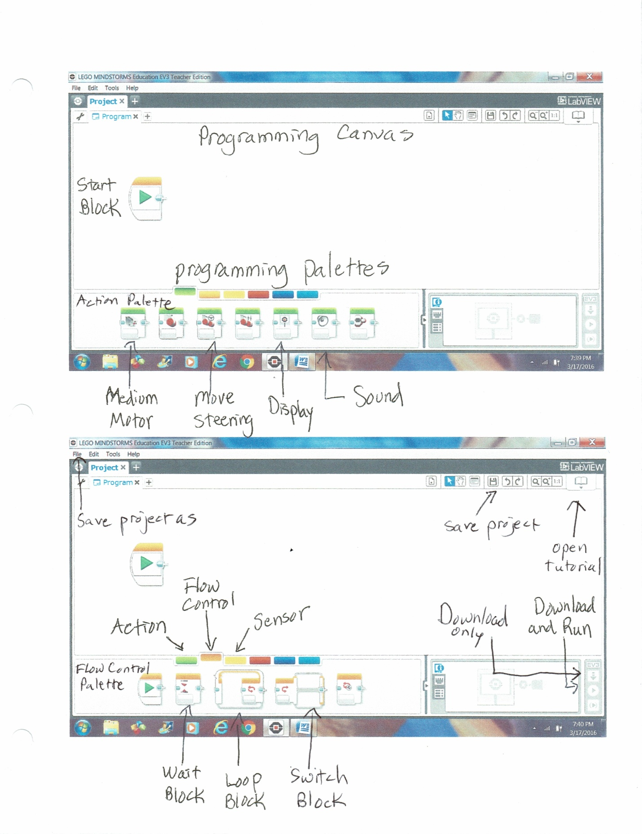
Lesson 4A: Palettes and Blocks: Flow Control Palette:  Touch and Color Sensors  MPI: Identify palettes and blocks used to program the EV-3 robot and explain their purposes by referring to a visual.  Materials: Programming Palettes and Blocks Visual, bricks with attached sensors and motors, cuboids, laptops (at least one per team), pencils  SEI Strategies: Seven Steps, Sentence Starters/Frames, Word Wheels  Lessons:  - Today we will continue learning about LEGO Mindstorms EV-3 programs. Who remembers the definition of program? A program is a set of step-by-step directions.  - Have students take out their copies of the Programming Palettes and Blocks Visual. Remember that clicking on ORANGE opens the Flow Control Palette. At the bottom of the page you will see the blocks in the Flow Control Palette. (Read them to students.)  - Today we are focusing on using the Wait Block.  - Turn on your laptops. Open up the LEGO Mindstorms software. Click on File, New Project, Program and then Open. You will see a blank canvas with a Start Block.  - Click on the Orange Flow Control Button. Click on a Wait Block and drag it up next to the Start Block. Click on the white Canvas to lock it on.  - Notice the hourglass on this block. It is waiting for something. You can use this block just as it is to have your robot wait before continuing. You will often set it for 1 or 2 seconds.  - We will be writing programs today to use with our sensors. Click on the clock in the mode box. You will see a menu. Find Touch Sensor on the menu and click on it. Slide your cursor over to Compare and then State and click. You will see in the picture that the sensor is waiting for the touch sensor to be pressed in (State 1). State means one of the choices: in or out, on or off. (Think of water: gas, liquid, solid are three states it can be in.) Look at the number 1 in the top corner. This means that the touch sensor has to be connected to Port 1 to work. If you need to change the port, you have to change the number.  - What do you want the robot to do when you press the button? You could choose a green sound block and add a sound, or a green motor block and run the motor. Add another block to your program now.  - Your program is done! Now you need to save it. Click on the small File button on the top of the page. Then click Save Project As. Name your project Touch Sensor and the number of your brick.  - Now double-click on Program. Rename it Touch and your initials.  - Click the Save Project icon up on the right side. Now your program is saved! It is not on your robot yet, though.  - Turn on the brick. Connect a USB cable from the brick to your laptop. When you see the name of your brick in the bottom corner box, the connection is ready. Click on the blue arrow to download your program. Click the right brick button to move to the files. Look for Touch Sensor #___. Press the middle Enter button. Now you should see your program. Press the down button to get to it. Press the Enter button again and your program will RUN! (Remember that now you have to press the touch sensor to have the robot do what you told it to do.)  - Go back to your program. Add a program for the next student by clicking the plus sign next to your program name. It’s the next student’s turn to write a program! You can change the robot’s reaction to the sensor.  - Repeat for any remaining students.  - Now let’s try a program with the Color Sensor. Click on the Orange Flow Control Button. Click on a Wait Block and drag it up next to the Start Block. Click on the white Canvas to lock it on. Click on the clock in the box. You will see a menu. Find Color Sensor on the menu and click on it. Slide your cursor over to Compare and then Color and click. You will see in the picture that the sensor is waiting for a color. Click in the box to choose a color. Look at the number 3 in the top corner. This means that the color sensor has to be connected to Port 3 to work. If you need to change the port, you have to change the number.  - What do you want the robot to do when it sees your color? You could choose a green sound block and add a sound, or a green motor block and run the motor. Add another block to your program now.  - Your program is done! Now you need to save it. Click on the small File button on the top of the page. Then click Save Project As. Name your project Color Sensor and the number of your brick.  - Now double-click on Program. Rename it Color and your initials.  - Click the Save Project icon up on the right side. Now your program is saved! It is not on your robot yet, though.  - Turn on the brick. Connect a USB cable from the brick to your laptop. When you see the name of your brick in the bottom corner box, the connection is ready. Click on the blue arrow to download your program. Click the right brick button to move to the files. Look for Color Sensor #___. Press the middle Enter button. Now you should see your program. Press the down button to get to it. Press the Enter button again and your program will RUN! (Remember that now you have to show the right color to have the robot do what you told it to do.)  - Go back to your program. Add a program for the next student by clicking the plus sign next to your program name. It’s the next student’s turn to write a program! You can change the robot’s reaction to the sensor.  - Repeat for any remaining students. | Vocabulary  program  canvas  palette  blocks  Flow Control  Sensor  Wait Block  state  Touch Sensor  Color Sensor  mode  parameter  files  project  program  download  run  definition  purpose

Lesson 4B: Palettes and Blocks: Flow Control Palette:  Gyro and Ultrasonic Sensors  MPI: Identify palettes and blocks used to program the EV-3 robot and explain their purposes by referring to a visual.  Materials: Programming Palettes and Blocks Visual, bricks with attached sensors and motors, cuboids, laptops (at least one per team), pencils  SEI Strategies: Seven Steps, Sentence Starters/Frames, Word Wheels  Lessons:  - Today we will continue learning about LEGO Mindstorms EV-3 programs.  - Turn on your laptops. Open up the LEGO Mindstorms software. Click on File, New Project, Program and then Open. You will see a blank canvas with a Start Block.  - Click on the Orange Flow Control Button. Click on a Wait Block and drag it up next to the Start Block. Click on the white Canvas to lock it on.  - We will be writing programs today to use with more sensors. Click on the clock in the mode box. You will see a menu. Find Gyro Sensor on the menu and click on it. Slide your cursor over to Compare and then Angle and click. You will see in the picture that the sensor is waiting for the gyro sensor to be moved more than 90 degrees.  - To understand the gyro, we need to know some math. When we talk about shapes in math, we usually measure degrees. (Draw a circle on the board and mark the center. Draw two lines to create an angle.) We measure parts of this circle by degrees. Label 0, 90, 180, 270 and 360 degrees. (Note: We use a round table for instruction, so I have used tape to mark these angles on the table.)Now draw a rectangle and show the 90 degree-angles. (For more practice, you could have students stand up and turn 90 degrees.)  - Our gyro is waiting for us to turn the robot 90 degrees or more. We could change that number.  - Look at the number 2 in the top corner. This means that the gyro sensor has to be connected to Port 2 to work. If you need to change the port, you have to change the number.  - What do you want the robot to do when you turn it? You could choose a green sound block and add a sound, or a green motor block and run the motor. Add another block to your program now.  - Your program is done! Now you need to save it. Click on the small File button on the top of the page. Then click Save Project As. Name your project Gyro Sensor and the number of your brick.  - Now double-click on Program. Rename it Gyro and your initials.  - Click the Save Project icon up on the right side. Now your program is saved! It is not on your robot yet, though.  - Turn on the brick. Connect a USB cable from the brick to your laptop. When you see the name of your brick in the bottom corner box, the connection is ready. Click on the blue arrow to download your program. Click the right brick button to move to the files. Look for Gyro Sensor #___. Press the middle Enter button. Now you should see your program. Press the down button to get to it. Press the Enter button again and your program will RUN! (Remember that now you have to move the robot to have the robot do what you told it to do.)  - Go back to your program. Add a program for the next student by clicking the plus sign next to your program name. It’s the next student’s turn to write a program! You can change the number of degrees.  - Repeat for any remaining students.  - Now let’s try a program with the Ultrasonic Sensor. Click on the Orange Flow Control Button. Click on a Wait Block and drag it up next to the Start Block. Click on the clock in the box. You will see a menu. Find Ultrasonic Sensor on the menu and click on it. Slide your cursor over to Compare and then Distance in Centimeters and click. Click in the box to choose #4, less than. Change the number in the other box to 15. You will see in the picture that the sensor is waiting for the distance to be less than 15 centimeters. .You will move the cuboid nearer to the sensor. You should get a reaction when the cuboid is less than 15 cm away. Look at the number 4 in the top corner. This means that the ultrasonic sensor has to be connected to Port 4 to work. If you need to change the port, you have to change the number.  - What do you want the robot to do when the distance is right? You could choose a green sound block and add a sound, or a green motor block and run the motor. Add another block to your program now.  - Your program is done! Now you need to save it. Click on the small File button on the top of the page. Then click Save Project As. Name your project Ultrasonic Sensor and the number of your brick.  - Now double-click on Program. Rename it Ultra and your initials.  - Click the Save Project icon up on the right side. Now your program is saved! It is not on your robot yet, though.  - Turn on the brick. Connect a USB cable from the brick to your laptop. When you see the name of your brick in the bottom corner box, the connection is ready. Click on the blue arrow to download your program. Click the right brick button to move to the files. Look for Ultrasonic Sensor #___. Press the middle Enter button. Now you should see your program. Press the down button to get to it. Press the Enter button again and your program will RUN! (Remember that now you have to move the cuboid towards the sensor to have the robot do what you told it to do.)  - Go back to your program. Add a program for the next student by clicking the plus sign next to your program name. It’s the next student’s turn to write a program! You can change the robot’s reaction to the sensor.  - Repeat for any remaining students. | Vocabulary  program  canvas  palette  blocks  Flow Control  Sensor  Wait Block  state  Gyro Sensor  degrees  Ultrasonic Sensor  distance  mode  parameter  files  project  program  download  run  definition  purpose

Lesson 5: Describing Programs  MPI: Identify palettes and blocks used to program the EV-3 robot and explain their purposes by referring to a visual.  Materials: blocks (wooden, Lego, etc.), Programming Palettes and Blocks Visual, Program Description and Word Bank, last week’s bricks with attached sensors and motors, cuboids, laptops (at least one per team),lined paper, pencils  SEI Strategies: Seven Steps, Sentence Starters/Frames, Word Wheels  Lessons:  - We are almost ready to begin building our first robot! However, good engineers need to be able to document, or explain, their work. Today we are going to practice describing our LEGO Mindstorms EV-3 programs.  - Turn on your laptops. Open up the LEGO Mindstorms software. Click on File, Open Project. You will see a list of Projects. Look for your group’s Motor project. Double-click to open it.  - Now you should see the different programs that students in your group have written. Click on yours. You should see your program.  - Here is a paper called “Program Description”. It has examples of sentence frames that will help you describe your program. Here is another paper with a Word Bank for describing your program. (Pass out reference copies in sheet protectors.)  - What is the name of your program? (e.g. Motor ab).. On the lined paper, write it as a title.  - Now write sentence one: My program is named ________.  - Next write another sentence. What blocks are in your program? Look at the Word Bank. Use your Programming Palettes Visual if you need it. Write a sentence: It uses ______ , ______and _______ blocks.  - Now write sentences for each block. ***Note: We are using Cause and Effect Language. The ____________ block makes the robot __________. Follow the examples in sentences 3, 4 and 5, but change the names of the blocks and what they can do. Ask your teammates if you need help.  - Students can take turns describing their programs. For lower-level writers, recreate the program description with blanks to fill in.  - Students store papers in binders. | Vocabulary  program  palette  blocks  Action  Flow Control  Medium Motor  Large Motor  Sensor  Wait Block  Compare  state  Touch Sensor  Color Sensor  Gyro Sensor  degrees  Ultrasonic Sensor  distance  less than/greater than  project  program  describe  description  purpose  cause  effect

Mindstorms Word Bank
Action Blocks Action
medium motor move lift arm up (down)
large motor move forward (backward)
move steering move forward (backward)
(turn)
move tank move forward (backward)
(turn)
display display a picture or word
sound play a tone (note)
play a sound(make a dog bark)
brick status light show or flash a red light

Flow Control Blocks
wait wait for 1 second
measure color (distance)
compare color (distance)
loop repeat the sound block
switch input the color and choose an action to output

My Blocks represent a program with one block

______________________________ Program Description

SAMPLE SENTENCES (Use with Word Bank):
1. My program is named ____________________.
2. It uses large motor, wait and sound blocks.
3. The first block is a large motor block. It makes the large motor run. This makes the pointer spin.
4. The second block is a wait block. It makes the robot wait for 1 second.
5 The third block is a wait block. It makes the color sensor compare color.
6. All of my blocks are sound blocks. This one makes the robot play a tone. This one makes the robot make a T-Rex roar.
7. This is a my block. It represents a program of sound blocks.
8. This is a switch block. It makes the robot use its sensor and choose what to do.
9. This is a loop block. It makes the robot repeat the program in the loop.
10. This is a display block. It makes the brick display a picture.
11. This is a light block. It makes the brick status light flash (change color).

Lesson 6A: Beginning to Build  MPI: Identify elements of the EV-3 robot by describing name, size, color and shape, using a word bank and sentence starters.  MPI: Explain steps in the process of building using sentence frames.  Materials: LEGO Mindstorms EV-3 kits (1 for 3 students), EV-3 Elements catalog and list, Protocols Anchor, Teamwork Anchor, Building Steps Anchor, Requesting Parts Sentence Starters, Building Process Sentence Frames, cuboids, EV-3 manuals (Note: Disassemble any previously built robots/bricks with attachments)  SEI Strategies: Seven Steps, Sentence Starters/Frames, Word Arrays, Visuals  Lessons:  - We are finally ready to begin building our first robot! First, let’s review our protocols for building. Refer to anchor:  - Only one person taking parts out at a time.  - Take out only the pieces you are told to take and be gentle.  - Put pieces on tray so they don’t get lost.  - Take out the tray from the bin with two hands.  - Put the parts away in the correct compartments.  - We need another anchor, about how to share the building. It will be a little bit like playing charades, but just the opposite. Try to use your words, not your hands!:  - Person 1 tells person 2 what pieces are needed for one step. Use your elements charts to help you describe the parts. Here are some phrases you could use: (Pass out Requesting Parts sentence starters). You should try not to show Person 2 the manual. Do NOT grab your own pieces.  - Person 3 has the manual. Person 3 describes the first step. Here are some phrases you might need: (Pass out Building Process Sentence Frames.) Use your words, not your hands. Don’t let Person 1 see the manual. Ask a classmate for help if you can’t figure out how to describe the step.  - After a few steps (or one if it has a lot of parts), switch jobs.  - Decide who will be person 1, 2 and 3. Person 1 should have the tray, Person 2 should have the bin, and Person 3 should have the manual.  - We have one more anchor, the steps in building, which may help you when you are building. Paying attention to this anchor will save you a lot of time later, having to fix mistakes:  - Build.  - Pay special attention to colors, size, direction.  - Pay special attention to where the cables go.  - Program, save project and save program.  - Attach cable from computer to brick.  - Download.  - Run!  - Begin building!  - Give students a 5-minute warning about cleaning up and putting the bins back together. | Vocabulary  bin  tray  compartment  element  axle  beam  gear  peg  Medium Motor  Large Motor  Touch Sensor  Color Sensor  Gyro Sensor  Ultrasonic Sensor  Cable  Port  describe  description  process

TEAMWORK
Use your words, not your hands!

- Person 1 tells person 2 what pieces are needed for one step.
- Person 3 has the manual. Person 3 describes the first step. (Don’t let Person 1 see the manual!)
- After a few steps (or one if it has a lot of parts), switch jobs.

Person 1: Tray
Person 2: Bin
Person 3: Manual

Steps Involved in Building:
- Pay special attention to colors, size, direction.
- Pay special attention to where the cables go.
- Program, save project (use group #) and save program (use your initials). Examples: TOUCH 1, TOUCH JO
- Attach cable from computer to brick.
- Download. (Use downward arrow button on computer)
- Run program! (Press down buttons to find program on brick; press enter (middle button).

Requesting Parts Sentence Starters
- Could I have a _long blue peg_____________?
- Please give me 2 _size 9 beams_____________s.
- I need this gray gear (point to gear on Elements paper).
- I need another small blue peg.

Building Process Sentence Frames
- Put the axle in the cross-shaped hole at the end of the beam.
- Put the short end of the long blue peg in the corner hole.
- Put the gear on the axle.
- Put the beam on the axle and these pegs.
- Line the beam up with the other beam.
- Push the axle through the second hole.
- Push in the red pegs.
- Attach the cable to Port A.
- Connect the cable from Port 3 to the color sensor.
- Put the ball in the bearing.
- Put the tire on the hub.
- Push the peg in from the back.
- Turn the motor around.
- Turn the robot upside down.
- Turn the robot right-side up.

Lesson 6B: Continuing to Build  MPI: Identify elements of the EV-3 robot by describing name, size, color and shape, using a word bank and sentence starters.  MPI: Explain steps in the process of building using sentence frames.  Materials: LEGO Mindstorms EV-3 kits (1 for 3 students), EV-3 Elements catalog and list, Protocols Anchor, Teamwork Anchor, Building Steps Anchor, Requesting Parts Sentence Starters, Building Process Sentence Frames, cuboids, EV-3 manuals  SEI Strategies: Seven Steps, Sentence Starters/Frames, Word Arrays, Visuals  Lessons:  - Today we’ll continue building our first robot! First, let’s review our protocols for building. Refer to anchor:  - Only one person taking parts out at a time.  - Take out only the pieces you are told to take and be gentle.  - Put pieces on tray so they don’t get lost.  - Take out the tray and bins with two hands.  - Put the parts away in the correct bin.  - Let’s review our other anchor, about how to share the building. Try to use your words, not your hands!:  - Person 1 tells person 2 what pieces are needed for one step. Do NOT grab your own pieces.  - Person 3 has the manual. Person 3 describes the first step. Use your words, not your hands. Don’t let Person 1 see the manual. Ask a classmate for help if you can’t figure out how to describe the step.  - After a few steps (or one if it has a lot of parts), switch jobs.  - Decide who will be person 1, 2 and 3. Person 1 should have the tray, Person 2 should have the bin, and Person 3 should have the manual. Begin building!  - Give students a 5-minute warning about cleaning up and putting the bins back together.  Note: The building process may continue for several weeks. When students are finished, they may go on to try the DEMO program with the brick button. Be sure to celebrate all their language use as well as the completion of the first robot! If individual groups are finished building, move on to more programming. | Vocabulary  bin  tray  compartment  element  axle  beam  gear  peg  Medium Motor  Large Motor  Touch Sensor  Color Sensor  Gyro Sensor  Ultrasonic Sensor  Cable  Port  describe  description  process

Lesson 7: Action Palette: Move Steering  MPI: Identify palettes and blocks used to program the EV-3 robot and explain their purposes by referring to a visual.  Materials: Programming Palettes and Blocks Visual, Steps in Debugging Anchor, Driving Base, laptops (at least one per team), pencils  SEI Strategies: Seven Steps, Sentence Starters/Frames, Word Wheels  Lessons:  - Today we will begin learning about LEGO Mindstorms EV-3 Move Steering programs.  - Remember that we said a program is a set of step-by-step directions. You have learned how to make a program run 1 motor. Your robot has two Large Motors. To program two motors at once, you need to use Move Steering or Move Tank Blocks. Move Steering works like the steering wheel of a car. One direction tells both motors and their wheels what to do. Move Tank gives each wheel a different direction. Move Steering and Move Tank are Action blocks. Today we are going to learn from LEGO Mindstorms tutorials about Move Steering Blocks. Be very careful to get the block with the little steering wheel! (I once spent several hours trying to find my mistake. I had used a Move Tank Block instead!)  - (Note: When programming, have one student write a program on each shared laptop. Then switch students until each one has created a program.) Turn on your laptops. Open up the LEGO Mindstorms software. Click on Robot Educator, Basics, Straight Move and then Open. You will see a tutorial on the right side of the page. In the top corner, you see 1/5. These means page 1 out of 5 pages. Page 1 is always a video. Click the play button to watch the video.  - Click to go to page 2. Page 2 has a link to building directions for the driving base, which were also in your manual.  - Now go to page three. This is the Interactive Program. Click on one block at a time to see what that block does. The first Move Steering Block makes the robot go forwards and stop. The next block is a wait block. The robot waits for 1 second. It is easier for the robot to have a break between moves. The next Move Steering Block makes the robot go backwards. Then there’s another Wait Block. The last block is another Move Steering Block. It makes the robot go forwards again.  - Page 4 lets you copy the program. Look at the first block. It’s a Move Steering Block. Drag a Move Steering Block from the Action Palette and link it to the Start Block on the left. Now look carefully at the three Move Steering Blocks in the program. What is different? First, notice the first box under the wheels. This called the mode. Click on this box in your first block. You will see a menu. This box was set at On for Rotations. This means the motor will spin for a number of times. The number 2 in the fourth box tells it to rotate 2 times. Change the number in your block to 2. (Notice the blue circles. They tell you what to change.) Look at the second box. The 0 means the robot will move in a straight line. Click on this box and see what happens to the arrow when you change the number! The third box is the speed, just like the blocks for the medium and large motors. The last box tells the robot to stop after the 2 rotations.  - Add a Wait Block.  - Now add another Move Steering Block. What is different? Change the mode to “On for Degrees.” This will make the motor turn for a number of degrees of a circle. Notice that the number of degrees is 720. Change these on your block. What else changed? Yes, the speed is now negative (minus). This makes the robot go backwards.  - Add another Wait Block.  - Add your third Move Steering Block. Now what has changed? This time the mode is set to On for Seconds, and the number of seconds is 1. The speed is back to 50, and the robot is moving forwards again.  - Your first program is done! Now you need to save it. Click on the small File button on the top of the page. Then click Save Project As. Name your project Move Steering and the number of your brick.  - Now double-click on Program. Rename it MS and your initials.  - Click the Save Project icon up on the right side. Now your program is saved! It is not on your robot yet, though.  - Turn on the brick. Connect a USB cable from the brick to your laptop. When you see the name of your brick in the bottom corner box, the connection is ready. Click on the blue arrow to download your program. Click the right brick button to move to the files. Look for Move Steering #___. Press the middle Enter button. Now you should see your program. Press the down button to get to it. Press the Enter button again and your program will RUN!  - If any student’s program is not running, explain the Steps in Debugging anchor!  - Go back to your program. Add a program for the next student by clicking the plus sign next to your program name. It’s the next student’s turn to write a program! You can change the modes, numbers, speeds and also the direction. (Repeat for any remaining students.) Have a look at the Curved Move Video and program to see the differences. | Vocabulary  program  palette  blocks  Action  Move Steering  definition  purpose  files  project  program  download  run
Steps Involved in Debugging:

- Check the power.
- Save the project again and download again.
- Check the cables.
- Check the building plans.
- Check the program.

Lesson 8: Action Palette: Move Tank  MPI: Identify palettes and blocks used to program the EV-3 robot and explain their purposes by referring to a visual.  Materials: Programming Palettes and Blocks Visual, Steps in Debugging Anchor, Driving Base, laptops (at least one per team), pencils  SEI Strategies: Seven Steps, Sentence Starters/Frames, Word Wheels  Lessons:  - Today we will learn about LEGO Mindstorms EV-3 Move Tank programs.  - Remember that Move Steering works like the steering wheel of a car. One direction tells both motors and their wheels what to do. Move Tank gives each wheel a different direction. Move Steering and Move Tank are Action blocks. Today we are going to learn from LEGO Mindstorms tutorials about Move Tank Blocks. Be very careful to get the block with the two little arrows!  - (Note: When programming, have one student write a program on each shared laptop. Then switch students until each one has created a program.) Turn on your laptops. Open up the LEGO Mindstorms software. Click on Robot Educator, Basics, Tank Move and then Open. Click the play button to watch the video.  - Now go to page three. This is the Interactive Program. Click on one block at a time to see what that block does. Notice that the arrow for direction has disappeared. Instead, you are setting a different speed for each motor. (Demonstrate how by taking a short step with one foot and a long one with the other, you will turn. If one foot goes backwards or stops and the other goes forward, you will also turn.  - Page 4 lets you copy the program. Notice the changes as you copy the program.  - Save Project As Move Tank and the number of your brick.  - Now double-click on Program. Rename it MT and your initials.  - Click the Save Project icon  - Connect a USB cable and download your program. Click the right brick button to move to the files. Look for Move Tank #___. Press the middle Enter button. Now you should see your program. Press the down button to get to it. Press the Enter button again and your program will RUN!  - If any student’s program is not running, refer to the Steps in Debugging anchor!  - Go back to your program. Add a program for the next student by clicking the plus sign next to your program name. It’s the next student’s turn to write a program! You can change the modes, numbers, and speeds. (Repeat for any remaining students.)  - After you have tried your program, write a program description for your Move Steering Program and your Move Tank Program. Put them in your binder! | Vocabulary  program  palette  blocks  Action  Move Steering  definition  purpose  files  project  program  download  run

Lesson 9: Add a Touch Sensor  MPI: Identify elements of the EV-3 robot by describing name, size, color and shape, using a word bank and sentence starters.  MPI: Explain steps in the process of building using sentence frames.  MPI: Identify palettes and blocks used to program the EV-3 robot and explain their purposes by referring to a visual.  Materials: LEGO Mindstorms EV-3 kits (1 for 3 students), EV-3 Elements catalog and list, Protocols Anchor, Teamwork Anchor, Building Steps Anchor, Requesting Parts Sentence Starters, Building Process Sentence Frames, Steps in Debugging Anchor, Driving Base, laptops (at least one per team),EV-3 manuals  SEI Strategies: Seven Steps, Sentence Starters/Frames, Word Arrays, Visuals  Lessons:  - Today we’ll add a touch sensor to our first robot! First, let’s review our protocols for building. Refer to anchor:  - Let’s review our other anchor, about how to share the building. Try to use your words, not your hands!:  - Take out your manual. Follow the building steps on pages 77-80.  - Remember what happened when we pressed the touch sensor before? Go to the tutorial at Robot Educator-Hardware-Touch Sensor-p.3 and study the program. Notice what the mode and numbers are set to.  - Now try modifying your Touch Sensor Program for the robot. Go to File, Open Project, Touch # ___, and your old program. Add some new blocks to make your program more interesting! Click the Save Project icon, then download and run. Remember that you need to press the Touch Sensor to start your program.  - More advanced students may want to try building a bumper and writing a bumper program. (See The Art of LEGO Mindstorms EV-3 Programming by Terry Griffin, bumper directions pp. 27-29; programming directions pp. 52-54, 66-67, 78-80. This book is used with the Home version; colors may be different.)  - Be sure to add a Program Description for your Touch Sensor Programs! ***Note: Go over anchor : Cause and Effect Language. Here are more ways to talk about cause and effect!:  - The move steering block makes the robot turn.  - Pressing the touch sensor makes the robot play a sound.  - When the color sensor detects the color red, the robot says “red”.  - When the ultrasonic sensor detects that an object is 10 centimeters away, the robot stops.  - When the gyro sensor detects a change of 90 degrees, the robot displays an image.  - When the color sensor detects a change in ambient light, the robot reacts by playing a note.  - When the color sensor detects a change in light intensity, the robot reacts by turning left. | Vocabulary  element  axle  beam  gear  peg  Medium Motor  Large Motor  Touch Sensor  Cable  Port  Bumper  describe  description  process

Lesson 10: Adding Some Fun: Action Palette: Display Blocks  MPI: Identify palettes and blocks used to program the EV-3 robot and explain their purposes by referring to a visual.  Materials: Programming Palettes and Blocks Visual, Steps in Debugging Anchor, Driving Base, laptops (at least one per team), pencils  SEI Strategies: Seven Steps, Sentence Starters/Frames, Word Wheels  Lessons:  - Today we will learn about LEGO Mindstorms EV-3 Display Blocks.  - A Display block shows a picture on the screen of the brick. By stringing together a number of pictures, you can make a small movie. For example, you can make the eyes appear to move, or a mouth open and close. Important note: You must place a wait block after each display block. 2 seconds is a good wait time. If you don’t use a wait block, your picture will not have enough time to load and be seen!  - Turn on your laptops. Open up the LEGO Mindstorms software. Click on Robot Educator, Hardware, Brick Display and then Open. Watch the video, study the program, and create your own.  - Save Project As Display and the number of your brick.  - Now double-click on Program. Rename it Dis and your initials.  - Click the Save Project icon  - Connect a USB cable and download your program. Click the right brick button to move to the files. Look for Display #___. Press the middle Enter button. Now you should see your program. Press the down button to get to it. Press the Enter button again and your program will RUN!  - Go back to your program. Add a program for the next student by clicking the plus sign next to your program name. It’s the next student’s turn to write a program! (Repeat for any remaining students.)  - After you have tried your program, write a program description for your Display Program. Put it in your binder! | Vocabulary  program  palette  blocks  Action  Display Block  definition  purpose  files  project  program  download  run

Lesson 11: Add a Lift Arm (Move Object)  MPI: Identify elements of the EV-3 robot by describing name, size, color and shape, using a word bank and sentence starters.  MPI: Explain steps in the process of building using sentence frames.  MPI: Identify palettes and blocks used to program the EV-3 robot and explain their purposes by referring to a visual.  Materials: LEGO Mindstorms EV-3 kits (1 for 3 students), EV-3 Elements catalog and list, Protocols Anchor, Teamwork Anchor, Building Steps Anchor, Requesting Parts Sentence Starters, Building Process Sentence Frames, Steps in Debugging Anchor, Driving Base, cuboids, laptops (at least one per team), EV-3 manuals  SEI Strategies: Seven Steps, Sentence Starters/Frames, Word Arrays, Visuals  Lessons:  - Today we’ll add a Lift Arm to our robot! First, let’s review our protocols for building. Refer to anchor:  - Let’s review our other anchor, about how to share the building. Try to use your words, not your hands!  - Don’t forget to refer to the Building Steps Anchor or Steps for Debugging if you need them.  - Take out your manual. Follow the building steps on pages 54-68.  - You can find the program by going to Robot Educator, Basics, Move Object and then Open. Click the play button to watch the video.  - Now go to page three. This is the Interactive Program. Click on one block at a time to see what that block does.  - Copy the program. You could add a display block or sound block at the end.  - Save Project As Move Object and the number of your brick.  - Now double-click on Program. Rename it MO and your initials.  - Click the Save Project icon  - Be sure to add a Program Description for your Move Object Program! | Vocabulary  element  axle  beam  gear  peg  Medium Motor  Large Motor  Lift Arm  Cable  Port  object  describe  description  process

Lesson 12: More Fun: Light Blocks and Loops  MPI: Identify palettes and blocks used to program the EV-3 robot and explain their purposes by referring to a visual.  Materials: Programming Palettes and Blocks Visual, Steps in Debugging Anchor, Driving Base, laptops (at least one per team), pencils  SEI Strategies: Seven Steps, Sentence Starters/Frames, Word Wheels  Lessons:  - Today we will learn about adding Brick Status Light Blocks and Loops to our programs.  - A Brick Status Light Block (Light Block for short) will let you add a blinking light or change the color of the light on the brick. Important note: You must place a wait block after each display block. 2 seconds is a good wait time. If you don’t use a wait block, your light will not have enough time to load and be seen! Add more seconds to the wait block to keep the light on longer.  - Turn on your laptops. Open up the LEGO Mindstorms software. Click on Robot Educator, Hardware, Brick Status Light and then Open. Watch the video, study the program, and create your own. Notice that you can change the color of the light, and whether it flashes or not.  - Save Project As Light and the number of your brick.  - Now double-click on Program. Rename it Light and your initials.  - Click the Save Project icon  - Connect a USB cable and download your program. Click the right brick button to move to the files. Look for Light #___. Press the middle Enter button. Now you should see your program. Press the down button to get to it. Press the Enter button again and your program will RUN!  - Go back to your program. Add a program for the next student by clicking the plus sign next to your program name. It’s the next student’s turn to write a program! (Repeat for any remaining students.)  - After you have tried your program, write a program description for your Display Program. Put it in your binder!  - Perhaps you will want to write a new program combining different kinds of Action Blocks! Your brick could flash red, show a danger sign, then say dog, followed by a dog growl and an “ouch!” (Name it Dog?)  - You can make a program repeat the whole sequence more than once by adding a Loop Block. Choose the ORANGE Flow Control Palette, then drag a Loop Block next to the start block. Drag blocks one by one into the Loop Block. Change the infinity sign at the end of the Loop Block to a small number (3 or 4). Your whole program will repeat 3 or 4 times! (Use Loop in the project and program names.)  - Don’t forget to describe your program! | Vocabulary  program  palette  blocks  Action  Brick Light Status  definition  purpose  files  project  program  download  run

Lesson 13: Putting it Together: Multitasking  MPI: Identify palettes and blocks used to program the EV-3 robot and explain their purposes by referring to a visual.  Materials: Programming Palettes and Blocks Visual, Steps in Debugging Anchor, Driving Base, laptops (at least one per team), pencils  SEI Strategies: Seven Steps, Sentence Starters/Frames, Word Wheels  Lessons:  - Today we will learn about how to program several actions at the same time.  - Turn on your laptops. Open up the LEGO Mindstorms software. Click on Robot Educator, Beyond Basics, Multitasking and then Open. Watch the video, and study the program. Notice that there is an extra wire coming out of the Start Block. After you create the first block on the second part, click on the gray bump on the right side of the start button, and drag a wire down to connect with the bump on your block. It should light up. Now your two parts should go at the same time.  - Another way to do it: Go to the ORANGE Flow Control Palette. The first block is a Start Block. Drag one up and put it under the other Start Block. Then create the second part of your program.  - Notice that the second sound block says number 2 and shows a loop. It will keep repeating the sound while the motor goes. The first sound block tells the sound to stop after the motor has stopped.  - Now create your own programs. Maybe a dog is barking while your robot runs!  - Save Project As Multi and the number of your brick.  - Now double-click on Program. Rename it Multi and your initials.  - Click the Save Project icon  - Connect a USB cable and download your program. Click the right brick button to move to the files. Look for Multi #___. Press the middle Enter button. Now you should see your program. Press the down button to get to it. Press the Enter button again and your program will RUN!  - Go back to your program. Add a program for the next student by clicking the plus sign next to your program name. It’s the next student’s turn to write a program! (Repeat for any remaining students.)  - After you have tried your program, write a program description for your Display Program. Put it in your binder! | Vocabulary  program  palette  blocks  Action  Brick Light Status  definition  purpose  files  project  program  download  run
Lesson 14: Add an Ultrasonic Sensor(Stop at Object)  MPI: Identify elements of the EV-3 robot by describing name, size, color and shape, using a word bank and sentence starters.  MPI: Explain steps in the process of building using sentence frames.  MPI: Identify palettes and blocks used to program the EV-3 robot and explain their purposes by referring to a visual.  Materials: LEGO Mindstorms EV-3 kits (1 for 3 students), EV-3 Elements catalog and list, Protocols Anchor, Teamwork Anchor, Building Steps Anchor, Requesting Parts Sentence Starters, Building Process Sentence Frames, Steps in Debugging Anchor, Driving Base, cuboids, laptops (at least one per team), EV-3 manuals  SEI Strategies: Seven Steps, Sentence Starters/Frames, Word Arrays, Visuals  Lessons:  - Today we’ll add an Ultrasonic Sensor to our robot! First, let’s review our protocols for building. Refer to anchor:  - Let’s review our other anchor, about how to share the building. Try to use your words, not your hands!  - Don’t forget to refer to the Building Steps Anchor or Steps for Debugging if you need them.  - Take out your manual. Follow the building steps on pages 41-47.  - You can find the program by going to Robot Educator, Basics, Stop at Object and then Open. Click the play button to watch the video.  - Now go to page three. This is the Interactive Program. Click on one block at a time to see what that block does. ***The Wait Block with the Ultrasonic Sensor is a bit confusing. The first wait block is actually telling the robot to use the sensor to measure the distance from the object (in centimeters), then to Change the Distance! decrease the distance, or get closer. The number 11 tells it to move forward 11 centimeters. In this example, the robot starts at 17 centimeters away, makes the distance 11 centimeters less by moving forwards, and stops at 6 centimeters from the object. In the second Wait Block, the robot is told to Increase the Distance or back up 6 centimeters, so that it is now 12 centimeters away from the object!  - Notice that in our earlier programs with the Ultrasonic Sensor, we used Compare the Distance.  - Copy the program. You could add display blocks or sound blocks at the end.  - Save Project As Stop at Object and the number of your brick.  - Now double-click on Program. Rename it SO and your initials.  - Click the Save Project icon  - Be sure to add a Program Description for your Stop at Object Program! | Vocabulary  element  axle  beam  gear  peg  Large Motor  Ultrasonic Sensor  Cable  Port  object  describe  description  process

Lesson 15: Add a Gyro Sensor  MPI: Identify elements of the EV-3 robot by describing name, size, color and shape, using a word bank and sentence starters.  MPI: Explain steps in the process of building using sentence frames.  MPI: Identify palettes and blocks used to program the EV-3 robot and explain their purposes by referring to a visual.  Materials: LEGO Mindstorms EV-3 kits (1 for 3 students), EV-3 Elements catalog and list, Protocols Anchor, Teamwork Anchor, Building Steps Anchor, Requesting Parts Sentence Starters, Building Process Sentence Frames, Steps in Debugging Anchor, Driving Base, laptops (at least one per team), EV-3 manuals  SEI Strategies: Seven Steps, Sentence Starters/Frames, Word Arrays, Visuals  Lessons:  - Today we’ll add a Gyro Sensor to our robot! First, let’s review our protocols for building. Refer to anchor.  - Let’s review our other anchor, about how to share the building. Try to use your words, not your hands!  - Don’t forget to refer to the Building Steps Anchor or Steps for Debugging if you need them.  - Take out your manual. Follow the building steps on pages 48-52.  - Create a new program : Select a Move Steering block. Set the mode to On. Set the direction arrow to 70 so it will turn. Set the speed to 20 so it will move slowly.  - Now add another Start Block under the first Start Block. (This is a Multitasking program). Add a Wait Block and set the mode to Gyro Sensor-Compare-Angle. Add a Move Steering Block and set the mode to Off. Add a Sound Block and choose a sound file (I used Power Down.)  - Save Project As Gyro Compare and the number of your brick.  - Now double-click on Program. Rename it GC and your initials.  - Click the Save Project icon  - Be sure to add a Program Description for your Gyro Program! | Vocabulary  element  axle  beam  gear  peg  Large Motor  Gyro Sensor  Cable  Port  angle  describe  description  process

Lesson 16A: Last but Not Least: The Color Sensor (Stop at Line)  MPI: Identify elements of the EV-3 robot by describing name, size, color and shape, using a word bank and sentence starters.  MPI: Explain steps in the process of building using sentence frames.  MPI: Identify palettes and blocks used to program the EV-3 robot and explain their purposes by referring to a visual.  Materials: LEGO Mindstorms EV-3 kits (1 for 3 students), EV-3 Elements catalog and list, Protocols Anchor, Teamwork Anchor, Building Steps Anchor, Requesting Parts Sentence Starters, Building Process Sentence Frames, Steps in Debugging Anchor, Driving Base, laptops (at least one per team),black electrical tape, EV-3 manuals  SEI Strategies: Seven Steps, Sentence Starters/Frames, Word Arrays, Visuals  Lessons:  - Today we’ll add a Color Sensor to our robot! Don’t forget about our anchor charts!  - Take out your manual. Follow the building steps on pages 69-72.  - You can find the program by going to Robot Educator, Basics, Stop at Line and then Open. Click the play button to watch the video.  - Now go to page three. This is the Interactive Program. Click on one block at a time to see what that block does. Notice that block 1 is a single Large Motor block. Only one motor is turned on, which causes the robot to turn. The next block is a Wait Block. It is set to Color Sensor-Compare-Reflected Light Intensity, less than 50%. In Reflected Light Intensity Mode, the Color Sensor measures the intensity of light reflected back from a red light–emitting lamp. The sensor uses a scale of 0 (very dark) to 100 (very light). Here your robot moves around on a white surface (100% reflected light) until a dark line (less than 50% reflected light) is detected (User Guide, p. 14). The last Large Motor block makes the robot stop.  - Copy the program. You could add display blocks or sound blocks at the end.  - Save Project As Stop at Line and the number of your brick.  - Now double-click on Program. Rename it SL and your initials.  - Click the Save Project icon  - Be sure to add a Program Description for your Stop at Line Program! | Vocabulary  element  axle  beam  gear  peg  Large Motor  Color Sensor  Cable  Port  reflect  intensity  percent  detect  describe  description  process

Lesson 16B: The Color Sensor (Line Following with Switch Blocks)  MPI: Identify elements of the EV-3 robot by describing name, size, color and shape, using a word bank and sentence starters.  MPI: Identify palettes and blocks used to program the EV-3 robot and explain their purposes by referring to a visual.  Materials: Driving Base with Color Sensor (1 for 3 students), EV-3 Elements catalog and list, Protocols Anchor, Teamwork Anchor, Building Steps Anchor, Steps in Debugging Anchor, laptops (at least one per team, EV-3 manuals, black electrical tape  SEI Strategies: Seven Steps, Sentence Starters/Frames, Word Arrays, Visuals  Lessons:  - Today we’ll create a Line Following Program for our robot! Don’t forget about our anchor charts!  - We will need our Driving Base with the Color Sensor pointing down.  - You can find the program by going to Robot Educator, Beyond Basics, Switch and then Open. Click the play button to watch the video.  - Now go to page three. This is the Interactive Program. Click on one block at a time to see what that block does. Notice that you first add a Loop Block, to keep the robot going until you press the back button to stop the program. The next block is a Switch Block. It is again set to Color Sensor-Compare-Reflected Light Intensity, less than 50%. This time the program has two choices. The true case (with the check mark ) does the following: If the color sensor detects intensity which is less than 50% (the dark line) (User Guide, p. 14), motor C will stop and Motor B will go. This causes the robot to turn left or counterclockwise. The false case (with the x) does the following: If the color sensor detects intensity which is more than 50% (the white space) (User Guide, p. 14), motor B will stop and Motor C will go. This causes the robot to turn right or clockwise. Therefore, the robot will turn one way until it detects the black line (and continues past it in the same direction.) Then it will turn the other direction until it again detects black and changes direction. This program is sometimes called the Wiggler Program.  - Copy the program. You could try slowing down the speed so that it’s easier to see the changes.  - Save Project As Line Follower and the number of your brick.  - Now double-click on Program. Rename it LF and your initials.  - Click the Save Project icon  - Be sure to add a Program Description for your Line Follower Program! | Vocabulary  Large Motor  Color Sensor  Cable  Port  Switch Block  reflect  intensity  percent  detect  describe  description  process

Lesson 16C: The Color Sensor (Revisiting Measure Color)  MPI: Identify elements of the EV-3 robot by describing name, size, color and shape, using a word bank and sentence starters.  MPI: Explain steps in the process of building using sentence frames.  MPI: Identify palettes and blocks used to program the EV-3 robot and explain their purposes by referring to a visual.  Materials: LEGO Mindstorms EV-3 kits (1 for 3 students), EV-3 Elements catalog and list, Protocols Anchor, Teamwork Anchor, Building Steps Anchor, Requesting Parts Sentence Starters, Building Process Sentence Frames, Steps in Debugging Anchor, Driving Base, laptops (at least one per team), cuboid, EV-3 manuals  SEI Strategies: Seven Steps, Sentence Starters/Frames, Word Arrays, Visuals  Lessons:  - Today we’ll revisit how to program our Color Sensor to react to a color. We’ll need to reposition the color sensor to aim forwards.  - Take out your manual. Follow the building steps on pages 73-76.  - You can find your old program by going to File, Open Project, Color Sensor # ___ and then Open. Locate the programs CS and your initials and open.  - Now the Wait Block is set to Color Sensor-Compare-Color. You chose a color. This time, change the blocks after the wait block to make your robot use move steering blocks!  - Save Project As Color Sensor Move and the number of your brick.  - Now double-click on Program. Rename it CSM and your initials.  - Click the Save Project icon  - Be sure to add a Program Description for your Color Sensor Program! How did your robot react when it detected your color? | Vocabulary  Large Motor  Color Sensor  Cable  Port  measure  react  detect  describe  description  process

Lesson 16D: The Color Sensor (Multiple Switch)  MPI: Identify elements of the EV-3 robot by describing name, size, color and shape, using a word bank and sentence starters.  MPI: Identify palettes and blocks used to program the EV-3 robot and explain their purposes by referring to a visual.  Materials: LEGO Mindstorms EV-3 kits (1 for 3 students), EV-3 Elements catalog and list, Protocols Anchor, Teamwork Anchor, Building Steps Anchor, Steps in Debugging Anchor, Driving Base, laptops (at least one per team), cuboid, EV-3 manuals  SEI Strategies: Seven Steps, Sentence Starters/Frames, Word Arrays, Visuals  Lessons:  - Today we’ll revisit how to program our Color Sensor to react to a color. We’ll need the color sensor to aim forwards.  - Go to Robot Educator, Beyond Basics, Multiple Switch Open. Click the play button to watch the video. How does the robot react when it senses blue? What about yellow?  - Now go to page three. This is the Interactive Program. Click on one block at a time to see what that block does. Notice that you first add a Loop Block, to keep the robot going until you press the back button to stop the program. The next block is a Multiple Switch Block. Like a Wait Block, it can be set to Color Sensor-Measure-Color. This time the program has three choices. The first case (no color) does the following: If the color sensor detects a color which is not blue or yellow, the two motors in the Move Tank Block will go at the same speed and the robot will go straight. The second case (blue) does the following: If the color sensor detects blue, motor C will go faster than motor B. This causes the robot to turn left or counterclockwise. The third case (yellow) does the following: If the color sensor detects yellow, motor B will go faster than motor C. This causes the robot to turn right or clockwise. In each case, the motion continues until the color changes or the back button is pressed to stop the loop.  - Copy the program. You can change the colors, or change the reaction to each color to a sound block (saying the color), a display block or a light block.  - Save Project As Multiple Switch and the number of your brick.  - Now double-click on Program. Rename it MSw and your initials.  - Click the Save Project icon  - Be sure to add a Program Description for your Multiple Switch Program! How did your robot react when it detected your colors?  - Can you change the switch to use an Ultrasonic Sensor, and have your robot growl when something is at 10” and bark when it gets to 6”? | Vocabulary  Large Motor  Color Sensor  Cable  Port  Tank Move Block  Multiple Switch Block  measure  react  detect  describe  description  process

Lesson 16E: The Color Sensor (Ambient Light)  MPI: Identify elements of the EV-3 robot by describing name, size, color and shape, using a word bank and sentence starters.  MPI: Identify palettes and blocks used to program the EV-3 robot and explain their purposes by referring to a visual.  Materials: Driving Base, laptops (at least one per team), cuboids  SEI Strategies: Seven Steps, Sentence Starters/Frames, Word Arrays, Visuals  Lessons:  - Today we’ll revisit how to program our Color Sensor to react to the amount of light in front of it. We’ll need the color sensor to aim upwards.  - Go to File, New Project, Program. Place a Loop Block on the canvas.  - Now place a Switch Block in the Loop. The mode is set to Color Sensor-Compare Ambient Light Intensity. Set the parameters to 2 (greater than) and 7 (light intensity). You may need to change the light intensity to a lower number if your room can not be darkened very well.  - For the True Case, add two Sound Blocks. Set the last parameter to 0 to completely play the sound. Select “Good” for the first file and “Morning” for the second. Now add a Move Steering Block. Set the mode to On and the speed to 30. Add a Wait Block and set it for 3 seconds. (This will keep the greeting from looping through too often, though it also slows the reaction to turning off the lights!) If the sensor detects enough light, it should say Good Morning and move straight ahead.  - For the False Case, add a Move Steering Block and set the mode to Stop. Then add a Sound Block, set the last parameter to 0, and choose the “Snoring” file. If you turn off the light, or put the robot in a dark place, it should stop running and start to snore.  - Save Project As Ambient Light and the number of your brick.  - Now double-click on Program. Rename it Lights Out and your initials.  - Click the Save Project icon.  - Be sure to add a Program Description for your Multiple Switch Program! How did your robot react to the light? | Vocabulary  Large Motor  Color Sensor  Cable  Port  Light Block  ambient  intensity  react  detect  describe  description  process
Lesson 17: Describing Reactions with Cause and Effect Language  MPI: Describe the robot’s reactions using cause and effect language from a model and sentence frames.  Materials: Driving Base, Cause and Effect Anchor, paper, pencils  SEI Strategies: Seven Steps, Sentence Starters/Frames, Word Arrays, Visuals  Lessons:  - Today we’ll learn how to describe our robot’s reactions in different ways, using cause and effect language.  - Go over anchor : Cause and Effect Language. Here are more ways to talk about cause and effect!:  - The move steering block makes the robot turn.  - Pressing the touch sensor makes the robot play a sound.  - When the color sensor detects the color red, the robot says “red”.  - When the ultrasonic sensor detects that an object is 10 centimeters away, the robot stops.  - If the gyro sensor detects a change of 90 degrees, the robot displays an image.  - If the color sensor detects a change in ambient light, the robot reacts by playing a note.  - When the color sensor detects a change in light intensity, the robot reacts by turning left.  - The robot displays the word “red when the color sensor detects the color red.  - The robot turns because the touch sensor gets pressed.  - Have students practice with their team, looking at earlier programs and program descriptions, and describing their robot’s reactions.  - The next lesson, have students write about two or three of their programs using varying cause and effect sentence frames. | Vocabulary  describe  description  process  cause  effect  detect  react

Examples of Cause and Effect Language
- The move steering block makes the robot turn.
- Pressing the touch sensor makes the robot play a sound.
- When the color sensor detects the color red, the robot says “red”.
- When the ultrasonic sensor detects that an object is 10 centimeters away, the robot stops.
- If the gyro sensor detects a change of 90 degrees, the robot displays an image.
- If the color sensor detects a change in ambient light, the robot reacts by playing a note.
- When the color sensor detects a change in light intensity, the robot reacts by turning left.
- The robot displays the word “red when the color sensor detects the color red.
- The robot turns because the touch sensor gets pressed.

Lesson 18: Putting It All Together: Describing Your Robot  MPI: Describe the robot’s reactions using cause and effect language from a model and sentence frames  Materials: Elements List, Driving Base, Cause and Effect Anchor, paper, pencils  SEI Strategies: Seven Steps, Sentence Starters/Frames, Word Arrays, Visuals  Lessons:  - Today we’ll learn how to describe our robot, including its major components and its reactions.  - First, look at your robot. What are the major components? Write a paragraph to describe it. For example:  My robot has 2 large motors and 1 medium motor. It has a touch sensor, a color sensor, a gyro sensor, and an ultrasonic sensor. It also has a bumper (or a lift arm.)  - Go over anchor : Cause and Effect Language. Pass out the Robot Description Word bank.  - Now describe what the different components are used for:  - The large motors make the robot move.  - The medium motor makes the lift arm go up and down.  - Pressing the touch sensor makes the robot play a sound.  - The color sensor detects colors or light intensity.  - The ultrasonic sensor compares or measures distance.  - The gyro sensor detects changes in angles.  - The brick screen can display images.  - Have students write about what the robot can do.  - If possible, create a video record of students running their programs before these robots are disassembled. | Vocabulary  describe  description  process  cause  effect  detect  react  intensity  compare  distance  angle  display  image
Robot Description Word Bank
EV-3 Major Parts Actions
medium motor moves, makes ______move, go forward/backward, turn
large motor moves, makes ______move, go forward/backward, turn
color sensor senses/measures/compares color, senses light
touch sensor senses touch
gyro sensor senses/measures movement
ultrasonic sensor measures/compares distance, senses another robot
infrared sensor receives infrared signals
infrared remote sends infrared signals
temperature sensor measures temperature
brick uses programs to input data from sensors
and output commands to motors

Robot Description
Our group built the _______________ robot using a LEGO Mindstorms EV-3 Education kit.
_________________ has ____ medium motor and ____ large motors. It also has a __________________ sensor, .
( a ________________ sensor), and an ____________________ sensor. All of the sensors and motors connect to the EV-3 ____________.
We ________________ the brick to tell the robot what to do.
The medium motor moves the ______________________. The large motors move the ___________________________________ (and the __________________________.
The ____________________ sensor can sense ______________, (the ___________________sensor can sense ___________________), and the ____________________ sensor can measure or compare _____________________.
Lesson 19: Disassembling Robots and Choosing Your Next Project  MPI: Identify elements of the EV-3 robot by describing name, size, color and shape, using a word bank and sentence starters.  Materials: LEGO Mindstorms EV-3 kits (1 for 3 students), EV-3 Elements catalog and list, Driving Base, cuboids  SEI Strategies: Seven Steps, Sentence Starters/Frames, Visuals  Lessons:  - We are finally ready to begin building our next robot! First, we will need to carefully disassemble our robots.  - Put pieces on the tray as you disassemble the robot so they don’t get lost.  - Take out the tray and bins with two hands.  - Put the parts away in the correct compartments. Look at the diagram for help.  - Pay special attention to colors and size.  - Be sure that you have all the cables and the charger.  - Put the manual in the bin, too!  - Now we are going to choose our next project. Go to Model Instructions to see some robots we can build. Play the videos to see what each robot does.  - (Depending which kits you have, students can choose one robot for each Core Set, or one robot from the Model Expansion Set plus one or two Core Sets. For example, the Spinner Factory requires two Core Sets and one Expansion Set. You should also think about time remaining in the course. The Core Set Models require less time than the Expansion Set Models.) | Vocabulary  element  axle  beam  gear  peg  Medium Motor  Large Motor  Touch Sensor  Color Sensor  Gyro Sensor  Ultrasonic Sensor  Cable  disassemble  Core Set  Expansion Set

Lesson 20: Building a More Complex Project  MPI: Identify elements of the EV-3 robot by describing name, size, color and shape, using a word bank and sentence starters.  MPI: Explain steps in the process of building using sentence frames.  Materials: LEGO Mindstorms EV-3 kits (1 for 3 students), EV-3 Elements catalog and list, Protocols Anchor, Teamwork Anchor, Building Steps Anchor, Requesting Parts Sentence Starters, Building Process Sentence Frames, laptops (one per project)  SEI Strategies: Seven Steps, Sentence Starters/Frames, Word Arrays, Visuals  Lessons:  - Today we’ll begin building our next robot! First, let’s review our anchors:  - Introduce the expansion kits if they will be used  - Go to Model Instructions. Find the robot your group chose by choosing either Model Core Sets or Model Expansion Sets. Click on the model you are building. The building instructions are on page 2. You will need to follow them on the computer. Be careful your computer does not skip a page! You could miss some very important steps.  - Allow students to begin building. Note: The building process may continue for several weeks.  - When students are finished, be sure to celebrate all their language use as well as the completion of the robot!  - Students should write a description of their new robot.  - Groups who have finished building may move on to the next lesson. | Vocabulary  bin  tray  compartment  element  axle  beam  gear  peg  Medium Motor  Large Motor  Touch Sensor  Color Sensor  Gyro Sensor  Ultrasonic Sensor  Cable  Port  describe  description  process

Lesson 21: Understanding and Describing the LEGO-Supplied Programs  MPI: Identify palettes and blocks used to program the EV-3 robot and explain their purposes by referring to a visual.  Materials: Programming Palettes and Blocks Visual, Program Description and Word Bank, completed robots, laptops (at least one per team),lined paper, pencils  SEI Strategies: Seven Steps, Sentence Starters/Frames, Word Banks  Lessons:  - You have completed your robot!  - Programming this robot is very complex. LEGO has created the program for us. We will simply download their program to the robot.  - Go to Model Instructions. Find the robot your group chose by choosing either Model Core Sets or Model Expansion Sets. Click on the model you are building. The program is on page 3. It might take a minute to load. Connect the USB cable and download to your robot!  - Read the program description by clicking on the link on page 3. Try to understand how your robot works.  - We have not used the blocks in all the palettes. See which blocks you DO recognize, and see what they do. Describe the parts of the program you can understand to a partner.  - If possible, print out the program and the program description so that the students can view the whole program at once. (I took the program descriptions to Staples and printed them out on 11 X 17 paper for better viewing. I then laminated them for future use.)  - The old programs on the brick should be removed so that they will not be run accidentally. To delete programs, connect the cable from the laptop to the brick. Click on the Tools button in the top left corner of the Mindstorms software, then Memory Browser. You will see a list of files. Choose and delete the files you no longer need.  - If individual groups are finished building, let them experiment with more programming. | Vocabulary  program  palette  blocks  Action  Flow Control  Medium Motor  Large Motor  Sensor  Wait Block  Compare  state  Touch Sensor  Color Sensor  Gyro Sensor  degrees  Ultrasonic Sensor  distance  less than/greater than  project  program  describe  description  purpose  cause  effect

