Links & Ways to Find Things Shared
(Page #2)

Wordless Shorts
“Soar” https://youtu.be/UUlaseGrkLc
“Ormie the Pig” https://youtu.be/EUm-vAOmV1o
“Meet the Robinson’s…You Failed!” https://youtu.be/AWtRadR4zYM
“Sweet Cocoon” https://youtu.be/D0a0aNqTehM

“The Lego Story” https://youtu.be/NdDU_BBJW9Y

“Famous Failures” https://youtu.be/zLYECIjmnQs
https://youtu.be/pPoGb8ZQtVg
https://youtu.be/Ydeyl0vXdP0
Book Videos:
“Your Fantastic Elastic Brain” https://youtu.be/ch3kbXBah5Y
“Giraffes Can’t Dance” https://youtu.be/zvuNjPLP9J0

Growth Mindset Activities:
Khan Academy Training Activity/Co-create a Drawing https://youtu.be/5VZRyGnsL5M
The Cup Challenge https://youtu.be/8bg69BEFRo4
Saving Sam (or Fred) https://youtu.be/L26KZ99xfT0
The Paper Challenge https://youtu.be/gQScYOXyh34

Candy Nuerons (See Pinterest for a variety of ways to make these models)
Materials:
1. 2.5 cups instant potato flakes
2. 2.5 cups hot water
3. 2 cups clean sand
3. One 1-gallon size Ziploc bag (each student)
4. Measuring cups
5. Spoons

Procedure:
- Combine the listed ingredients in a Ziploc bag.
- Mix them thoroughly with a spoon.
- Close each bag tightly and continue mixing with hands.
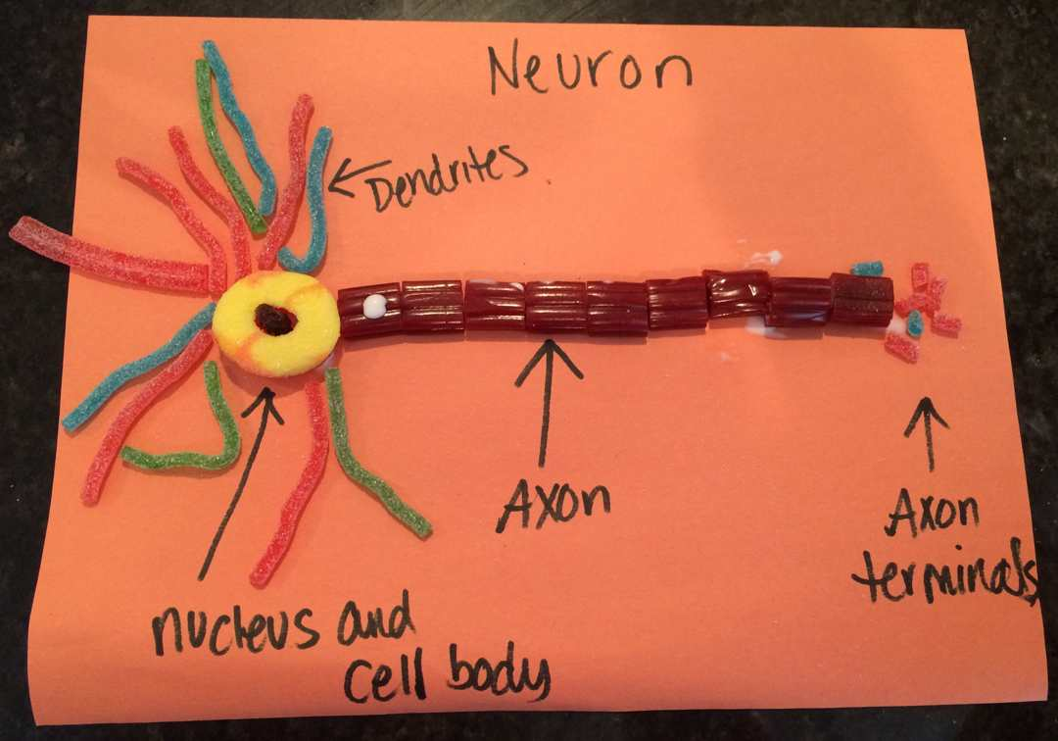 Bag-O-Brains
