**Links & Ways to Find Things Shared**

**(Page #3)**

**Other Activities Shared:**

(*Some images are from my classroom and others from Google Images. Directions and more information can be found on Pinterest)

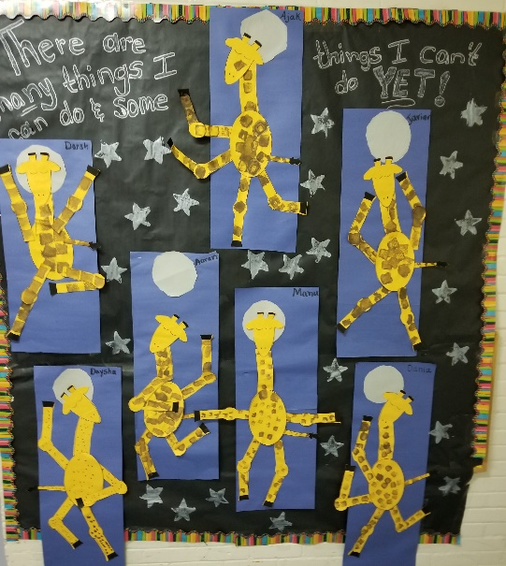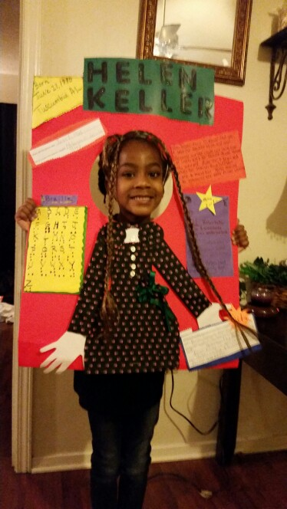

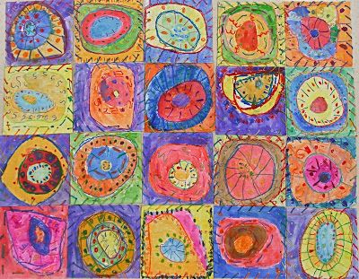

**Molly Curren**

**E.S.L. Teacher**

**North Attleboro Public Schools**

**Work: (508) 643-2148 Cell: (508) 212-7191**

**Email:** [**mcurren@naschools.net**](mailto:mcurren@naschools.net)

[**mcurren275@comcast.net**](mailto:mcurren275@comcast.net)

