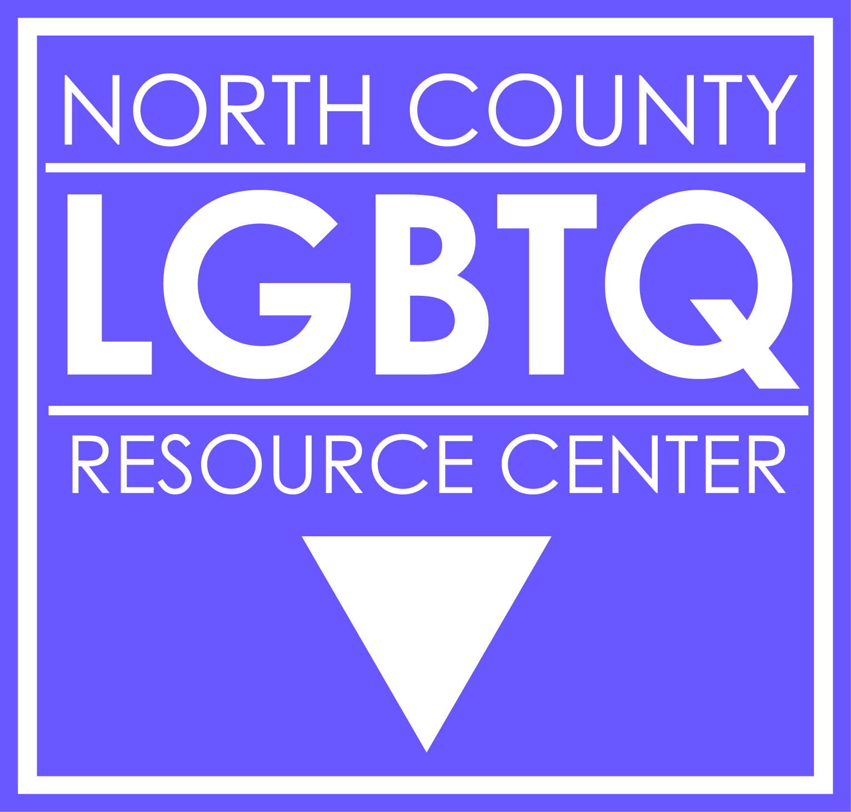

LGBTQ Students
Protocol for Inclusive and Affirming Schools

- LGBTQ Competency Training: for all staff - classified, certificated and administrators.

- Visibly Supportive Staff: stickers or badges for staff who have received competency training and wish to make their support of LGBTQ youth clear.

- Facilities and programs access: facilities and programs should accessible to all in alignment with student’s gender identity and CA laws. Gender neutral restrooms should be available and accessible to all students.

- Name/Gender Marker Changes: name/gender marker change forms should be aligned with CA laws to protect privacy of students. Forms should be easily used and understood by students and staff.

- Curriculum Inclusion: implementation of LGBTQ inclusive curriculum in all grades that adheres to the local/state/federal education laws. (Fair, Accurate, Inclusive and Respectful Act; California Healthy Youth Act)

- Dedicated Staff: One district level staff dedicated to being point person for all issues related to LGBTQ students.

- School Libraries: will have books that reflect the LGBTQ community, are tagged and catalogued as such so they can easily be searched and found by students and staff.

- Bullying Policies: enumerated anti-bullying and non-discrimination policies. Review and update policies to specifically list protections based on sexual orientation, gender identity and gender expression

- Reporting Incidents of Bullying: District policy that is easily understood by students, staff and parents. The use of PBIS or restorative justice-type approaches used to curb future bullying incidents

- Access to LGBTQ-Inclusive Electronic Resources: Ensure that school computers have not blocked access to organizations that provide helpful and necessary resources for student and staff (i.e. The Trevor Project, PFLAG, GLSEN, GSA Network, etc.)

- LGBTQ-Inclusive Clubs: Empower and support student led LGBTQ-inclusive clubs (GSAs, etc.) at all secondary schools

