Framework of Modalities
Modes | Types | Definition/Explanation | Write some Examples from Video (if Applicable)
Verbal | Languaging:  Translanguaging  Monolingual | Flexibly embedding features of multiple named languages in one’s speech.  Parallel monolingual conversations; Maintaining the use of English or Spanish throughout bilingual interactions.
 | Sentence type:  Command, Question  Statement | Teachers, presenters, or peers using a command, question, or statement in their verbal interactions.
 | Sound verbalization | Presenter creates sounds to accompany their actions.
 | Initiator/Responder | Initiating or respond to verbal prompts.
Visual | Gaze | Eliciting joint attention, or directing one's own attention to an object or an inattentive person.
 | Print | Interaction with print.
 | Image | Interaction with images in the form of pictures, photos, drawings, etc.
Action | Manipulation of object:  Holding, Demonstrating  Enacting | Physical movement of artifacts.
 | Facial Expression
 | Gesture | Hand movements or facial expressions that are used to signify or expand upon the current action or situation.
 | Spatial movement | Movement from one area to another (e.g., kitchen, table, closet, floor; as well as layout, distance)

Characteristics/Features of Objects
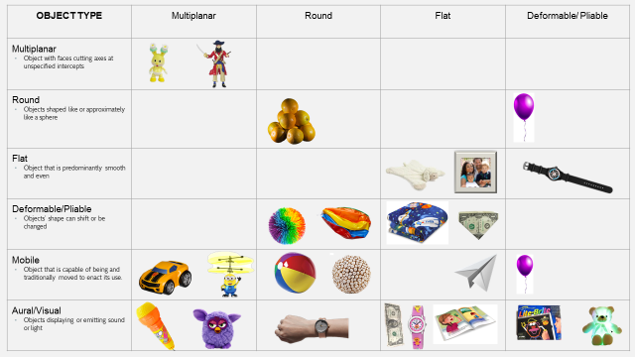
Identify the characteristics/features of your objects:

