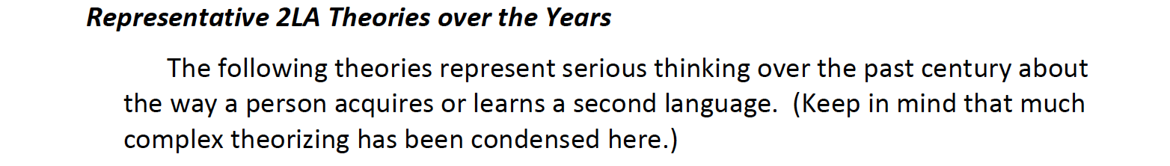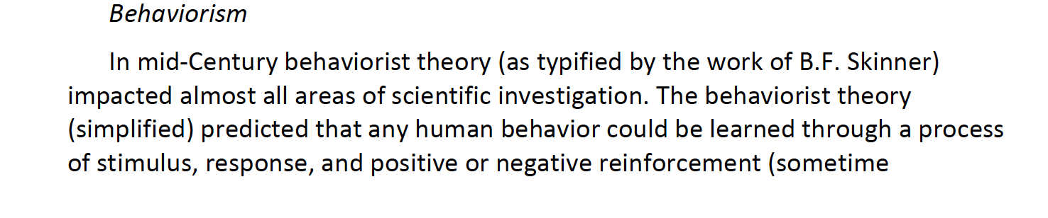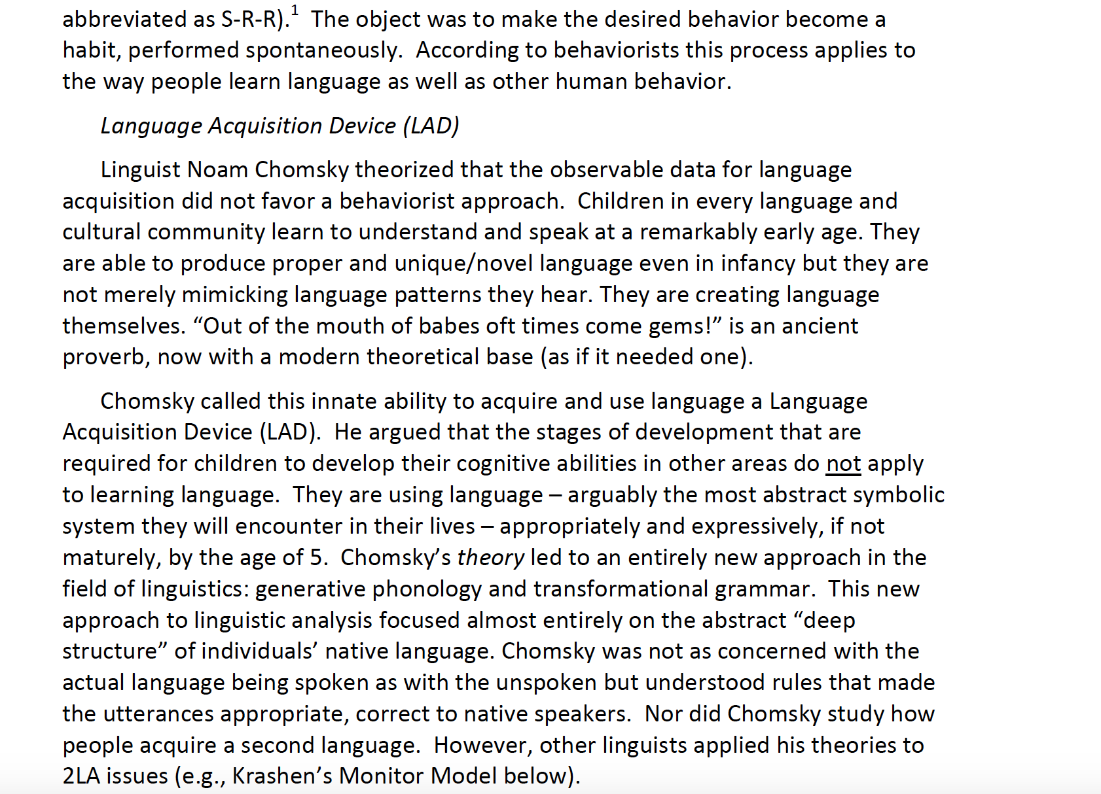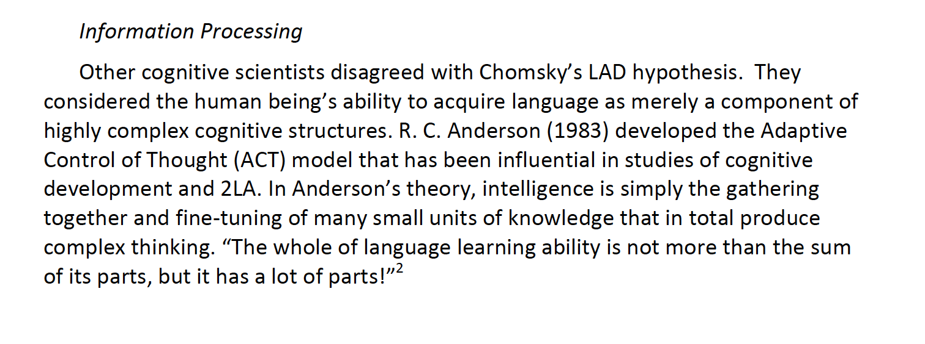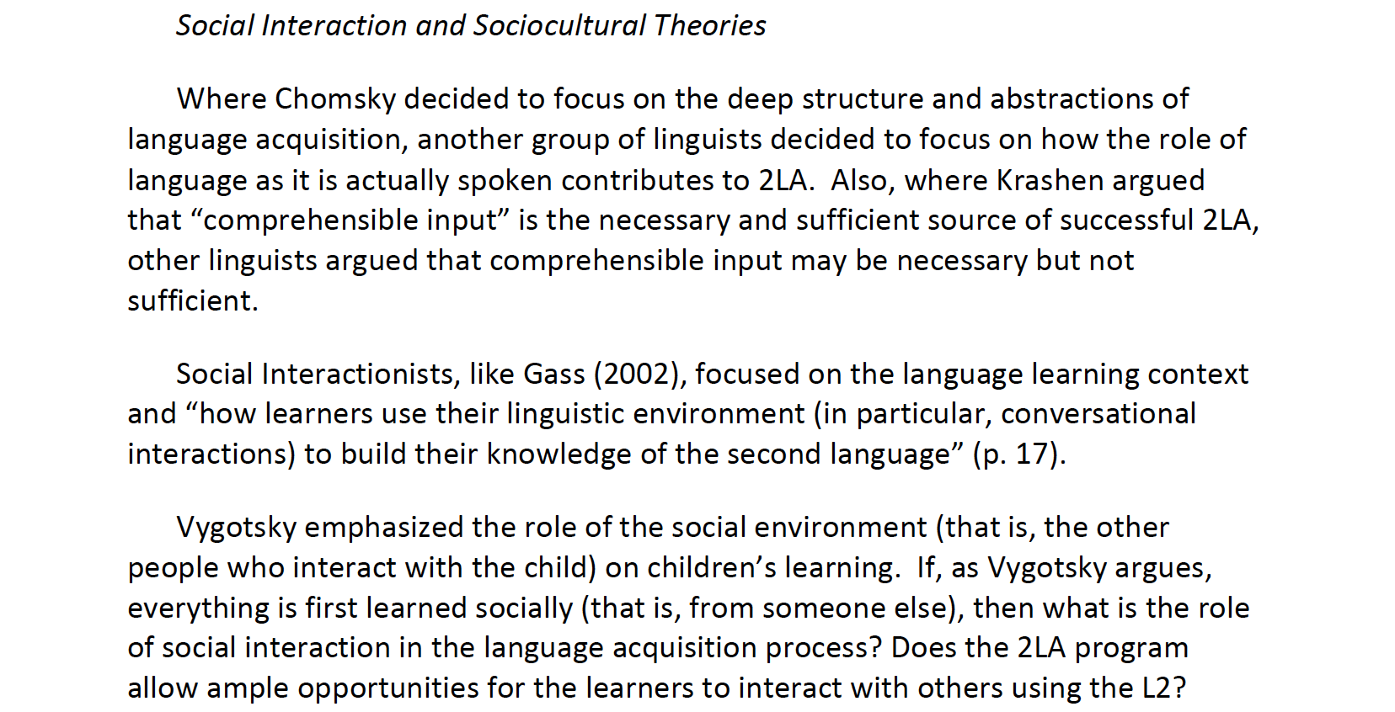

**Reference**

Malone, D. (2012). Theories and research of second language acquisition. *Reading for day 2, Topic SLA Theories*.

The whole text is a direct quotation from this reference.