"Seeds for Communication" ESL Curriculum Unit Overview: Group Experiences and Language Goals

(Note, this Overview of the "Seeds" is longer and more detailed than the "Digested Overview;" again, it is an "ideal" view of the project; not all elements of the following were implemented in the pilot project, due to time constraints. The pacing of this allows more time for scaffolding activities.)

This unit is distributed throughout the school year, with an average of 3 lessons per month. Activities coincide with the fall and winter (planning) stages and the spring (implementation) stage of garden creation. The Unit is intended to be complementary to the existing curriculum for ELLs, giving an opportunity for contextualized language use and academic vocabulary spanning ELA, Social Studies, and Sciences. It provides opportunities for student choice and agency within a project learning approach, starting from the broad question, "What is the connection between myself, seeds, culture, and agriculture? How can a garden express who I am?"

The Unit's CEPA (Curriculum Embedded Performance Assessment) foresees participation in an end of year garden dedication, with presentation of individual projects that may involve photos with captions, readings of oral histories, video documentation, and presentations of personal research into seeds, food cultures, and urban and rural farming traditions.

Sentence-level skills addressed in this unit include use of pronouns, prepositional phrases, verb tenses, including active and passive verbs; discourse level skills include signal words for sequencing in writing, and oral/written skills for interviewing and transcribing, summarizing, sequencing, analyzing, presenting, and persuading. Real life language applications are addressed through lessons on planning and budgeting, letter writing, and publicity. Technology integration includes video-recording in Seesaw and I-movie.

Writing through LEA, the Learning Experience Approach (group writing following a lived experience) is used to catalyze both use of target vocabulary and group recognition ("noticing") of rules for grammar and syntax, and expressive sentence and paragraph construction. Students are given a rubric for expectations of use of target language structures, and pre-prepared vocabulary and grammar sheets as a reference throughout the unit. For vocabulary, an emphasis on word families -- different forms of target words -- is intended to exercise elasticity in usage and sentence construction.

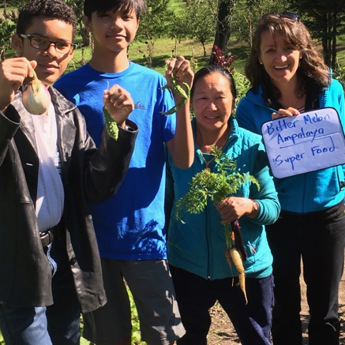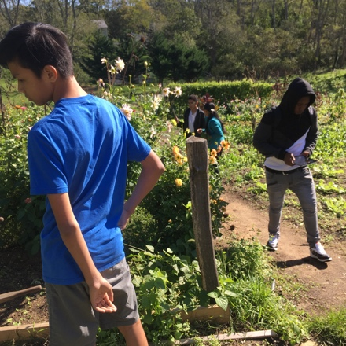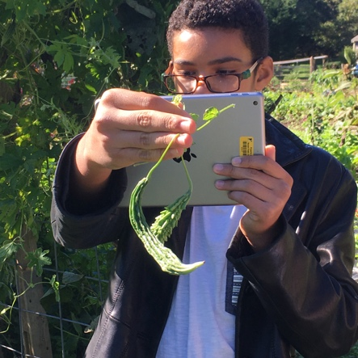

(Students exploring and documenting experience at Down Home Farm, Truro, guided by Francie Randolph, Executive Director of Sustainable Cape, and Digree Bhala, farmer.)
1. Introduction to Curriculum Unit: Food, Seeds, and You
Speaking: Students use picture dictionaries or Google Images to discuss names of common fruits and vegetables. They identify fruits and vegetables that are typical in their home countries.
Second Hour: Explain Project Learning, and discuss guiding questions for the Unit: "What is the connection between myself, seeds, culture, and agriculture? How can a garden express who I am?" Students watch and discuss ten-minute TED Talk: A Guerilla Gardener in South Central L.A./Ron Finley.
Handout and discuss materials for the Curriculum Unit, including rubric for final project and summary of Language Objectives and target vocabulary.
Key Vocabulary: names of vegetables in English and other languages; from video: defiant, Councilman, Dialysis, Sustain/Sustainability/Sustainable, Pride, Honor, "ecolutionary," "food desert," "flip the script"

2. Listening Comprehension: Survival and Sustainable Farming
Students view and discuss videos about Puerto Rican Hurricane, self-sufficiency and farming
Second video: introduction to the organization, "Sustainable Cape " and its support for local farmers, including Truro's Nepalese farmers, Digree and Bhala Rai.
Language objective: Form questions with Who/What/Where/When/Why/How
Key vocabulary: self-sufficient, non-profit, volunteer, organic, global warming, climate, region,
Caribbean

3. Field Trip: Questioning, note-taking, and photographic documentation of a visit to a local farm. Students visit the Down Home Farm, organically operated by Nepalese farmers Digree and Bhala Rai, in Truro) and a local farm-to-table restaurant (Flying Fish, Wellfleet.)
Language Objective: Oral questioning/written notetaking
Key Vocabulary: compost, rotation, species, variety, fertility, humus, nutrition

4. LEA Group Writing: brainstorming for details. Students pool their learning about local farms, farm-to-table restaurants, and the local economy. They choose individual focuses for paragraph writing, to contribute to a newspaper article about their field trip.
Language Objective: recounting, recording details in words and phrases. Grammar: review/practice reported versus direct speech for quotations
Key Vocabulary: (review of previous)
Tech Skill: Using Thesaurus.com to find descriptive adjectives for sharpening detail

5. LEA Group Writing: Writing paragraphs, main ideas and details. Individually, students write paragraphs for the body of an article about their field trip; they study a "column" for structuring an expository article, then together, they write an introduction and a conclusion.
Language Objective: To review and use a template for expository writing. Generating main ideas for paragraphs.

6. Listening Comprehension: What is culture? Students examine a specific culture through a video (Wampanoag traditional and modern culture of Cape Cod). They prepare for an oral history assignment to learn more about food and agriculture in their own home countries.

7. Oral History Class Reports Students bring in their oral history research about traditional recipes, foods, and agriculture, and collate information in a chart. What crops could we try to grow together on Cape Cod? What are the requirements of each plant?
Students view a video about greenhouse growing techniques, hydroponics, season extension, temperature and day-length requirements for different plants. They study Cape climate statistics, including average last and first frost dates. What provisions would be necessary to grow Puerto Rican, Philippine, or Jamaican crops in Cape Cod?
Key Vocabulary: plant periodicity, climate, average temperature range, plant tolerance, plant stress
Language Objectives: Listening and notetaking. Grammar review: passive construction

8. Writing: Letter Writing workshop (Using community resources through communications skills). Students write letters to obtain information about growing their traditional vegetables from Cunamesset Farms (a farm with Jamaican employees and a focus on Jamaican cuisine), Cooperative Extension, or Master Gardeners.
Language Objective: Organizing a letter with a heading, date, text body and salutation.

9. Interviewing to Seek Inspiration: What can we learn about social change and cultural diversity and pride from a noted community farm activist? Students view a video interview with Karen Young Washington, who started the Bronx's Familia Verde Community Garden and farmer's market to correct "food apartheid." They formulate interview questions, then have a video conference with the activist. Objective: to understand how conviction leads to action that involves structuring a project and budget.
Target Vocabulary: Activist, activism, stakeholders, fundraising, "food desert," "food apartheid," affordability, access, budget, spread-sheet.
Language Objective: listening, Interviewing and notetaking

10. LEA Group Writing: Students together brainstorm a topic sentence and introductory paragraph for an article about Karen Young Washington, then break out in pairs to brainstorm details and write paragraphs for the body of an article about her.
Language Objective: Writing skills: expressing main ideas, enhancing detail with adjectives and adverbs. Adding sequencers.
Key vocabulary: recycling of previous vocab.

11. Technology: Using I-movie for Documentation of Experience. Use Seesaw for blogging. Students make short videos of the empty garden space to document its condition. They record their own voice overs or group conversation to assess measures needed to improve the garden space. Then they pool their video footage to shape a short I-movie, experimenting with captioning and voice-over.
Use Seesaw to upload video to a class blog,
"Language Diggers"
Language Objective: captions, transitions, voice-over

12. Field Trip to Middle School Greenhouse/visit to culinary program at Nauset Regional High School. Student interviews: Learning about greenhouses, hydroponic technologies and season extension. Learning about importance of cultural knowledge in the kitchen.
Language Objective: Questioning and notetaking
Key Vocabulary: Hydroponic, season extension, saturate/saturation, aeration/drainage (of soil)/sterile potting soil/pathologies

13. Team and Individual Planning. Planning a group garden project and final outdoor event. Planning modalities of publicity for the event. Defining individual interests and possible individual contributions to the group project.
Advance practice with video-documentation, using classmates as interview subjects. Students make short videos, asking and answering the questions: "What is your previous experience with producing food? How do you feel about it? Is it an activity for others or can you imagine doing it yourself? What could be fun about it? What would make it interesting for you?" Students learn to use SeeSaw for class blog "Language Diggers" to share information/experience/research, photos and videos.

14. Field Trip to Middle School Greenhouse -- Plant Propagation Workshop: Cuttings, Grafting, and Seeds. Students create planting pots for their seedlings using recycled newspaper; they plant their seeds. Then they experience other means of plant propagation: Cuttings, tubers or rhizomes, and tree grafting. They learn the difference between sexual and asexual plant reproduction. They set up a camera and tripod to record growth of their seedlings in slow motion.
Language Objective: Interviewing skills and note-taking. Summarizing experience (Students make videos of each other, interviewing about plant propagation techniques.)
Key Vocabulary: cuttings, grafting, root-stock, scion wood, rooting hormone, sexual and asexual plant reproduction

15. LEA Writing: Students compose an introductory paragraph for an expository article about their plant propagation workshop. In pairs, they write paragraphs for the body of the article, then share. Together, they compose a closing paragraph.
Homework: Students use portions of the article as voice over, together with video footage, to compose an I-movie about the field trip.
Language Objective: Expository essay structure, combining descriptive language with images.
Key Vocabulary: recycling vocabulary about plant propagation.

16. Garden Making: Outdoor Work Day, Planning and Design -- Students and volunteer groups (Food Forest Initiative, Nauset Garden Club) work together to lay the groundwork for a garden: cardboard mulch to smother weeds, wood mulch, and compost windrows. (Materials distributed by hand using wheelbarrows.) Chosen mushroom inoculants are applied to wood mulch. During a break for potluck lunch, students and volunteers discuss the nature of a volunteer organization, and the relationship between design, action, and reflection.
Students document the event with photos and video recordings.
Language Objective: Analysis of Action Cycle
Key Vocabulary: synergy/synergic, "Nesting Functions", mulch/mulching, inoculate/inoculation, Fungus, Spores, Mycelia, Decompose/Decomposition, Aerobic/Anaerobic, Soil Flora and Fauna, "sweat equity"

17.Seeding and Transplanting: Outdoor Work Day
Students transplant their seedlings into the garden. They plant a Wampanoag "Three Sisters" polyculture garden (corn, squash, beans). They reflect on the difference between monoculture and polyculture plantings. They document the workday with photos and video recordings.
Language Objective: Differentiate simple past and present perfect use and structure
Key Vocabulary: planting distances, drip irrigation, water pressure, water conservation, soil moisture, retain/retention

18. LEA Writing: Individually, students express what interested them most about the two garden work days. The group develops introductory paragraphs based on each student's interest, at "stations" using poster paper. At each station, students help each other develop 2-3 paragraph topic sentences to guide writing for the body of an essay. Students may choose either a narrative or expository structure.
Language Objective: Narrative or Expository structuring of ideas based on experience.
Key Vocabulary: Review of previous (Quizlet)

19. Field Trip to Cunamesset Farms: Food and Culture Revisited, Key Question: "What is the connection between myself, seeds, culture, and agriculture? How can a garden express who I am?"
Key Vocabulary: Integrity, Accomplishment, Priority/prioretize, Enthusiastic/enthusiasm, authentic, standards

20. Individual Projects -- Students get assistance in realizing their individual contributions/final graded presentations as part of the CEPA (Curriculum Embedded Performance Assessment). Assistance consists of reflection on chosen focus, selection and ordering of content, and mode of presentation.

21. Individual Projects -- Students work independently on their individual projects.

22. Presentation/Assessment of Individual Projects and Group Planning for final event.

22. Presentations in garden

