MATSOL May 29, 2019 Framingham
Collaborative Responsive Teaching: Implications for Bilingual Learners, Teachers, and Researchers
Presenters: Maria Geueke, Theresa Austin, & Hatice Celebi

Context of Scenario #1 3rd Grade English Language Learners - Transitional ESL Class WIDA Levels 3-5

 | Racial & Cultural Identities | Linguistic Background | Familial and class background
Gabriel | Puerto Rican | Home languages are Spanish and AAVE/Puerto Rican English | Low socioeconomic background. Family qualifies for food stamps. Mother doesn’t always understand use of AAVE and coloquial varieties of her sons. She values her sons learning Spanish and fears her sons wanting to assimilate into White European culture. Lives with mother, stepfather, and four brothers and a younger sister.
Olivia | Puerto Rican and White | Doesn't understand Spanish and knows perhaps one or two words.  Struggles in reading and writing in English with WIDA levels emerging with high levels of oral/aural language (listening and speaking expanding) | Low socioeconomic background.Little time spent with paternal father who is Puerto Rican and speaks Spanish and who has been in jail since Olivia was two. Olivia lives with White monolingual English speaking mother and biracial transgender brother.
Leonardo | Puerto Rican | Home languages are Puerto Rican English and colloquial Spanish and English, although he knows only a few phrases in Spanish. | Low socioeconomic background.His paternal dad speaks Spanish and sibling speak Puerto Rican English with some knowledge of Spanish. Sister is in 6th grade whose teacher identifies her as having a lot of behavioral issues. L lives with his brothers and sister with a foster parent.

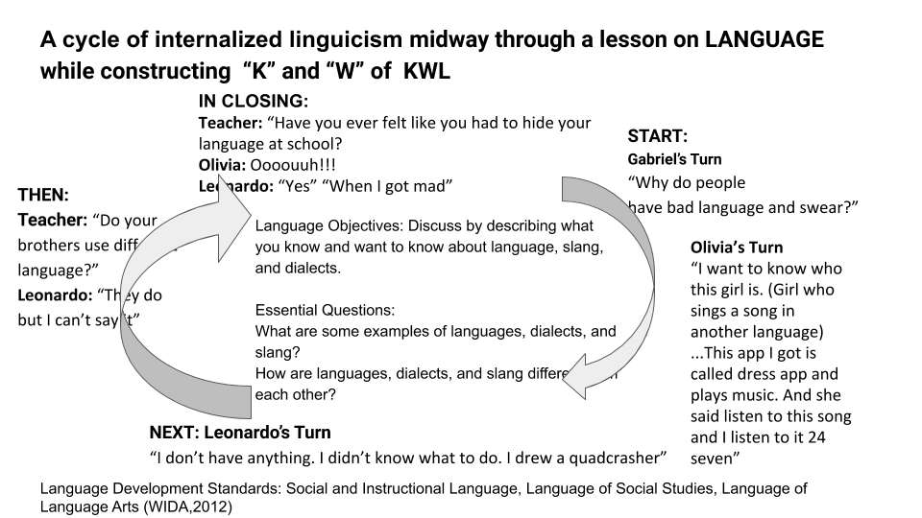

Context of Scenario #2 12th Grade English Language Learners - Foundational ESL Class WIDA Levels 2-3

 | Racial & Cultural Identities | Linguistic Background | Family and Class background
Leonel | Afro Puerto Rican | Home languages: Spanish and AAVE/Puerto Rican English. Spanish and English oral and aural levels both high and reflect developed bilingualism. No formal education to develop any literacy levels in Spanish and literacy levels in English low. WIDA levels. Presumed to be SLIFE but not formally recognized & Special needs identified by Special Ed team. | Family on food stamps. Absent paternal father is African American,  L is third oldest sibling with parental responsibilities for younger siblings including Jeremiah.  Father of two girls and one baby girl.
Jeremiah | Puerto Rican, | Home languages: Spanish and AAVE/Puerto Rican English. Spanish aural levels much higher than speaking.Presumed to be SLIFE but not formally recognized & Special needs identified by Special Ed team. | Younger brother of L. J says he should help L answer if he doesn’t respond in class.

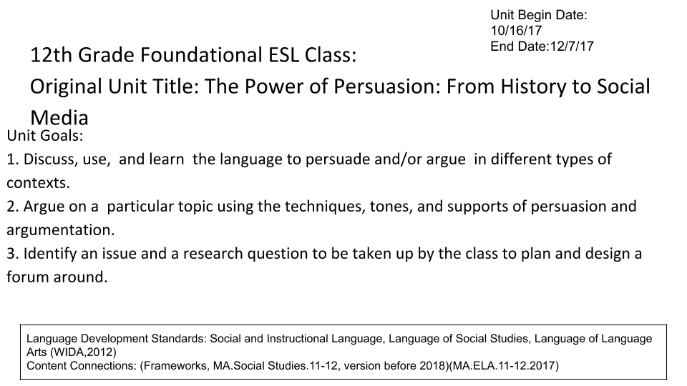

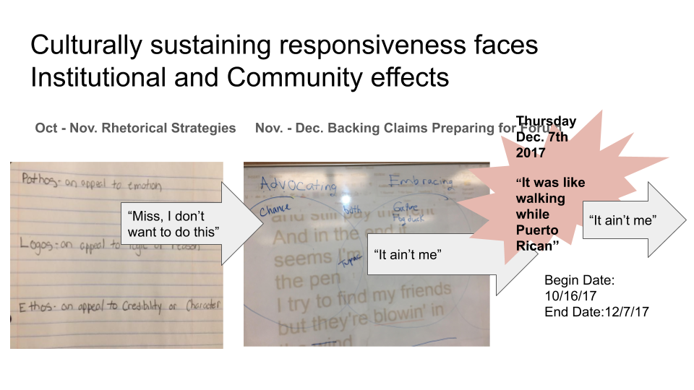
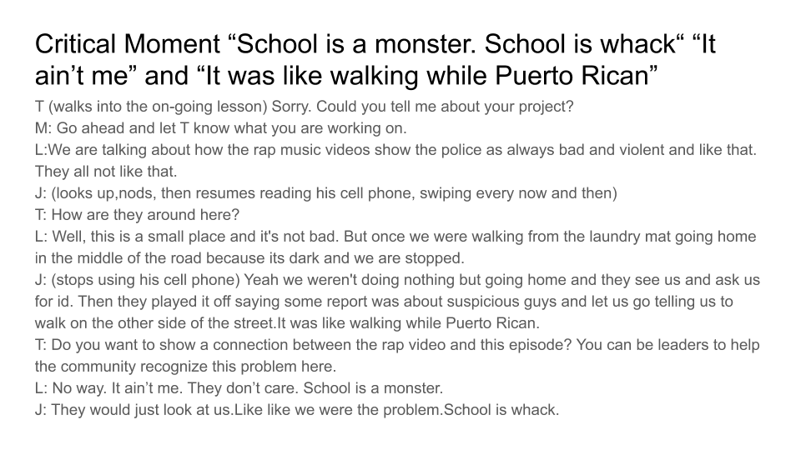

Context of Scenario #3- SLIFE/Turkey/University

SLIFE

“Students with Limited or Interrupted Formal Education (SLIFE) "are English language learners who have experienced interrupted education due to war, civil unrest, migration, or other factors; who have never had the opportunity to participate in any type of schooling before entering school in the United States; or who have experienced limited education in their home countries due to lack of resources or trained teachers, the type of schooling they participated in, or other circumstances." (DeCapua & Marshall, 2010)”.
Source: https://www.matsol.org/slife-resources
An extension of disengagement
From an interview with a language teacher about SLIFE, Turkey, University Level
I: In terms of language teaching pedagogies and practices, do you get requests or comments from SLIFE about how to teach them better ?
T:These students are usually not the type of the students who would ask for a request or raise a comment. [they are] reserved, ...housing, working and providing for their families; they are silent., sit at the back; they do not bring any comments or concerns.
*I: Interviewer , T: Teacher
Resource List for Addressing Long term Institutional Effects on Multilingual Learners

Collaborative Responsive Teaching: Implications for Bilingual Learners, Teachers, and Researchers
Presenters: Maria Geueke, Theresa Austin & Hatice Celebi
MATSOL May 29, 2019

Organizations

National Association for Bilingual Education
http://www.nabe.org/

National Association for Multicultural Education
https://www.nameorg.org/

Multistate Association for Bilingual Education
https://www.massmabe.org/

Articles

Young, V. (2004). Your Average Nigga. College Composition and Communication, 55(4), 693.

Books

Banaji, M. R., & Greenwald, A. G. (2013). Blindspot : hidden biases of good people. Delacorte Press.

Casanova, U. (2010). ¡Sí se puede! : learning from a high school that beats the odds. Teachers College Press.

De Jong, E. (2011). Foundations for multilingualism in education: From principles to practice. Caslon Publishing: Philadelphia, PA.

Emdin, C. (2016). For White folks who teach in the hood ... and the rest of y’all too : reality pedagogy and urban education. Beacon Press.

García, O., Johnson, S. I., & Seltzer, K. (2017). The translanguaging classroom: Leveraging student bilingualism for learning.

Morrell, E. (2013). Critical media pedagogies: Teaching for achievement in city schools. New York: Teachers College Press.

Sue, D. W. (2015). Race talk and the conspiracy of silence : understanding and facilitating difficult dialogues on race. Wiley.

