HAND OUTS

Addressing local/global literacies and cultures in Bogotá in Teacher Education
Amparo Clavijo Olarte PhD
Universidad Distrital Francisco José de Caldas
aclavijoolarte@gmail.com

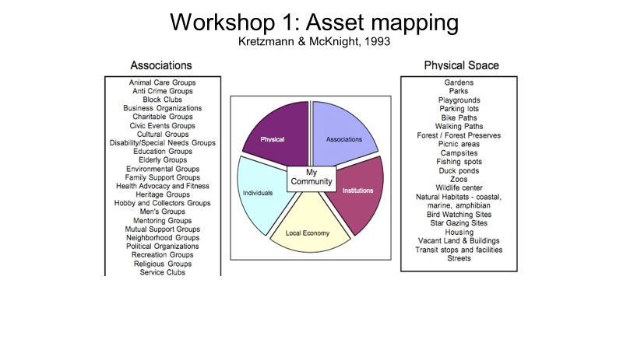
References
Bartolome, L. (2004). Critical Pedagogy and Teacher Education: Radicalizing Prospective Teachers. Teacher Education Quarterly, Winter, 97-122.
Cochran-Smith, M., Ann Marie Gleeson, and Kara Mitchell (2004). Teacher Education for Social Justice: What’s Pupil Learning Got To Do With It? Berkeley Review of Education. 1 (1), pp. 35-61
Dantas-Whitney, M. & Eileen Dugan Waldschmidt (2009) Moving Toward Critical Cultural Consciousness in ESOL and Bilingual Teacher Education, Bilingual Research Journal, 32:1, 60-76, DOI: 10.1080/15235880902965888
Darder, A. (2016) Critical Leadership for Social Justice: Unveiling the Dirty Little Secret of Power and Privilege.

Johnson, K. & Golombek, P. (2011), (Eds). Research on Second Language Teacher Education: A Sociocultural Perspective on Professional Development. New York: Routledge

Lopez-Gopar, M. (2016). Decolonizing Primary English Language Teaching. London: Multilingual Matters.
López-Gopar, M. (2018) (Ed.) International Perspectives on Critical Pedagogies in ELT. Gewerbestrasse, Switzerland: Palgrave, Macmillan
Mejia, MR (2011). Educaciones y Pedagogías Críticas desde el Sur. La Paz, Bolivia: Ministerio de Educación.
Ministerio de Educación Nacional 2006a. Educación: Visión 2019. Bogotá: MEN.
Ministerio de Educación Nacional 2006b. Estándares básicos de competencias en lenguas extranjeras: Ingles. [Basic standards of competences in foreign languages: English.] Bogotá: Ministerio de Educación. https://www.mineducacion.gov.co/1759/w3-article-115174.html

Sharkey, J. Clavijo-Olarte, A & Ramirez, M. (2016). Developing a deeper understanding of community-based pedagogies with teachers: Learning with and from teachers in Colombia. Journal of Teacher Education. 67 (4), pp. 306-319.

Shor, I. & Freire, P. (1987). A Pedagogy for Liberation: Dialogues on Transforming Education. London: Bergin & Garvey.
Velez-Rendon, G. (2002). Second Language Teacher Education: A Review of the Literature. Foreign Language Annals. 35, 4. Pp. 457-467.

