Word Bank of Adjectives to Classify Insects

Color Words | Size Words | Shape Words | Number Words | Detail Words
yellow  green  brown  orange  red  black  white | little  tiny  long  thin | round  triangular  oval  worm-like 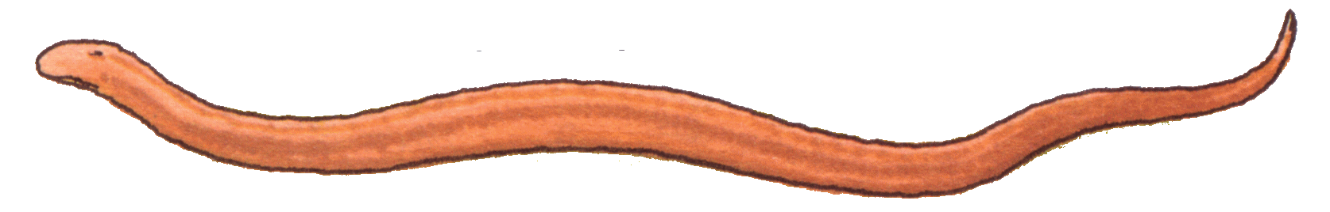 | one 1  two 2  three 3  four 4  five 5  six 6 | slimy  shiny  spotted  creepy
-ing words that can be used to describe

wiggling flying crawling curling
