
English Learner Progress Record (Grades 3-5) | Levels 2→3 | Listening

Name: Grade:
U.S. School  Start Date: |  | Progress Record  Start Date:

 | CVC Criteria | Listening | Date | Can-Do # | Topic | I need to work on …
To get to Level 3, I need to … |  | 3.1 Follow directions.  3.2 Listen to an explanation and match it to a picture.  3.3 Match descriptions to illustrations.  3.4 Listen to a story and sort pictures. [Listen to an explanation and …]
  3 – Developing
  Complexity
  Series of related sentences
  Vocabulary
  General & some specific vocabulary
  Control
  Meaning overrides communication errors
 |  |  | Date | Can-Do # | Topic | I need to work on …
At Level 2 I can … |  | 2.1 Listen to descriptions and sort pictures.  2.2 Listen and arrange pictures.  2.3 Follow two-step directions.  2.4 Listen and draw pictures.  2.5 Listen to choices and express an opinion.
  2 – Emerging
  Complexity
  Phrases, short sentences
  Vocabulary
  High frequency vocabulary
  Control
  Language w/errors inhibiting communication
 | CVC Criteria | Listening | Date | Can-Do # | Topic | I need to work on …

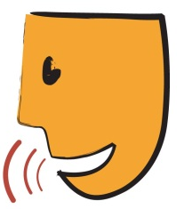
English Learner Progress Record (Grades 3-5) | Levels 2→3 | Speaking

Name: Grade:
U.S. School  Start Date: |  | Progress Record  Start Date:

 | CVC Criteria | Speaking | Date | Can-Do # | Topic | I need to work on …
To get to Level 3, I need to … |  | 3. 1 Answer questions about [school subjects]  3.2 Re-tell stories/events.  3.3 Listen to stories/ explanations and make predictions.  3.4 Listen to stories/ explanations and guess why things happened.  3.5 Offer solutions to social conflicts.  3.6 Make presentations.  3.7 Solve problems.
  3 – Developing
  Complexity
  Series of related sentences
  Vocabulary
  General & some specific vocabulary
  Control
  Meaning overrides communication errors
 |  |  | Date | Can-Do # | Topic | I need to work on …
At Level 2 I can … |  | 2.1 Ask everyday questions.  2.2 Restate facts about school topics.  2.3 Describe [people, events, objects, or people].  2.4 Talk about yourself with other students.
  2 – Emerging
  Complexity
  Phrases, short sentences
  Vocabulary
  High frequency vocabulary
  Control
  Language w/errors inhibiting communication
 | CVC Criteria | Speaking | Date | Can-Do # | Topic | I need to work on …

English Learner Progress Record (Grades 3-5) | Levels 2→3 | Reading

Name: Grade:
U.S. School  Start Date: |  | Progress Record  Start Date:

 | CVC Criteria | Reading | Date | Can-Do # | Topic | I need to work on …
To get to Level 3, I need to … |  | 3.1 Interpret data from charts and graphs.  3.2 Identify main ideas and some details.  3.3 Sequence events in stories [articles, explanations, historical accounts].  3.4 Use context clues and illustrations to figure out the meaning of words or phrases.
  3 – Developing
  Complexity
  Series of related sentences
  Vocabulary
  General & some specific vocabulary
  Control
  Meaning overrides communication errors
 |  |  | Date | Can-Do # | Topic | I need to work on …
At Level 2 I can … |  | 2.1 Read texts with illustrations and identify facts and ideas.  2.2 Find changes to root words in sentences or stories.  2.3 Identify elements of stories [characters, setting, etc.]  2.4 Follow written directions. (visually supported)
  2 – Emerging
  Complexity
  Phrases, short sentences
  Vocabulary
  High frequency vocabulary
  Control
  Language w/errors inhibiting communication
 | CVC Criteria | Reading | Date | Can-Do # | Topic | I need to work on …

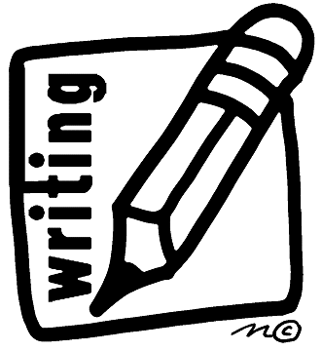
English Learner Progress Record (Grades 3-5) | Levels 2→3 | Writing

Name: Grade:
U.S. School  Start Date: |  | Progress Record  Start Date:

 | CVC Criteria | Writing | Date | Can-Do # | Topic | I need to work on …
To get to Level 3, I need to … |  | 3.1 Write stories or reports  3.2 Write sentences that go together  3.3 Write what is the same and different about two sets of information  3.4 Write about things or people or ways to do something
  3 – Developing
  Complexity
  Series of related sentences
  Vocabulary
  General & some specific vocabulary
  Control
  Meaning overrides communication errors
 |  |  | Date | Can-Do # | Topic | I need to work on …
At Level 2 I can … |  | 2.1 Make lists from labels or with other students  2.2 Finish or write sentences using word walls  2.3 Fill in graphic organizers, charts, and tables  2.4 Write a comparison about [some realia]
  2 – Emerging
  Complexity
  Phrases, short sentences
  Vocabulary
  High frequency vocabulary
  Control
  Language w/errors inhibiting communication
 | CVC Criteria | Writing | Date | Can-Do # | Topic | I need to work on …

