
English Learner Progress Record (Grades 3-5) | Levels 3→4 | Listening

Name: Grade:
U.S. School  Start Date: |  | Progress Record  Start Date:

 | CVC Criteria | Listening | Date | Can-Do # | Topic | I need to work on …
To get to Level 4, I need to … |  | 4.1 Listen to information and apply to a new situation.  4.2 Listen to an explanation and point out details on an illustration.  4.3 Listen to [a story, an explanation]  4.4 Listen about authors [scientists, etc.] and act out what you hear.
  4 – Expanding
  Complexity
  Moderate discourse
  Vocabulary
  Specialized and some technical vocabulary
  Control
  Language w/minimal errors
 |  |  | Date | Can-Do # | Topic | I need to work on …
At Level 3 I can … |  | 3.1 Follow directions.  3.2 Listen to an explanation and match it to a picture.  3.3 Match descriptions to illustrations.  3.4 Listen to a story and sort pictures. [Listen to an explanation and …]
  3 – Developing
  Complexity
  Series of related sentences
  Vocabulary
  General & some specific vocabulary
  Control
  Meaning overrides communication errors
 | CVC Criteria | Listening | Date | Can-Do # | Topic | I need to work on …

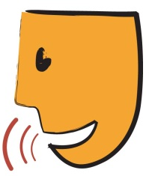
English Learner Progress Record (Grades 3-5) | Levels 3→4 | Speaking

Name: Grade:
U.S. School  Start Date: |  | Progress Record  Start Date:

 | CVC Criteria | Speaking | Date | Can-Do # | Topic | I need to work on …
To get to Level 4, I need to … |  | 4.1 Give reasons for an opinion.  4.2 Discuss stories, issues and concepts.  4.3 Give oral reports.  4.4 Compare solutions to a problem.  4.5 Compare and contrast [ideas from a subject].
  4 – Expanding
  Complexity
  Moderate discourse
  Vocabulary
  Specialized and some technical vocabulary
  Control
  Language w/minimal errors
 |  |  | Date | Can-Do # | Topic | I need to work on …
At Level 3 I can … |  | 3. 1 Answer questions about [school subjects]  3.2 Re-tell stories/events.  3.3 Listen to stories/ explanations and make predictions.  3.4 Listen to stories/ explanations and guess why things happened.  3.5 Offer solutions to social conflicts.  3.6 Make presentations.  3.7 Solve problems.
  3 – Developing
  Complexity
  Series of related sentences
  Vocabulary
  General & some specific vocabulary
  Control
  Meaning overrides communication errors
 | CVC Criteria | Speaking | Date | Can-Do # | Topic | I need to work on …

English Learner Progress Record (Grades 3-5) | Levels 3→4 | Reading

Name: Grade:
U.S. School  Start Date: |  | Progress Record  Start Date:

 | CVC Criteria | Reading | Date | Can-Do # | Topic | I need to work on …
To get to Level 4, I need to … |  | 4.1 Classify features of genres.  4.2 Choose the graphic organizer that matches a text.  4.3 Find details that support main ideas.  4.4 Distinguish fact and opinion.
  4 – Expanding
  Complexity
  Moderate discourse
  Vocabulary
  Specialized and some technical vocabulary
  Control
  Language w/minimal errors
 |  |  | Date | Can-Do # | Topic | I need to work on …
At Level 3 I can … |  | 3.1 Interpret data from charts and graphs.  3.2 Identify main ideas and some details.  3.3 Sequence events in stories [articles, explanations, historical accounts].  3.4 Use context clues and illustrations to figure out the meaning of words or phrases.
  3 – Developing
  Complexity
  Series of related sentences
  Vocabulary
  General & some specific vocabulary
  Control
  Meaning overrides communication errors
 | CVC Criteria | Reading | Date | Can-Do # | Topic | I need to work on …

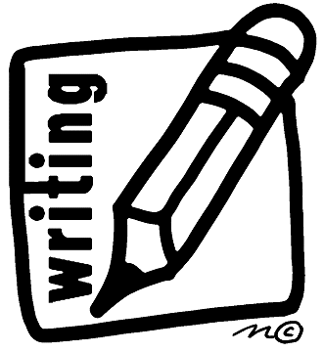
English Learner Progress Record (Grades 3-5) | Levels 3→4 | Writing

Name: Grade:
U.S. School  Start Date: |  | Progress Record  Start Date:

 | CVC Criteria | Writing | Date | Can-Do # | Topic | I need to work on …
To get to Level 4, I need to … |  | 4.1 Use graphic organizer to take notes  4.2 Summarize information about a subject  4.3 Write different kinds of texts  4.4 Tell how I solved a problem
  4 – Expanding
  Complexity
  Moderate discourse
  Vocabulary
  Specialized and some technical vocabulary
  Control
  Language w/minimal errors
 |  |  | Date | Can-Do # | Topic | I need to work on …
At Level 3 I can … |  | 3.1 Write stories or reports  3.2 Write sentences that go together  3.3 Write what is the same and different about two sets of information  3.4 Write about things or people or ways to do something
  3 – Developing
  Complexity
  Series of related sentences
  Vocabulary
  General & some specific vocabulary
  Control
  Meaning overrides communication errors
 | CVC Criteria | Writing | Date | Can-Do # | Topic | I need to work on …

