TITLE: Humanizing the CAEP Accreditation Process: Enacting Change from the Inside Out
Abstract:
To achieve or to renew accreditation, Educational Preparation Providers (EPPs) must generate a self-study report to the Council for the Accreditation Education Preparation (CAEP), proving that each of the CAEP standards is met. As such, this paper explores the author’s involvement in a self-study report for a graduate level literacy program and the resulting action research conducted to improve it. By examining the program through CAEP’s lens an inside-out view emerged, encouraging change with potential to improve access for candidates within the program. Specifically, it highlights three lessons learned which have potential to make writing future CAEP self-study reports a more seamless process.
Introduction
Accreditation is a means of quality assurance that indicates that a university/college and/or its programs has met and maintains a high level of standards established by accrediting councils and professional organizations. The Council for the Accreditation of Education Preparation (CAEP) is an “agency that accredits educator preparation providers (EPP)” that provide programs leading to teacher certification, licensure, or endorsement (CAEP, 2020, Letter C section). To achieve or to renew accreditation, EPPs must generate a self-study report, proving that each of the CAEP standards, listed below, is met.
- Standard RA.1: Content and Pedagogical Knowledge
- Standard RA.2: Clinical Partnerships and Practice
- Standard RA.3: Candidate Quality and Selectivity
- Standard RA.4: Satisfaction with Preparation
- Standard RA.5: Quality Assurance System and Continuous Improvement
- Standard RA.6: Fiscal and Administrative Capacity
My engagement in writing the self-study report led to an in-depth exploration of the literacy program, yielding valuable lessons. By focusing on three lessons learned and their implications for ongoing self-assessment, I, along with a colleague, now retired, recognized the importance of the alignment of assessments with standards and the need for a database of student exemplars. Furthermore, our involvement became an action research project allowing us to explore potential changes in the program structure to improve accessibility and promote continued accreditation. Three lessons learned and the actions we implemented are outlined below.
- Charting the waters. To determine the best matches for each criterion of the standards, we created a chart that listed the indicators of each standard and their corresponding courses. We included assessments as evidence to support how the program addressed each standard. Initially developed to assist in writing the self-study report, we realized that the chart could also be used for ongoing self-assessment and future accreditation processes. This lesson highlights the importance of organizing and aligning program components with accreditation standards for improved clarity and efficiency.
- Aligning each assessment with standards and grading scales. Though designed with the standards in mind, we failed to list them directly on assignment guidelines or rubrics. This lack of transparency became an issue, as candidates may not have been aware of the standards being assessed. To address this, we revised all assessment materials to include explicit references to both the CAEP standards and relevant professional organization standards, such as the International Literacy Association. This lesson emphasizes the importance of clearly communicating the alignment between assessments and standards to promote transparency and understanding among candidates and evaluators. Another major advantage of taking the time to do this on the front-end is that it should help streamline the next accreditation visit. Being able to speak to the association of the assessments with the CAEP standards without having to conduct an intensive search to match them should make the process smoother.
- Creating and maintaining a database of exemplar assessments. Throughout the process of working on the CAEP self-study report, my colleague and I had to support various components, (i.e., assessments) within our program and courses with exemplars, i.e., student work examples that demonstrated the mastery of specific literacy concepts. Or, as Newlyn (2013) describes, “past work completed by former students who have undertaken work of a specified quality” (p. 26). On the surface, this sounds relatively easy. Unfortunately, this was not the case as it became a labor-intensive task. Searching through three years of candidates’ work, looking for the perfect examples to showcase knowledge of a particular literacy concept and/or ability to apply it, took a great deal of time and attention to detail. To prevent this situation from happening again, we designed a method for identifying, storing, and retrieving student exemplars effectively. This lesson highlights the need for a systematic approach to curating and organizing exemplar assessments, which can save time and ensure the availability of quality examples for future accreditation purposes.
Centering on the application possibility afforded by the action research we conducted, these lessons represent practical insights gained through the self-study report process. They can provide valuable guidance for other educational programs seeking to meet CAEP standards and streamline their accreditation processes.
A More In-Depth Look at Lesson 1: Creating a Chart to Align Program Components with Accreditation Standards
A chart is an effective tool for visualizing the connections between program components and standards which, ultimately, helps to ensure comprehensive coverage. As a beginning point, I have outlined a step-by-step process to get you started:
- Identify the accreditation standards that apply to your specific program, e.g., CAEP Standards for Accreditation at the Advanced Level. These standards outline the criteria that needs to be met for accreditation.
- List the standards and their corresponding indicators in a table or spreadsheet (we used Google Sheets because of the real-time collaboration possibility) with columns representing each of the accreditation standards.
- Determine the associated program components that align with the accreditation standards, e.g., courses, assessments, and other relevant aspects. List these in the rows of the chart.
- Establish connections for the program components with the standards listed in the columns, identifying their correlation with the applicable standard by indicating their intersection with a checkmark, X, color coding, or any other visualization method that works for you.
- Include a column that allows you to provide evidence or documentation that supports the alignment between the program components and the standards, e.g., specific assignments, projects, course-based assessments, surveys, and syllabi. Not done initially, I also recommend including a column or row that indicates where the evidence or documentation is stored. Doing so will save you time in the long run.
- Review and update the chart in a timely and consistent manner. It should be a dynamic tool that evolves over time, reflecting changes (i.e., modifications or improvements) to your program and/or accreditation guidelines.
Initially, the chart served as a beginning point for a seemingly overwhelming task. It anchored us and gave us a place to start the accreditation process. In short time, we recognized that its true value was that of a visual aid for organizing and understanding the alignment between the accreditation standards and our program components. Beyond this, it also afforded the opportunity to identify areas of weakness or ones we needed to address more fully. Ultimately, the chart provided a clear overview of how our program met (or, in some cases, did not meet) the required standards.
Figure 1. Modified Chart Example
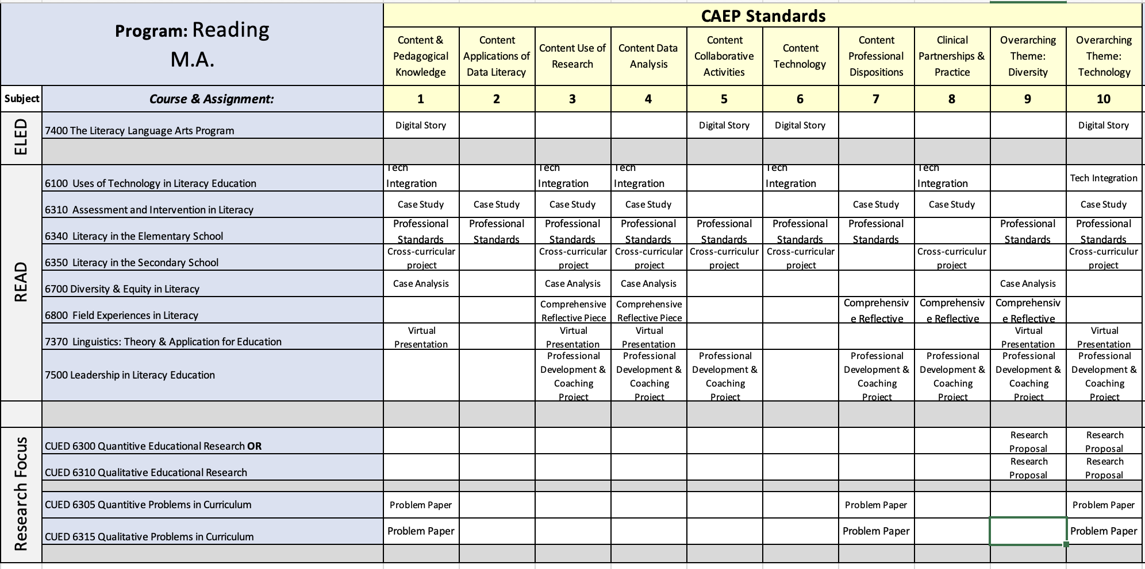
Conclusion
The presentation’s focus connected to the conference theme in several ways. First, it laid the groundwork for innovative and creative ways to meet CAEP standards, ensuring continued accreditation. Following this, by sharing successful strategies for positive change, the session, potentially, strengthened attendees’ insight into what it means to be a change agent. Beyond this, it provided an unobstructed view into the planning process for improving access and success to promote “higher education opportunities and success in completing degrees, certifications, and credentials that lead to a productive career in the workforce of today and the future” (ACHE, 2023 Call for Proposals).

References
Council for the Accreditation of Educator Preparation. (2020). Glossary.
http://caepnet.org/glossary?letter=C
Newlyn, D. (2013). Providing exemplars in the learning environment: The case for and against.
Universal Journal of Education and Research, 1(1), 26-32.

