
English Learner Progress Record (Grades 6-8) | Levels 1→2 | Listening

Name: Grade:
U.S. School  Start Date: |  | Progress Record  Start Date:

 | CVC Criteria | Listening | Date | Can-Do # | Topic | I need to work on …
To get to Level 2, I need to … |  | 2.1 Follow directions with more than one step  2.2 Listen and sort pictures  2.3 Listen and put pictures in order  2.4 Listen and find information on charts and tables
  2 – Emerging
  Complexity
  Phrases, short sentences
  Vocabulary
  High frequency vocabulary
  Control
  Language w/errors inhibiting communication
 |  |  | Date | Can-Do # | Topic | I need to work on …
At Level 1 I can … |  | 1.1 Follow one-step directions  1.2 Match everyday language to pictures  1.3 Point to things that my teacher says  1.4 Match school language to pictures
  1 – Entering
  Complexity
  Single words
  Vocabulary
  Most common vocabulary
  Control
  Memorized language
 | CVC Criteria | Listening | Date | Can-Do # | Topic | I need to work on …

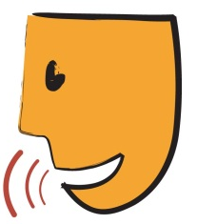
English Learner Progress Record (Grades 6-8) | Levels 1→2 | Speaking

Name: Grade:
U.S. School  Start Date: |  | Progress Record  Start Date:

 | CVC Criteria | Speaking | Date | Can-Do # | Topic | I need to work on …
To get to Level 2, I need to … |  | 2.1 Use everyday language to talk about school subjects  2.2 Tell main ideas from class  2.3 Use example sentences to describe situations.  2.4 Tell about things we do everyday  2.5 Tell what I need or want  2.6 Talk to friends  2.7 Ask for things
  2 – Emerging
  Complexity
  Phrases, short sentences
  Vocabulary
  High frequency vocabulary
  Control
  Language w/errors inhibiting communication
 |  |  | Date | Can-Do # | Topic | I need to work on …
At Level 1 I can … |  | 1.1 Answer yes/no and choice questions  1.2 Use words that are common  1.3 Repeat words and sentences  1.4 Answer who, what, when, where, and why questions
  1 – Entering
  Complexity
  Single words
  Vocabulary
  Most common vocabulary
  Control
  Memorized language
 | CVC Criteria | Speaking | Date | Can-Do # | Topic | I need to work on …

English Learner Progress Record (Grades 6-8) | Levels 1→2 | Reading

Name: Grade:
U.S. School  Start Date: |  | Progress Record  Start Date:

 | CVC Criteria | Reading | Date | Can-Do # | Topic | I need to work on …
To get to Level 2, I need to … |  | 2.1 Put pictures in order based on text  2.2 Find main idea in a sentence  2.3 Find information from text features  2.4 Follow along while listening  2.5 Sort words and phrases  2.7 Use words I know to finish sentences  2.8 Use my home language to help learn English.  2.9 Use bilingual dictionaries and glossaries.
  2 – Emerging
  Complexity
  Phrases, short sentences
  Vocabulary
  High frequency vocabulary
  Control
  Language w/errors inhibiting communication
 |  |  | Date | Can-Do # | Topic | I need to work on …
At Level 1 I can … |  | 1.1 Know that letters and sounds match to things  1.2 Match school things to words  1.3 Find everyday signs and words  1.4 Find author and illustrator  1.5 Find one-word answers to who, what, when, and where questions in a story  1.7 Use picture dictionaries
  1 – Entering
  Complexity
  Single words
  Vocabulary
  Most common vocabulary
  Control
  Memorized language
 | CVC Criteria | Reading | Date | Can-Do # | Topic | I need to work on …

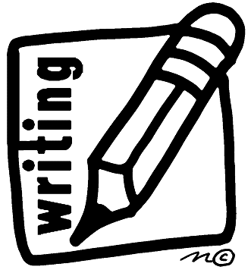
English Learner Progress Record (Grades 6-8) | Levels 1→2 | Writing

Name: Grade:
U.S. School  Start Date: |  | Progress Record  Start Date:

 | CVC Criteria | Writing | Date | Can-Do # | Topic | I need to work on …
To get to Level 2, I need to … |  | 2.1 Finish pattern sentences  2.2 Finish sentences with my own ideas  2.3 Put sentences together  2.4 Finish graphic organizers with information about me  2.5 Answer yes or no to who, what, when, where, and why questions
  2 – Emerging
  Complexity
  Phrases, short sentences
  Vocabulary
  High frequency vocabulary
  Control
  Language w/errors inhibiting communication
 |  |  | Date | Can-Do # | Topic | I need to work on …
At Level 1 I can … |  | 1.1 Draw pictures about ___________  1.2 Use common words  1.3 Label pictures and graphs  1.4 Make vocabulary cards  1.5 Write lists from word banks
  1 – Entering
  Complexity
  Single words
  Vocabulary
  Most common vocabulary
  Control
  Memorized language
 | CVC Criteria | Writing | Date | Can-Do # | Topic | I need to work on …

