
English Learner Progress Record (Grades 6-8) | Levels 2→3 | Listening

Name: Grade:
U.S. School  Start Date: |  | Progress Record  Start Date:

 | CVC Criteria | Listening | Date | Can-Do # | Topic | I need to work on …
To get to Level 3, I need to … |  | 3.1 Listen and tell what I think  3.2 Listen and tell main ideas and details  3.3 Listen and use strategies  3.4 Listen and sort examples
  3 – Developing
  Complexity
  Series of related sentences
  Vocabulary
  General & some specific vocabulary
  Control
  Meaning overrides communication errors
 |  |  | Date | Can-Do # | Topic | I need to work on …
At Level 2 I can … |  | 2.1 Listen and match what I hear to pictures  2.2 Listen and tell if it is in the past, present or future  2.3 Listen and put pictures in order
  2 – Emerging
  Complexity
  Phrases, short sentences
  Vocabulary
  High frequency vocabulary
  Control
  Language w/errors inhibiting communication
 | CVC Criteria | Listening | Date | Can-Do # | Topic | I need to work on …

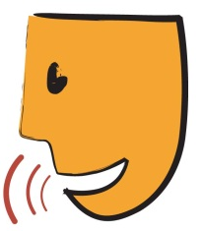
English Learner Progress Record (Grades 6-8) | Levels 2→3 | Speaking

Name: Grade:
U.S. School  Start Date: |  | Progress Record  Start Date:

 | CVC Criteria | Speaking | Date | Can-Do # | Topic | I need to work on …
To get to Level 3, I need to … |  | 3.1 Tell ways to solve problems  3.2 Compare and contrast how people are  3.3 Put processes, cycles, procedures, and evens in order  3.4 Interview people to get information  3.5 Make predictions based on ideas
  3 – Developing
  Complexity
  Series of related sentences
  Vocabulary
  General & some specific vocabulary
  Control
  Meaning overrides communication errors
 |  |  | Date | Can-Do # | Topic | I need to work on …
At Level 2 I can … |  | 2.1 Tell about people, places, things, and things that happen  2.2 Ask who, what, when, where, why questions to help me understand  2.3 Tell about school-related things  2.4 Talk about things in pictures
  2 – Emerging
  Complexity
  Phrases, short sentences
  Vocabulary
  High frequency vocabulary
  Control
  Language w/errors inhibiting communication
 | CVC Criteria | Speaking | Date | Can-Do # | Topic | I need to work on …

English Learner Progress Record (Grades 6-8) | Levels 2→3 | Reading

Name: Grade:
U.S. School  Start Date: |  | Progress Record  Start Date:

 | CVC Criteria | Reading | Date | Can-Do # | Topic | I need to work on …
To get to Level 3, I need to … |  | 3.1 Understand words with multiple meanings  3.2 Find topic sentence, main ideas, and details  3.3 Answer questions about what I read  3.4 Tell the difference between fact and opinion  3.5 Put paragraphs/ sentences in order
  3 – Developing
  Complexity
  Series of related sentences
  Vocabulary
  General & some specific vocabulary
  Control
  Meaning overrides communication errors
 |  |  | Date | Can-Do # | Topic | I need to work on …
At Level 2 I can … |  | 2.1 Match ideas/things/information to where they came from  2.2 Sort information from graphs  2.3 Follow directions from what I see or read  2.4 Match sentences to pictures  2.5 Tell what is the same and what is different in things  2.6 Find main idea in a sentence
  2 – Emerging
  Complexity
  Phrases, short sentences
  Vocabulary
  High frequency vocabulary
  Control
  Language w/errors inhibiting communication
 | CVC Criteria | Reading | Date | Can-Do # | Topic | I need to work on …

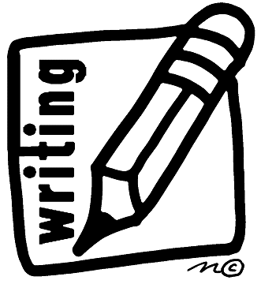
English Learner Progress Record (Grades 6-8) | Levels 2→3 | Writing

Name: Grade:
U.S. School  Start Date: |  | Progress Record  Start Date:

 | CVC Criteria | Writing | Date | Can-Do # | Topic | I need to work on …
To get to Level 3, I need to … |  | 3.1 Write reports using a form  3.2 Write short pretend and true stories  3.3 Write my ideas on a graphic organizer  3.4 Compare and think about how I did using a rubric
  3 – Developing
  Complexity
  Series of related sentences
  Vocabulary
  General & some specific vocabulary
  Control
  Meaning overrides communication errors
 |  |  | Date | Can-Do # | Topic | I need to work on …
At Level 2 I can … |  | 2.1 Make lists of words that go together  2.2 Take notes  2.3 Write questions  2.4 Write to tell something using letters or email
  2 – Emerging
  Complexity
  Phrases, short sentences
  Vocabulary
  High frequency vocabulary
  Control
  Language w/errors inhibiting communication
 | CVC Criteria | Writing | Date | Can-Do # | Topic | I need to work on …

