
English Learner Progress Record (Grades 9-12) | Levels 3→4 | Listening

Name: Grade:
U.S. School  Start Date: |  | Progress Record  Start Date:

 | CVC Criteria | Listening | Date | Can-Do # | Topic | I need to work on …
To get to Level 4, I need to … |  | 4.1 Listen and tell what a word means  4.2 Listen and figure out what I need to do  4.3 Categorize genres read aloud  4.4 Listen and compare traits
  4 – Expanding
  Complexity
  Moderate discourse
  Vocabulary
  Specialized and some technical vocabulary
  Control
  Language w/minimal errors
 |  |  | Date | Can-Do # | Topic | I need to work on …
At Level 3 I can … |  | 3.1 Listen and tell what I think  3.2 Listen and tell main ideas and details  3.3 Listen and use strategies  3.4 Listen and sort examples
  3 – Developing
  Complexity
  Series of related sentences
  Vocabulary
  General & some specific vocabulary
  Control
  Meaning overrides communication errors
 | CVC Criteria | Listening | Date | Can-Do # | Topic | I need to work on …

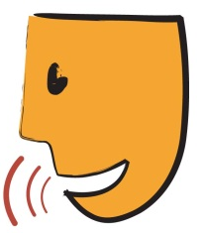
English Learner Progress Record (Grades 9-12) | Levels 3→4 | Speaking

Name: Grade:
U.S. School  Start Date: |  | Progress Record  Start Date:

 | CVC Criteria | Speaking | Date | Can-Do # | Topic | I need to work on …
To get to Level 4, I need to … |  | 4.1 Choose a side and use evidence to defend it  4.2 Tell about issues and ideas  4.3 Compare and contrast how people see things  4.4 Make choices and tell pros and cons of them  4.5 Use and explain slang and idioms  4.6 Use speaking strategies
  4 – Expanding
  Complexity
  Moderate discourse
  Vocabulary
  Specialized and some technical vocabulary
  Control
  Language w/minimal errors
 |  |  | Date | Can-Do # | Topic | I need to work on …
At Level 3 I can … |  | 3.1 Tell ways to solve problems  3.2 Compare and contrast how people are  3.3 Put processes, cycles, procedures, and evens in order  3.4 Interview people to get information  3.5 Make predictions based on ideas
  3 – Developing
  Complexity
  Series of related sentences
  Vocabulary
  General & some specific vocabulary
  Control
  Meaning overrides communication errors
 | CVC Criteria | Speaking | Date | Can-Do # | Topic | I need to work on …

English Learner Progress Record (Grades 9-12) | Levels 3→4 | Reading

Name: Grade:
U.S. School  Start Date: |  | Progress Record  Start Date:

 | CVC Criteria | Reading | Date | Can-Do # | Topic | I need to work on …
To get to Level 4, I need to … |  | 4.1 Compare and contrast _________________  4.2 Understand information  4.3 Infer meaning  4.4 Match cause to effect  4.5 Tell how useful data or graphic information
  4 – Expanding
  Complexity
  Moderate discourse
  Vocabulary
  Specialized and some technical vocabulary
  Control
  Language w/minimal errors
 |  |  | Date | Can-Do # | Topic | I need to work on …
At Level 3 I can … |  | 3.1 Understand words with multiple meanings  3.2 Find topic sentence, main ideas, and details  3.3 Answer questions about what I read  3.4 Tell the difference between fact and opinion  3.5 Put paragraphs/ sentences in order
  3 – Developing
  Complexity
  Series of related sentences
  Vocabulary
  General & some specific vocabulary
  Control
  Meaning overrides communication errors
 | CVC Criteria | Reading | Date | Can-Do # | Topic | I need to work on …

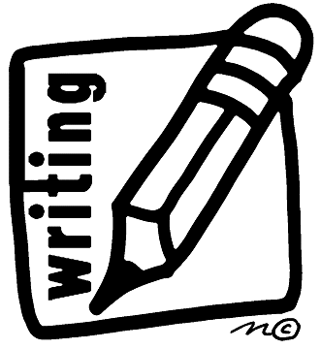
English Learner Progress Record (Grades 9-12) | Levels 3→4 | Writing

Name: Grade:
U.S. School  Start Date: |  | Progress Record  Start Date:

 | CVC Criteria | Writing | Date | Can-Do # | Topic | I need to work on …
To get to Level 4, I need to … |  | 4.1 Summarize notes from lecture or text  4.2 Revise work based on feedback  4.3 Write stories and reports for different purposes  4.4 Defend ideas and opinions  4.5 Write reports on school-related
  4 – Expanding
  Complexity
  Moderate discourse
  Vocabulary
  Specialized and some technical vocabulary
  Control
  Language w/minimal errors
 |  |  | Date | Can-Do # | Topic | I need to work on …
At Level 3 I can … |  | 3.1 Write reports using a form  3.2 Write short pretend and true stories  3.3 Write my ideas on a graphic organizer  3.4 Compare and think about how I did using a rubric
  3 – Developing
  Complexity
  Series of related sentences
  Vocabulary
  General & some specific vocabulary
  Control
  Meaning overrides communication errors
 | CVC Criteria | Writing | Date | Can-Do # | Topic | I need to work on …

