ESL English 3
Quarter II Research Paper

A Historical Figure that Americans Need to Know

There are many important historical figures I think of when I think of America. Some people might include an important president like Abraham Lincoln. Other people might mention a person who changed American beliefs like Martin Luther King Jr. Other people might think of the famous jazz musician Louis Armstrong.
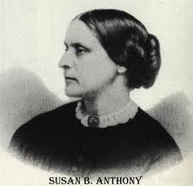
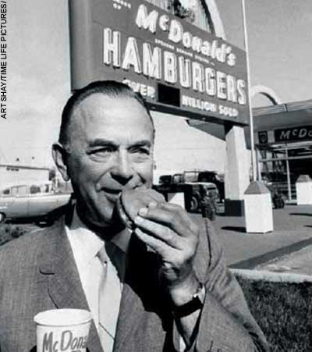
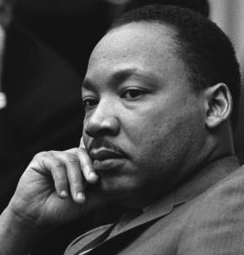

For your first paper in Quarter II, you will choose a historical figure from your home culture. Pick a person that you think is so important that Americans should know about her or him.

- Your person must be dead.

- Your person must have had a positive (good) impact on your country or culture.

- Your paper will be 2-3 pages long, and it will include one picture.

Part 1 - Brainstorming Ideas

- Think by yourself or ask friends, siblings, parents, other students about the typical
people instrumental to your native culture/country. Consider people involved
in/associated with these ideas:

• history/wars • ceremonies/holidays • morals/values
• religion • work/business • education system
• language • travel • friendships
• art/music • racism • goals in life
• food

List as many people as you can that fall into these (above) areas.

- What important events have occurred in your country that you think Americans should know about? Name at least 3 and EXPLAIN them.

- Which people listed in #1 are involved in the events you listed in #2?

Part 2 - Choosing the Best Person

Pick your best three choices from the previous page and answer these questions.

Person #1:

1) What facts and information does the typical American need to know about your
person?

2) Why are these facts and pieces of information about this person important for a typical
American to know?

3) How has this person positively affected your native country and culture?

Person #2:

1) What facts and information does the typical American need to know about your
person?

2) Why are these facts and pieces of information about this person important for a typical
American to know?

3) How has this person positively affected your native country and culture?

Person #3:

1) What facts and information does the typical American need to know about your
person?

2) Why are these facts and pieces of information about this person important for a typical
American to know?

3) How has this person positively affected your native country and culture?

Check with Teacher- decide together on best person.
Part 3- Research

You must collect research about your person, so that you know the important details of his or her life. During your research, you will need to collect the following information:

- 2-3 pictures of your historical figure. You will only use one in your paper.

- 2-3 reference articles/books about your historical figure.

- At least three quotations spoken by that person. It should be something that shows us one of the most important qualities of your historical figure. For example for Martin Luther King, a student might choose a quote like "He who passively accepts evil is as much involved in it as he who helps to perpetrate it. He who accepts evil without protesting against it is really cooperating with it."

Your research will start using the library page:

http://www.revereps.mec.edu/rhs_web/learning_commons_wp/wordpress/

OR

Use the Learning Commons App on your iPad

For each source, make a print out or save a copy of the article and make sure you have the full
bibliographical information on the source. We will discuss this during class as well.
Check-in with your teacher when you have your articles and pictures. Your teacher must sign off on your research before you can continue. __________________________________
Part 5 - Organizing your paper

INTRODUCTION- Paragraph 1 :
You will need an introduction that helps us understand:

- Who are you?
- Why you are interested in this person?
- Who is your person?
- What is a biography?

__________________________________________________________________________________________________________________________________________________________________________
__________________________________________________________________________________________________________________________________________________________________________
__________________________________________________________________________________________________________________________________________________________________________
__________________________________________________________________________________________________________________________________________________________________________
__________________________________________________________________________________________________________________________________________________________________________
__________________________________________________________________________________________________________________________________________________________________________
__________________________________________________________________________________________________________________________________________________________________________
__________________________________________________________________________________________________________________________________________________________________________
__________________________________________________________________________________________________________________________________________________________________________
THESIS STATEMENT: What is your WHOLE essay about?
__________________________________________________________________________________________________________________________________________________________________________
BODY-Paragraphs 2-4:

Paragraph 2

You will need to answer:

1. What is your person’s full name?
2. Where was your person born?
3. When is your person’s birthday and date of death?
4. Who was in your person’s family?
5. One fact from childhood.

Topic Sentence:
______________ had a _________________________childhood.

Quote:  ______________ had a _________________childhood  because he/she states, “________________________  ____________________________________________  ____________________________________________  ___________________________________________”. | Explanation:  This quote explains“________________________________  _________________________________________________  _________________________________________________  _________________________________________________
Answer 1: | Answer 2:  Answer 3:
Answer 4: | Answer 5:
Conclusion Sentence:

Overall, _____________________’s childhood can best be described as _________________________.

Paragraph 3

You will need to answer:

1. What job did your person have?
2. Why is your person important?
3. How did your person make your country a better place?
4. Tell me one important thing your person did.
5. Tell me another important thing that your person did.

Topic Sentence:
______________ had a _________________________adulthood.

Quote:  ______________ had a _________________adulthood  because he/she states, “________________________  ____________________________________________  ____________________________________________  ___________________________________________”. | Explanation:  This quote explains“________________________________  _________________________________________________  _________________________________________________  _________________________________________________
Answer 1: | Answer 2:  Answer 3:
Answer 4: | Answer 5:
Conclusion Sentence:

Overall, _____________________’s adult hood can best be described as _________________________.

Paragraph 4

You will need to answer:

1. Do you respect this person? Why?
2. Would you like to be friends with this person? Why?
3. Do you think this person is important? Why?
4. Did this person change the world? Why?
5. If you could meet this person, what would you say to him or her? Why?

Topic Sentence:
In my opinion, ___________________ was a _____________________________ person.

Quote:  I think _______________was a  _________________ person because he/she states,  “__________________________________________  ____________________________________________  ____________________________________________  ___________________________________________”. | Explanation:  This quote explains“________________________________  _________________________________________________  _________________________________________________  _________________________________________________
Answer 1: | Answer 2:  Answer 3:
Answer 4: | Answer 5:
Conclusion Sentence:

Overall, _____________________is a ____________________________person because ______________________

______________________________________________________________________________________________.

CONCLUSION- Paragraph 5:
For your conclusion, you must explain:
1. Why is your person still important?
2. Why is he or she, in your opinion, the most important historical figure from your country.

__________________________________________________________________________________________________________________________________________________________________________
__________________________________________________________________________________________________________________________________________________________________________
__________________________________________________________________________________________________________________________________________________________________________
__________________________________________________________________________________________________________________________________________________________________________

Check-in with your teacher when you have completed your first draft. _________________

