ACES Rubric

 | Expectations |  | Score
A | Answer the question using recycled words.
C | Cite evidence from the text. | 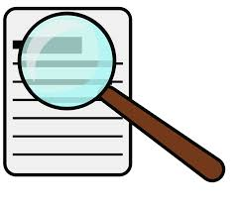  - In the story...  - On page__ it says...  - The author said…
E | Fully explain your answer. | - I know that… because…
S | Sum it up with a closing sentence | - All in all, …  - Clearly, ...  - As you can see, ,..
 | Amount of support | No Support: Wrote on regular paper +2  Little Support: Used sidebar +1  Much Support Sentence starters or fill-in and sidebar +0
 | Total Score

