Construct-Irrelevant Variance: when a second variable interferes with the measurement of the original variable being assessed.

Example: A student’s English language proficiency interferes with measuring their mathematical ability.

To win a game, Tamika must spin an even number on a spinner identical to the one shown below.
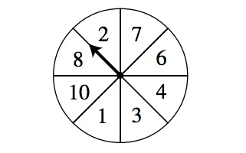
Are Tamika’s chances of spinning an even number certain, likely, unlikely, or impossible?

A. certain
B. likely
C. unlikely
D. impossible

Source: Massachusetts Department of Education (2003b)

