Monitor Comprehension
Metacognition Thinking Stems
- I think …
- I notice …
- This does not make sense to me …
- I realize …
- I feel …
Questions:
Is this book fiction or non-fiction?
What is the book about?
What is the title of the book?
Who is the author?
Who is the illustrator?
What is the theme of the story?
How do you know this? Where did you locate the evidence?
Who are the characters in the story?
Who is the main character? How did you come to this conclusion?
Where is this story taking place?
When is this story taking place?
What do you think the author’s purpose is?
How did you come to this conclusion?
What is the theme to this story?
Underline your evidence. Point to your evidence. List your evidence.

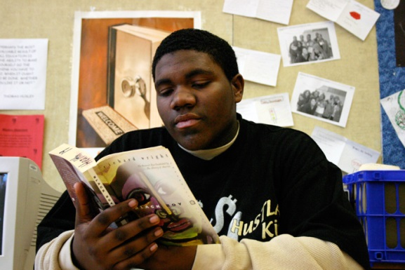
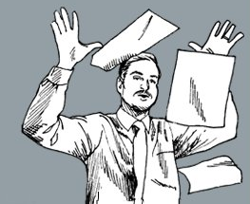
Good readers just don’t read the words and say “I’m done!”
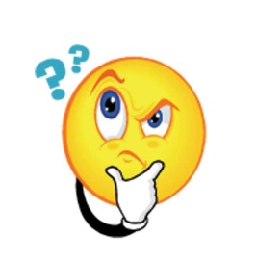
Good readers “think” about what they are reading

Look at the cover
What is the title?
Who is the author?
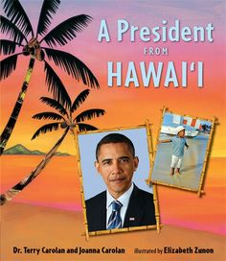
Title: name of the book

Author: person who wrote the story

Illustrator: person who made all the pictures
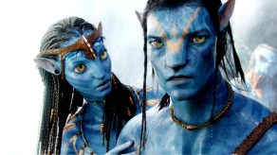
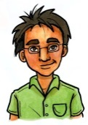
Characters: people in the story
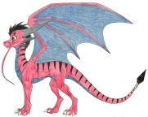

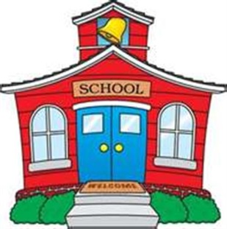
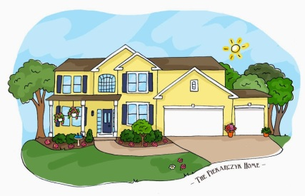
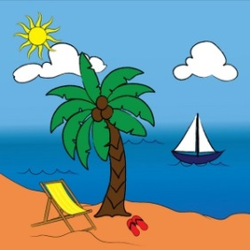
Setting: where the story takes place
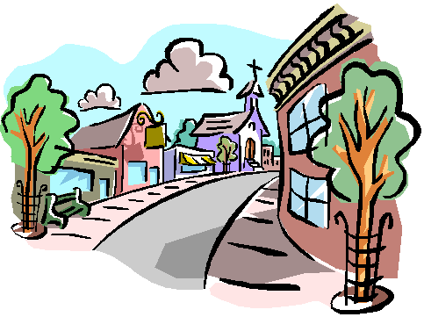

Fiction Elements
NOT TRUE
Realistic Fiction Fantasy
- COULD happen - could NOT happen
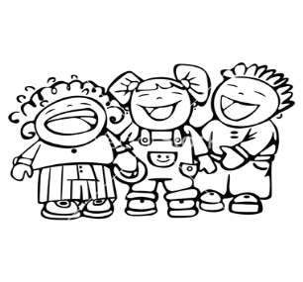
- Not real
- Read to enjoy
- Entertains you
- Makes you laugh

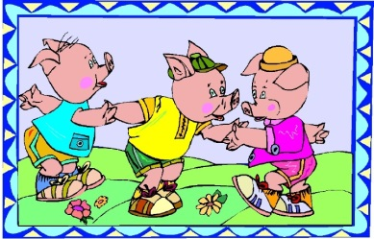

- Talking animals

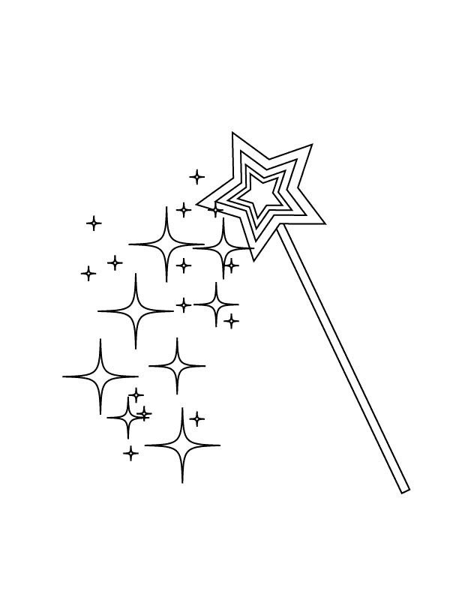
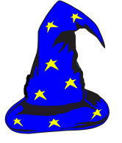

- Can have magic
Fiction Story Elements
NOT TRUE
Title: The name of the book

Author: The person who wrote the text

Illustrator: The person who draws or paints the pictures of the book
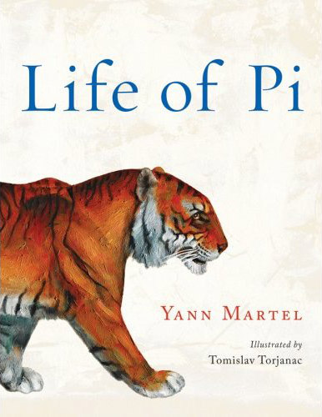

Theme: The theme is what topic or genre the story is on.
“The topic of the story is… “
“The theme of the story is…”

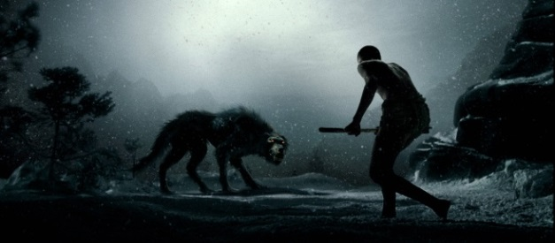

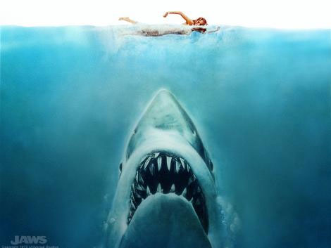

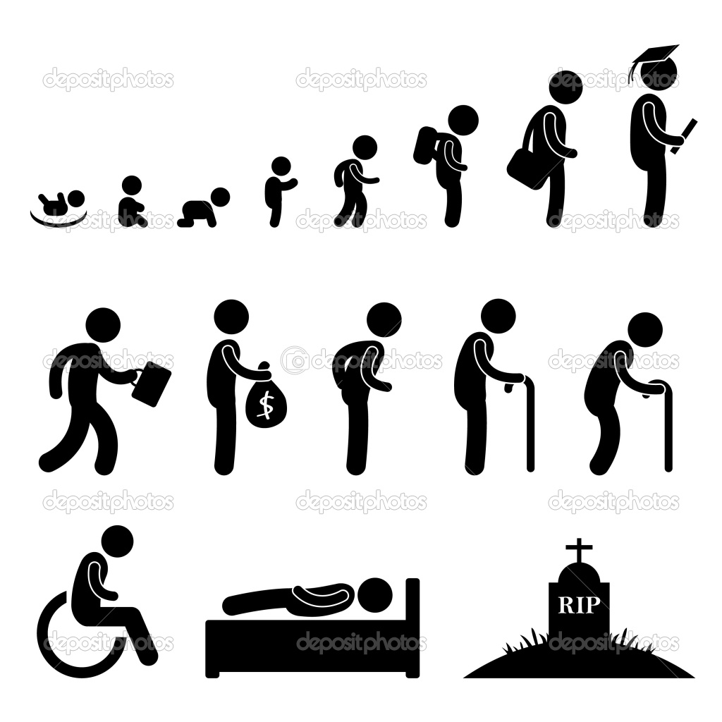
Love Man versus Nature

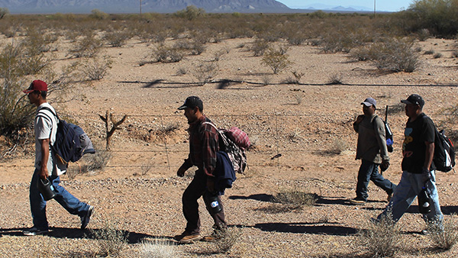

Life Cycle Immigration / Moving

Setting:
The setting is when and where the story takes place.
“The story takes place … “
“The setting of the story is … “
“The setting of the story is inside … “
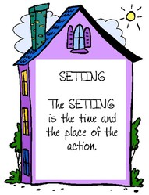
“The setting of the story is outside … “
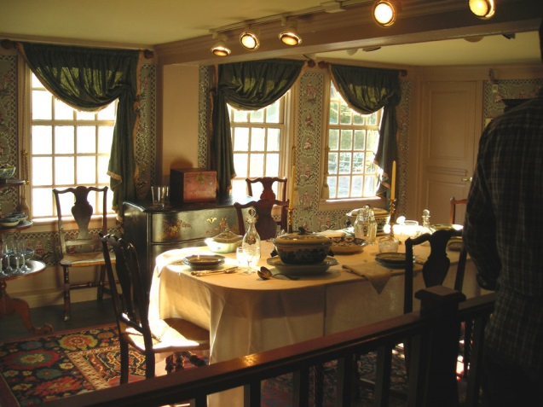

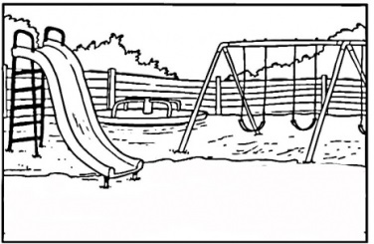

Characters:
The characters are the people, animals, or things that take part in the action in the story.
“The character in the story is …”
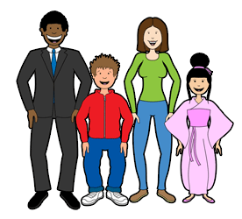
“The characters in the story are …”
