# **Lexile®Lexile 101 – Differentiated Literacy for ELLs**

[jharalson@maldenps.org](mailto:jharalson@maldenps.org) @jharalsonedu

# **What is Lexile?**

(This is a “cheat sheet” only – for more information visit Lexile.com.)

A Lexile measure is a valuable piece of information about either a student’s reading ability or a text’s complexity. Lexile measures are shown as a number with “L” after it. For example, 880L is 880 Lexile.

A student gets his or her **Lexile reader measure** from a reading test. For instance, if a student receives an 880L on her test, she is an 880 Lexile reader.

Higher Lexile score = higher reading ability. The Lexile range goes from BR (beginning reader) to above 1600L for the most advanced, college-ready readers.

A book, article or text gets a **Lexile text measure** when it's analyzed by MetaMetrics (the company that created Lexile). For example, the first "Harry Potter" book measures 880L, so it's called an 880 Lexile book.

The idea behind Lexile is this: If you know a students’ Lexile score and a book’s Lexile number, you can predict how well a student *will* *actually understand what they’re reading.*

Let’s say a reader’s Lexile measure is 600L (600 Lexile). This means the reader will probably understand about 75% of a book with the same Lexile measure (600L). The 75% comprehension rate is called **“targeted”** **reading.**

(This rate is based on independent reading. If the reader receives teacher support and scaffolds, their understanding will increase.)

The **target reading rate** is the point at which a reader will comprehend enough to understand, but also will face *some* reading challenges. At this point, a reader is neither bored nor frustrated. (Think of targeted reading as the “Goldilocks” of books – it’s a kids’ “just right” range.)

# **Where can I find a Lexile test?**

If your school uses a literacy/ELA textbook series, many of these publishers have their own versions of the Lexile test, even if they’re hard to find or not immediately available. Call/email your textbook supplier and ask. Additionally, many standardized tests (like IOWA Basic Skills) provide a Lexile score. (Unfortunately the MCAS doesn’t do this.) Our department at MHS use Lexile tests from Hampton Brown Edge.

According to Meta Metrics, these textbook publishers provide Lexile tests:

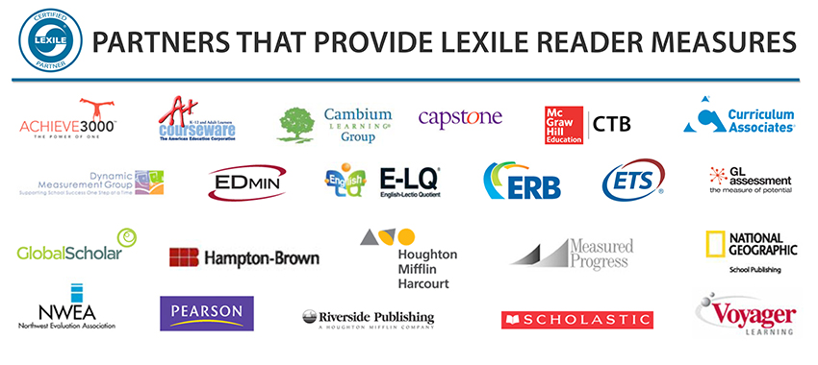

If your textbook series or standardized tests at your school don’t include Lexile, try and lobby (politely!) to your director/relevant curriculum supervisor. It’s a helpful measure to get kids reading. Kids can’t reasonably read – and improve in reading – if they’re not reading stuff they can understand.

You can give your students the test at different points of the year – Sept., December, and May, for example – to see how growth would work.

If you absolutely, positively, **cannot** get a student’s Lexile score, Lexile can still be a pretty helpful tool. You could familiarize yourself with the Lexile range of the books you teach, and understand what Lexile “looks like” at different ends of the comprehension spectrum. If a student is displaying zero comprehension, it might work to show them texts at a different range, to build background knowledge and see if their understanding will increase. The “Find a Book” feature on Lexile.com, a very thorough catalog of relevant books rated by Lexile, can help kids find books even if they don’t know their exact score. If someone doesn’t know their own Lexile score, they can take a reading quiz after selecting “I Don’t Know My Lexile” on the website. The reading quiz can give students a good idea of their range.

# **What do I do after I get a student’s Lexile score?**

The Lexile score you get represents a student’s **75% comprehension rate** – i.e., at this Lexile score, they will understand 75% of the words on the page.

Here’s how you can make a target reading range for your students:

1. First, you want to round the Lexile raw score up by 50-100, depending on the number.

For example, a Lexile raw score of 710 would be rounded **up** to 750.

A Lexile raw score of 770 would be rounded **up** to 800.

This rounded up number represents the “instructional” reading level – what your ELL can comprehend **with teacher support.**

1. Next, subtract 300 from this number. For example, if you rounded up to 750, you’d subtract 300 to get 450. If you rounded up to 800, you’d subtract 300 to get 500.
2. You now have a range from low to high. This range from the low number to the highest number – 450-750 or 500-800 in the examples – represent the **students’ independent reading level.**  Books categorized in this range will represent a good independent reading challenge for students. Books at the lower range will be easier for a student to understand – this is more like “fun” reading.

# **OK. I calculated my students’ Lexile range. Now what?**

Awesome. Now you can do lots of things!

These students all used lexile.com to find a book they actually want to read. but i still couldn't get my shy student to smile.

For research projects, you can direct a student to primary sources and texts they can comprehend. Students looking for new books can be directed there, too.

NewsELA.com, a free website with news articles sourced from reputable publications, “Lexiles” its articles – you can actually click on a news article and get different versions of the same article in different Lexile scores.

At our school, we are explicitly teaching the Lexile system to our students. In our ELL department, we’ve created a leveled independent reading library. Explaining the system to students, we have color-coded our classroom library books by Lexile. Books at 100L are red, 200L are orange, and so on. We go down the colors of the rainbow, adding stickers to the front cover so students can easily identify the book by its Lexile number. There are many possibilities for labeling, depending on the needs of your students and the setup of your classroom library.

With discretion, we share the Lexile ranges with our ELLs. I encourage students to “own” their reading, setting goals to increase their reading range. For the most part, with practice, students’ range increases – and when they see this, so does their confidence and “buy in” to reading.

(If you are concerned about students’ reactions to their range, here’s what I tell students: “There is no “shame” in being at a lower reading range. Your brain is a muscle, and independent reading is “lifting weights.”)

Here’s what I’ve noticed. While independent reading took a **lot** of buy-in before, after implementing Lexile in our library, **almost all of my students are invested in free reading.**  In other words, students **aren’t** getting bored by reading or “fake read” if they are choosing books in the appropriate Lexile range.

When students get to read texts they can actually understand – and when they see that their Lexile range improves over time – I’ve found a huge increase in reader buy-in and an increased identification of students as readers.

If you’re not an ELA teacher or independent reading doesn’t make sense for your school, there are still a lot of ways you can use this measure. What is the Lexile range of your textbooks/books/content/articles you give students? Could you differentiate the texts you give students by Lexile? The possibilities are endless!

# Thank you for reading! This was modified/clarified by Jessica Haralson using Lexile.com and other Lexile resources. Feel free to e-mail me at [jharalson@maldenps.org](mailto:jharalson@maldenps.org) if you want more support or want to share some new Lexile strategies you’ve come up with! We’re all in this together!

*For more research documenting the importance of creating a free reading program in schools, check out Kelly Gallagher’s *Readicide,* or *Book Love* by Penny Kittle. Both books are by master teachers who solidly craft an argument that independent reading vital to a school’s balanced literacy program. Of course, every school – and every reader - are different. Your mileage may vary!