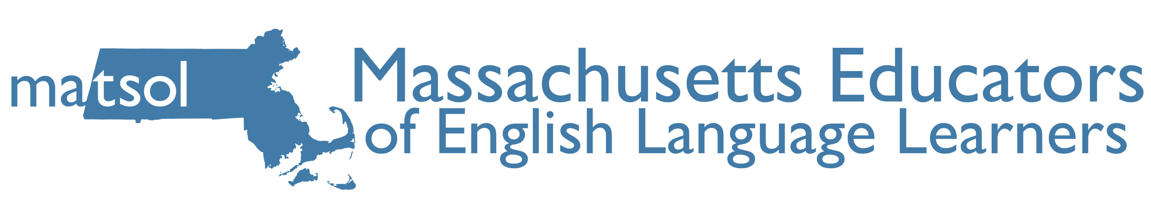
2015 Conference –Framingham, MA

Song Project Resource Packet

Presenter:

Christopher Meoli

CATS Academy Boston
cmeoli@ethical-education.com

