Equity. As the American Library Association grapples with how to create access to information for all, the association defines equity as:
“When some are excluded or lack the knowledge, income, equipment, or training necessary to participate fully in public discourse, they must overcome obstacles to access in order to ensure fairness. In other words, fairness also demands remedies to redress historic injustices that have prevented or diminished access in the first place: for, just as there can be no fairness without equality, there can be none without justice.”
The D5 Coalition on equity: “Improving equity is to promote justice, impartiality and fairness within the procedures, processes, and distribution of resources by institutions or systems. Tackling equity issues requires an understanding of the underlying or root causes of outcome disparities within our society.”
________________________________________________________________________________
Starting with our first best practices report in 2001, Everyday Democracy has included an assessment of our work alongside that of our community partners in every major evaluation project. The practice has helped us continually improve our knowledge, practice and promotion of equity in strengthening local and national democracy. Over the years, we have taken lessons from our initiatives to build principles and practices of equity into our organizational culture, which, in turn, has helped to shape the support we provide to local civic engagement efforts.
A note about Everyday Democracy
Everyday Democracy goes beyond what many typically think of as civic participation: we help bring all kinds of people together face-to-face to talk about and collectively move the needle on issues most important to ensuring the well being of their communities. We are a leader in making this kind of public participation accessible and routine to everyday people around the country. We believe that as long as there are inequitable societal structures in place preventing people of different ethnic, socioeconomic, gender, sexual orientation and educational backgrounds from taking part in civic life, a true democracy cannot exist. Equity and democracy go hand in hand. We work across the country to help groups understand this connection and to design civic engagement efforts that bring together people across all spectrums to work towards positive change on public issues.
We are by no means experts on equity. We do, however, continually work at “walking the talk” as we embed principles of equity into our learning and that of our communities in strengthening local democracy.
The following set of examples illustrates Everyday Democracy’s commitment and ongoing work to keep equity front and center in our learning efforts.
Example #1: Holding the mirror up to ourselves
In our 25 years of supporting local civic engagement efforts, we have learned from local coalitions about the connection between communities’ practices to address racial/ethnic and economic equity and the capacity of those communities to organize and support empowered and productive public participation. We have also learned the value of working on racial and other forms of equity inside our organization, in order to be more effective in our work with communities.
Our internal learning on racial equity started with the 2001 report Toward Competent Communities: Best Practices for Producing Community-Wide Study Circles. For the first time in our work, the research provided us with a comprehensive analysis of how communities focusing on issues of racism and race relations used our tools and advice. We gained critical insights from the research, including the need for our staff to better understand racial equity in order to more effectively support these communities.
We began hosting internal trainings and discussions on the concepts of structural racism, white privilege and power. The experiences were sometimes difficult for staff, but, organizationally, we knew we needed to evolve our thinking and coaching on racial equity.
During this same time period, we realized that our nearly all White European American staff did not reflect the diversity and experience of our communities. Our office location in a rural, predominately white and wealthy town in Northeastern Connecticut often stood as a barrier to recruiting and retaining people of color. As a result, we relocated our office in 2008 to the city of East Hartford, Conn., to build a more ethnically diverse staff and to continue building our knowledge on and experience with racial equity and its connection to strengthening local and national democracy.
Within just a few years of our move, we were able to diversify the ethnicity and experience of our staff. We continued our internal development on issues of racial equity, and included our pool of consultants in these trainings and dialogues. All of this has enabled us to create a number of culturally-appropriate coaching modules and trainings—on topics ranging from building a diverse working coalition, to framing public issues in way that speaks to all kinds of people, to guiding action plans that benefit many, not just a select few.
Example #2: Connecting structural racism to public issues and grassroots organizing
In the past two decades of our work at Everyday Democracy, we have bumped up against the color line in communities in every region of the U.S., and in communities of all sizes and demographic make-up. We learned that systemic structures rooted in racism stand in the way of making progress on all types of public issues – and on realizing the promise of democracy. With this realization, we and our community partners built an equity lens in all aspects of organizing, dialogue, and action. Understanding the structures that support inequity (with a particular emphasis on structural racism) is essential for effective dialogue and long-term change on every issue.
As we worked alongside communities, we also learned that—no matter their demographic make-up or the issue they were addressing—structural racism had an impact on the the public issue they were addressing. Taking on racism was critical to making progress on the issue.
With this understanding, we expanded our discussion materials to include elements of structural racism and we have coached communities to do the same. For example, our Strong Starts for Children discussion guide on early childhood development surfaces the fact that people of color still bear the burden of unjust treatment and unfair policies stand in the way of all young children achieving success. Building Prosperity for All helps communities find ways to change the systems that create both poverty and racism. We’re currently updating our discussion guide on strengthening relations between communities and their police departments to place greater emphasis on disparities in how people of color are treated by law enforcement as compared to European Americans.
Example #3: Becoming co-learners
Everyday Democracy has been a learning organization since its founding. We built the plane as we flew it, researching, field testing and documenting ways for communities to organize themselves into dialogues to create positive change on public issues. We took our learning from communities to build new and improved coaching and training modules. These communities essentially served as our “learning laboratories.”
This “laboratory” view of communities, however, began to shift over the years. Although communities benefited from our research and evaluation lessons, they had their own learning needs.
We now work with communities as co-architects in crafting joint learning experiences. The following examples illustrate some of this work:
- Partnering with a cohort of communities to co-create goals and content for a series of learning exchanges, placing their needs at the center of the agenda.
- Working with external evaluators to design and conduct participatory, culturally competent evaluations.
- Providing communities with coaching and tools to collect data that supports their own learning and improvement of civic engagement practices, and that explicitly supports equitable processes and outcomes.
Example #4: Recognizing that there are multiple pathways to community change
For a number of years, Everyday Democracy has coached communities on a “model” for connecting dialogue to community change. The approach we have developed walks people through the steps of building a multicultural and multisector coalition; training on small-group facilitation; hosting multiple dialogue sessions; and shaping next steps on ideas generated from the dialogues (see diagram below). The process is not for the faint of heart.
Learning with our community partners, we realized that this time-intensive, one-size-fits-all model to civic engagement does not necessarily work for everyone and does not always take local context into consideration. Our original soup-to-nuts engagement model is now growing into set of principles that communities can thread through new or existing civic efforts.
Our approach is evolving from this…
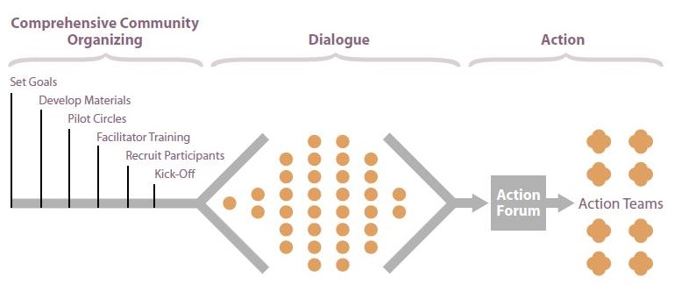
…to using dialogue as an approach guided by the following principles:
- Create opportunities for people, institutions, and government to work together for the common good
- Involve diverse groups of people so that they have opportunities to speak honestly and listen to each other
- Make decisions and policies that reflect everyone’s voice, particularly those who have been marginalized or excluded
- Share knowledge, resources, and power
- Recognize how structural racism has shaped our nation and our communities
- Use an understanding of racial equity to create equitable opportunities and outcomes
- Connect local change to the creation of sustainable local democracy
- Connect local and state efforts to a national movement to strengthen democracy
Everyday Democracy’s work to embed an “equity lens” into our learning continues to take shape. As we navigate this difficult, yet important and impactful work, we invite you to contact us with questions and/or insights.
Carrie Boron Deloris Vaughn
Organizational effectiveness and learning officer Evaluation specialist
860-727-5905 860-727-5927
cboron@everyday-democracy.org dvaughn@everyday-democracy.org

